

Department of Information Technology
COLLEGE OF ENGINEERING

CENTRAL LUZON STATE UNIVERSITY
Science City of Muñoz, Nueva Ecija

Click to Eat: A Mobile-Based Food Delivery Application Exclusive for the CLSU Community

A Capstone Project
Presented to the
Faculty of the Department of Information Technology

In Partial Fulfillment
of the Requirements for the Course IT CAPSTONE 4100
IT Capstone Project 2

By:

BALAGOT, ANGELIKA S.
MAURO, JR. FERNANDO DC.

December 2021

Click to Eat: A Mobile Based-Food Delivery Application
Exclusive for the CLSU Community

Balagot, Angelika S.
Mauro, Jr. Fernando DC.

Disclaimer:

“This project is submitted to the Department of Information Technology, College of Engineering in partial fulfillment of the requirements for the course “IT CAPSTONE 4100 IT Capstone Project 2” under the program of Bachelor of Science in Information Technology at the Central Luzon State University, Science City of Muñoz, Nueva Ecija. It is the product of our own work except where indicated in the text. The project report or any portion thereof including the source code or any section may be freely copied and distributed provided that the source is acknowledged.”
APPROVAL SHEET
This Capstone Project entitled Click to eat: A MOBILE-BASED FOOD DELIVERY APPLICATION EXCLUSIVE FOR THE CLSU COMMUNITY proposed and submitted by Angelika S. Balagot and Fernando DC. Mauro Jr. in partial fulfillment of the requirements for the course for IT CAPSTONE 4100 IT Capstone Project 2 – Final Capstone Oral Presentation, has been examined and found in order and is hereby recommended for acceptance and approval for IT CAPSTONE 4100 IT Capstone Project 2- Final Oral Presentation.

CAPSTONE PROJECT PROPOSAL COMMITTEE

CENON CONRADO C. DIVINA
Chairman
_________________
Date Signed

NEMESIO A. MACABALE JR. GEMLYN S. INOCENCIO
Adviser/Member Technical Critic/Member ________________ ________________
Date Signed Date Signed

Accepted and approved in partial fulfillment of the requirements for the course IT CAPSTONE 4100 IT Capstone Project 2 – Final Capstone Oral Presentation.

DR. KHAVEE AGUSTUS W. BOTANGEN
Department Chair, IT
_________________
Date
CERTIFICATION OF MANUSCRIPT EDITING

This is to certify that the undersigned has read, reviewed and edited the manuscript of ANGELIKA S. BALAGOT and FERNANDO DC. MAURO JR. entitled Click to eat: A MOBILE-BASED FOOD DELIVERY APPLICATION EXCLUSIVE FOR THE CLSU COMMUNITY as a requirement for the completion of the IT CAPSTONE 4100 IT Capstone Project 2. This further certifies that the scope of editing is within the technical preparation of manuscript only. This certification is issued to the aforementioned researchers for English Critic requirements.

Issued this ____^{th} day of ______,2021, Science City of Munoz Nueva Ecija.

Name of the English Critic
Designation/Position
Address of the English Critic

TABLE OF CONTENTS
Title Page ……………………………………………………………………………………...i
Disclaimer …………………………………………………………………………………… ii
Approval Sheet ……………………………………………………………………………....iii
Certification of Manuscript Editing ……………………………………………………….... iv
Table of Contents ………………………………………………………………………….....v
List of Figures ……………………………………………………………………………….vii
List of Tables ………………………………………………………………………………...xi

- INTRODUCTION ………………………………………………………………… 1
- Problem Statement…………………………………………………………... 1
- Objectives ……..…………………………………………………………….. 4
Specific Objectives ………………………………………………..... 4
- Scope and Limitation ………………………………………………………...4
- Importance of the Study …………………………………………………… . 7
- REVIEW OF RELATED LITERATURE ……………………………………….. 9
- METHODOLOGY ………………………………………………………………...15
- PLANNING …………………………………………………………………16
- ANALYSIS ………………………………………………………………….19
- DESIGN ……………………………………………………………………..20
- IMPLEMENTATION ……………………………………………………….22
- RESULTS AND DISCUSSION……………………………………………………24
- PLANNING …………………………………………………………………24
- ANALYSIS ………………………………………………………………….31
- DESIGN ……………………………………………………………………..38
- IMPLEMENTATION ……………………………………………………….48
- CONCLUSION AND RECOMMENDATION …………………………………..58
APPENDICES ……………………………………………………………………...59
A. USER INTERFACE AND USER MANUAL …………………………………...59
B. EVALUATION FORM FOR USER ACCEPTABILITY ……………………...118
REFERENCES ………………………………………………………………………………..127

LIST OF FIGURES
Figure 1: SDLC Waterfall Methodology ….…………………………………………………… 15
Figure 2: Cause and Effect Diagram …………………………………………………………… 28
Figure 3: Conceptual Framework ……………………………………………………………… 33
Figure 4: Process Flow Diagram for Vendor (a) ………………………………………………. 34
Figure 5: Process Flow Diagram for Vendor (b) ………………………………………………. 35
Figure 6: Process Flow Diagram for Customer ………………………………………………....36
Figure 7: Process Flow Diagram for Courier ………………………………………………….. 37
Figure 8: Use Case Diagram …………………………………………………………………… 38
Figure 9: Context Diagram ……………………………………………………………………...39
Figure 10: Data Flow Diagram ………..………………………………………………………...40
Figure 11: Exploded DFD of Process 1 …………………………………………………………41
Figure 12: Exploded DFD of Process 2 …………………………………………………………42
Figure 13: Exploded DFD of Process 3 …………………………………………………………42
Figure 14: Exploded DFD of Process 4 …………………………………………………………43
Figure 15: Exploded DFD of Process 5 …………………………………………………………43
Figure 16: Exploded DFD of Process 6 …………………………………………………………44
Figure 17: Entity Relationship Diagram …..…………………………………………………… 45
Figure 18: Relational Data Model ……………………………………………………………….46
Figure 19: System Testing in Localhost ………………………………………………………...51
Figure 20: System Testing in Webhost ..………………………………………………………...52
Figure 21: Explanation about System …………………………………………………………...54
Figure 22: Vendor Testing the System ………………………………..………………………...54
Figure 23: Vendor Evaluation of System ………..……………………………………………...54
Figure 24: Courier Testing the System ……………………………………..…………………...55
Figure 25: Courier Evaluation of System …………………………………..…………………...55
Figure 26: Customer Testing the System ……………………………………..………………...55
Figure 27: Customer Evaluation of System ………………………………...…………………...55
Figure 28: Create an Account ………..……………………………………..…………………...59
Figure 29: Register as Courier………. ……………………………………..…………………...60
Figure 30: Register as Customer ……..……………………………………..…………………...61
Figure 31: Register as Vendor ……….……………………………………..…………………...62
Figure 32: Login ……………………..……………………………………..…………………...63
Figure 33: Reset Password …………..……………………………………..…………………....64
Figure 34: Index for Vendor ………………………………………………..…………………...65
Figure 35: Upload New Product ……..……………………………………..…………………...66
Figure 36: View/Manage Food ……………………………………………..…………………...67
Figure 37: Update Product …………...……………………………………..…………………...68
Figure 38: Food Categories Page …….……………………………………..…………………...69
Figure 39: Food Orders on Vendor …..……………………………………..…………………...70
Figure 40: View Order Details ……….……………………………………..…………………...71
Figure 41: Available Foods …………..……………………………………..…………………...72
Figure 42: Order Details with Courier .……………………………………..…………………...73
Figure 43: Cancel an Order …………..……………………………………..…………………...74
Figure 44: Vendor Profile …………………………………………………..…………………...75
Figure 45: Update Profile …………………………………………………..…………………...76
Figure 46: Pending Deliveries ……….……………………………………..…………………...77
Figure 47: Items to be pick-up ……….……………………………………..…………………...78
Figure 48: Completed Orders ………..……………………………………..…………………...79
Figure 49: Cancelled Items …………..……………………………………..…………………...80
Figure 50: Index for Customer ……….……………………………………..…………………...81
Figure 51: View Food ………………..……………………………………..…………………...82
Figure 52: List of Registered Vendors .……………………………………..…………………...83
Figure 53: View Stores with Available Items …………………………………….……...……...84
Figure 54: Cart ……………………….……………………………………..…………………...85
Figure 55: Summary ………………………………………………………..…………………...86
Figure 56: Customer’s Profile ………..……………………………………..…………………...87
Figure 57: Update Profile …………………………………………………..…………………...88
Figure 58: Pending Orders …………...……………………………………..…………………...89
Figure 59: To be Delivered …………..……………………………………..…………………...90
Figure 60: To Receive ………………..……………………………………..…………………...91
Figure 61: Cancelled Items …………..……………………………………..…………………...92
Figure 62: Complete Orders ………….……………………………………..…………………...93
Figure 63: Courier’s Index …………...……………………………………..…………………...94
Figure 64: Delivery Requests ………...……………………………………..…………………...95
Figure 65: Stores ……………………..……………………………………..…………………...96
Figure 66: View Store ………………..……………………………………..…………………...97
Figure 67: Deliveries ………………………………………………………..…………………...98
Figure 68: Item to Deliver …………………………………………………..…………………...99
Figure 69: Courier Profile …………………………………………………..…………..……...100
Figure 70: Update Profile …………….……………………………………..………………….101
Figure 71: Successfully Delivered …...……………………………………..………………….102
Figure 72: Login …………………….……………………………………..…………………..103
Figure 73: Password Reset …………...……………………………………..………………….103
Figure 74: User Registration Selection ……………………………………..………………….104
Figure 75: Courier Registration ……...……………………………………..………………….104
Figure 76: Customer Registration …....……………………………………..………………….105
Figure 77: Vendor Registration ……...……………………………………..………………….105
Figure 78: Vendor Homepage ……….……………………………………..………………….106
Figure 79: Vendor Search Result …………………………………………..………………….106
Figure 80: Product Upload …………..……………………………………..………………….107
Figure 81: Product Details ………………………………………………..……………………107
Figure 82: Update Product ……….……………………………………..………………….......108
Figure 83: View Orders ……………..……………………………………..…………………..108
Figure 84: View Order Details w/o Courier Selected …………………………………….…....109
Figure 85: Selection of Courier ……………………………………………..………………….109
Figure 86: View Order Details w/ Selected Courier ……………………………………..…….110
Figure 87: Order Cancellation ……….……………………………………..………………….110
Figure 88: Vendor’s Profile ………….……………………………………..………………….111
Figure 89: Vendor Update Profile …………………………………………..………………….111
Figure 90: Customer’s Homepage …...……………………………………..………………….112
Figure 91: Product Details …………...……………………………………..………………….112
Figure 92: Unchecked Item in Cart ….……………………………………..………………….113
Figure 93: Checked Item in Cart …….……………………………………..………………….113
Figure 94: Customer’s Profile ……….……………………………………..………………….114
Figure 95: Customer Update Profile ………………………………………..………………….114
Figure 96: Courier’s Homepage ……...……………………………………..………………….115
Figure 97: Delivery Request Details ………………………………………..………………….115
Figure 98: Items to Deliver …………..……………………………………..………………….116
Figure 99: Courier Profile …………………………………………………..………………….116
Figure 100: Courier Update Profile …...……………………………………..…….…………..117

LIST OF TABLES
Table 1: Existing Food Ordering Applications…………..………………………………….......11
Table 2: Available Existing Alternatives……………………………………………………..…12
Table 3: Activities and Deliverables for Planning Phase…………………………………..……19
Table 4: Activities and Deliverables for Analysis Phase…………………………………..……20
Table 5: Activities and Deliverables for Design Phase………………………………………….22
Table 6: Activities and Deliverables for Implementation Phase…………………………..…….23
Table 7: Estimated Cost of the Proposed System ……………………………………………… 30
Table 8: System Requirements Checklist ……………………………………………………… 32
Table 9: Development Components ……………………………………………………………. 48

CHAPTER I
INTRODUCTION
Nowadays, having an easy-to-go access to everything is a beneficial aspect for everyone. It could be an easy access to information, news, devices, and food. According to Joshi et. al. (2019), Food is one of the basic necessities of humans. It is significant because it nourishes the human body, thus maintaining human life. That is why having an easy-to-go food services is popular these days which is food delivery application/system. In addition to that, Sharma (2020) said that food delivery application allows food consumers to place an order from a diverse range of fields with a single click on their mobile phones and then wait for the ordered food that will be delivered by the courier on their places.
People nowadays are struggling not only with their busy schedules but also by the threat of the current virus (COVID-19). In that sense, a food delivery application is helpful to lessen their struggle and have a food on their places by just clicking their mobile phones. Also, delivery application will lessen customer’s doubt of being infected by the virus since they don’t need to interact with other people at the supermarket or grocery store.
Central Luzon State University (CLSU) is a public university on a 658-hectare campus in Science City of Muñoz, Nueva Ecija, Philippines. It is the lead agency of the Muñoz Science Community and the seat of the Regional Center for Research and Development in Central Luzon. It is one of the biggest schools in Central Luzon. The university continually offers a high-quality education even in times of pandemic.
The health and safety of every student and staff in CLSU after a pandemic should be the most prioritized. Places such as canteens, eateries, bakeries, and other fast-food restaurants inside the university should minimize the crowds. It is essential to follow the safety protocols and guidelines even when the post-pandemic period has come. Following the protocols will lessen the risk of being infected.
Since the university is large in size and the university canteen and other food vendors are far from every college and office, it is applicable to have a delivery system inside the university. Click to Eat is a big help to minimize the crowds in eateries and other fast-food restaurants inside the university. Also, this application allows students and professors to maximize their time in doing their academic stuff because they will just order from the application and the food will be delivered by the courier. Also, Click to Eat gave opportunities to the people who lose their job during a pandemic since the vendors will be needing a courier who will deliver the foods.
- PROBLEM STATEMENT
- University Canteens and Eateries are crowded
Once the post-pandemic period has come, the food consumers such as students, faculties, and staff will be at high risk of getting exposed to the virus that has caused the current pandemic.
- Safety protocols will be violated
Then if the canteens and eateries inside the university will become crowded it will violate the safety protocols of the university such as social distancing and other gatherings. Since it is the priority of the university to keep everyone safe inside the campus.
- Distance of food consumers from food providers inside the campus.
Since CLSU is large in size, colleges and other buildings are far from each other especially the College of Agriculture (CAg) and College of Fisheries (CF). The food consumers such as students, faculties, and staffs will commute or walk a long distance whenever they want to eat since not every building has its own canteen.
- Conflict schedules of food consumers
Another thing that was noticed during the face-to-face method of education is the conflicting schedules of food consumers like students. Because not all students have the same time of break, some students have the chance to eat their meals early, and some have their meals on late time. This situation results to an insufficient supply of foods especially to small canteens that is located on nearby colleges.
Therefore, to make sure that everyone inside CLSU is safe and will not cause them to spend their time to commute or walk in a long distance, this project builds an application that lets them easily order their lunch or snacks during their breaks that is delivered on their location safely.
- OBJECTIVES
This project aims to develop an android food delivery application that can be used by food stores and consumers inside the Central Luzon State University for ordering and delivering food within the campus.
Specific Objectives
- To create an online system for viewing food stores and restaurants with their available food and meals.
- To design and build a convenient and secure online system where users have their verification ID for ordering food and meals.
- To build a food delivery system within the university and nearby residences and dormitories that addresses IATF’s requirement.

- SCOPE AND LIMITATION
The proposed system will be capable of maintaining the health protocol and guidelines in the post-pandemic period. Only the students inside the university and vendors within’ the university proper will be allowed to register in Click to Eat Application. The Delivery service will only be limited inside the CLSU properties.
The proposed system will be capable of maintaining the health protocol and guidelines in the post-pandemic period. Only the students inside the university and vendors within’ the university proper will be allowed to register in Click to Eat Application. The Delivery service will only be limited inside the CLSU properties.
Administrator
The administrator of the application is the only user who can modify the rules of creating, posting and deleting the items. They can also monitor every transaction that has been made by the vendors and consumer. They have access to every record, so that, if ever a problem occurs between customers and vendors, there will be records that can be checked to resolve the problem.
Vendors
The vendors are allowed to create and delete their products on the application, edit the descriptions and price of the products, and view transaction records of every food that has been purchased. They can also approve or disapprove the orders of the customer.

Customers
The customers are allowed to cancel the food order as long as the vendor does not yet approve the transaction. They can also add an item to their cart and buy it later on. The items to the cart can also be removed by the customer if they don’t feel buying it anymore.
Couriers
The courier of the deliveries will be the person who will apply for the official Click to Eat delivery system. Couriers can either accept or decline the food to be deliver. And lastly, couriers will be able to confirm payments.
The CLSU Click to Eat can be accessed through android enabled mobile and website which allows the system to maximize the accessibility and portability of it. In terms of payments, the system will only be available through cash-on-delivery for initial launching. The application can be use anytime as long as the vendors or the shop is not yet closed and still accepting orders from the customers. In addition, the amount of the purchased meals will not be limited, the consumer can order all the meals that they want, but the delivery fees may vary.
However, the Click-to-Eat Application project will not cover the maintenance phase in the methodology since this project’s purpose is only to complete the final requirements of the developers/researchers which will allow them to graduate.
- IMPORTANCE OF THE STUDY
This study is beneficial for the students, professors, and staff of the university to lessen their activity of walking or commuting just to get to eateries and canteens, instead of using their time to focus on their academic stuff. It is also an essential application for vendors inside the university because it helps them to minimize the number of customers in their store. In addition, couriers or riders can also benefit from this service because this application needs to have a courier who delivers all the ordered foods by the customer from the vendor.
CLSU Students
The system allows students to have an easy-to-go food delivery service that helps them to decide what food they want to order, and even if the canteen or eatery was far from their location while ordering, they can still have their order. This system also helps students to lose their doubt of getting infected by the virus since they will not be interacting with other students. In addition, this system is following the goal of the university by prioritizing the health of each student.
CLSU Employee
This system helps professors and other staff of the university to lessen their worry about thinking of what they could eat, or even worrying about going too far and crowded canteens or eateries inside the university. Because this system makes it easier for them to decide what they could have on their lunch or other meals by just checking the available menus from the different stores in the university, and having their chosen meals by checking them out from the system.
Food Seller
The system allows vendors to gain a lot of orders from customers around the university with the use of their mobile phones and will lessen their work of accompanying a lot of customers to their store since it is the post-pandemic period it is a goal to minimize the number of people inside a store.
Couriers
This system helps persons who lost their job in times of pandemic, especially those who are riders or couriers because it lets them be the individual who grants the wishes of every customer inside the university to have an easy-to-go food delivery service. In this way, since there are a lot of stores inside the university, it also needs to have a lot of couriers to deliver the food needed by the customers.
Other Individuals and Offices
This study would be a good reference for other individuals or organizations who will have the same study. It would also be helpful for future studies who wish to upgrade the system by using other methods of developing it.

CHAPTER II
REVIEW OF RELATED LITERATURE
This chapter includes other accomplished literature from different authors together with their use on this study. In addition, this chapter involves other available alternatives that exists today that will provide comparison between those alternatives and on the system that researchers are proposing.
Food delivery is a courier service which stores, restaurants, or third-party application delivers food to consumers on demand, these days, orders are executed through mobile applications, websites or even via telephone (Viktor, 2020). In addition, food delivery system is no longer a new thing for individuals especially at this time, many users all over the world are using the system because it is an easy thing to operate. The food delivery system has a wide impact in terms of efficiency, time management, and technology.
Almost all of the people have their own mobile device that can be used to order from the delivery application system. Gupta (2019) says that technology is the reason why food delivery has a huge impact on the generation today. The benefits of using this system will allow customers to enjoy eating their favorite meals while staying in their favorite place or working place. In this way, they can maximize their tasks to do and they can also maximize their time management.
Time management involves the process of determining needs, setting goals to achieve these needs, prioritizing and planning tasks required to achieve these goals (Lakein, 1973). Time management is also the reason why the food delivery service is in nowadays. People who are busy with their tasks will no longer be disturb when taking a lunch or snacks.
There are a lot of existing food delivery applications available worldwide and one of this application is Tapingo. According to Dunn (2018), on her post at Uloop Scholarship website page, she enumerated 7 Food Ordering Applications for Students. Tapingo is one of the applications that she mentioned, it is different from the other because this app is exclusively for college students. The application allows students to browse menus, place orders, pay for the meal, and schedule the pickup or have it delivered. In terms of payment students are able to use their university’s meal dollars. Tapingo launched into five campus first such as Santa Clara University which is located on California and many more. This application has the similarity on the study in terms of it is exclusively available for university, and also allows consumers to place their order from the application. But also, the two has their distinction, Click to Eat food delivery system is only available in CLSU campus, and can be accessed by anyone such as students, staffs, and other individuals.
Below is the table showing the 7 Food Ordering Applications for Students by Dunn on her post at Uloop Scholarship website page. The tables show the list of the different food ordering application by Dunn, together with their remarks which discussed on how each application works, difference between each application and the range of each apps based on the location.
Table 1: Existing Food Ordering Applications
Food Ordering Applications | Remarks
GrubHub | According to Dunn, GrubHUb is one of the most prominent food ordering apps, it is available in 900 cities in California. GrubHub lets customers to type their location, then the it will find the list of restaurants that is close to their location. The application also makes recommendations for their users based on their ordering history.
Seamless | Seamless is an app belonging to GrubHUb’s brand portfolio, but Dunn separated it since it is a separate app. Seamless is known for a food delivery system that does not charge delivery fees for their customers.
Tapingo | Tapingo is the used application of researchers since it is closely similar to the proposed study because the application is available for student customers and are located mainly in universities.
HealthyOut | HealthyOut is an application that best fit for customers that have a highly specific dietary needs of what they eat because it allows them to search for menu that fall within a certain caloric range.
Eat24 | Eat24 is a popular food delivery application that works with 20,200 restaurants. Based on the blog of Dunn, Eat24 is based on common pieces, local tips, and customer ratings, it uses an algorithm to choose the very best dishes for you. If you're the one picking up the bill, you can also use your camera to check your credit card via the app.
DoorDash | DoorDash application has a feature of real-time tracking after placing an order, it allows users to watch their order move through the preparation and delivery processes and predict when it will arrive.
Uber Eats | Uber Eats claims an ordering takeout as easy as requesting a ride, it also allows their users to add dishes to their cart, and check it out through the app. It also helps students with dietary needs to use their Special Instructions field to write their request s that is applicable to the dish that they have ordered.

In todays’ generation there are a lot of food delivery application that offer good services for their clients nowadays these are Grab Food and Food Panda. These two are the most popular application here in the Philippines. As such, the developers used this as an existing alternative for the study.
Table 2 illustrates the differences of the available food delivery application which are Grab Food and Food Panda from Click to Eat food delivery system. The three are differentiated in terms of their Geographical Availability, Time Availability, Partnerships, and Remarks.
Table 2: Available Existing Alternatives

Food Delivery Service | Geographical Availability | Time Availability | Partnerships | Remarks
Grab Food  (Grab.com) | Grab Food’s delivery services is only available in the following are: Metro Manila, Rizal, Cavite, Laguna, Pampanga, Cebu | Grab Food’s is 24 hours available, Monday to Sunday. | Grab Food’s supports online orders from any restaurant within’ the service range. | Grab Food’s is only available in selected areas.
Food Panda (Cleverism.com) | Food Panda is Available widely. | Food Panda is also 24 hours available from Monday to Sunday. | Food Panda only supports selected fast-food restaurant. | Even Food Panda is available widely, it does not support small restaurants and canteens inside the university.
Click to Eat | Click to Eat is exclusively available inside CLSU Campus. | Click to Eat can be use anytime as long as the vendors or the shop is not yet closed and still accepting orders from the customers. | Click to Eat supports online orders from stores and restaurants inside CLSU. | Click to Eat is only available in stores and restaurants inside the CLSU campus.

Grab Food is a food delivery service that connects local food businesses to people (Grab.com). When a customer places an order with Grab Food, they receive it and assign a Grab Food delivery partner to pick up the order from the restaurant and bring it to the customer.
Grab Food’s Advantage (Grab.com) is it presents a variety of food based on what’s available around such as Filipino, Wester, Asian, and many more. Another advantage is that Grab Food is available 24 hours a day, and operates from Monday through Sunday. The disadvantage of using Grab Food is it is not available in some parts of the Philippines since it is only available in areas in Metro Manila, Rizal, Cavite, Laguna, Pampanga, and Cebu.
Another food delivery system is the Food Panda (Cleverism.com, 2021). which is the leading global online food delivery marketplace, originated in Berlin, Germany, and operates in more than 40 countries including Philippines. It was launched in the Philippines in June 2014.
The advantage of having a Food Panda application is it will save individuals from hassles of table reservations; they don’t need to go out and buy their food personally just like what other food delivery systems do (Cleverism.com). Food Panda also allows users to conveniently discover food around neighborhood and directly order their favorite meals online or via mobile. However, since there is a large amount or order delivered, Food Panda cannot track the delivery of orders, which results in paying a large amount to the restaurant, which is the cause of fraud.
Nevertheless, even these two delivery systems are available and ready to develop their services in many areas, there are some factors that can be considered such as speed of delivery and supports in local food vendors like canteens and small fast-food restaurants inside the university. That is why having a very owned university delivery system application should be implemented.
Click to Eat is an application that supports the fast-foods restaurants, bakeries, canteens, and other food services or stores inside the university that will only be available exclusively for CLSU community. Since the application focuses on serving CLSU community and nearby residences only, it has a feature where the users should upload their ID for identity verification. In that way, fake accounts will be prevented and service integrity will be maximized.

CHAPTER III
METHODOLOGY
The Click to Eat food delivery application used the Systems Development Life Cycle (SDLC) Waterfall Methodology. This methodology has four phases which is shown in figure 1. First by determining the human information requirements in the planning phase; then analyzing the system needs; designing the system, testing and integrating the system; and lastly implementing the developed system.

Figure 1: SDLC Waterfall Methodology
- PLANNING
In this phase, researchers determine the requirements that are needed to successfully develop the system. These requirements include determining the problem of the target organization which is the CLSU community with the use of an interview to gather information. With the help of the gathered information, researchers create a feasibility study that scopes the project’s technical, operational, and economic feasibility. The planning phase includes the following activities:
- Interviewing
The method of interviewing was used by researchers to gather information, researchers conduct an interview with the target users of the system such as CLSU vendors, students, staff, and other personnel inside CLSU. Since the country are currently in the midst of a pandemic, researchers were not able to interview the mentioned persons personally. In that case, researchers conducted questions containing information that help the user and system need with the use of an interview virtually. Since CLSU has a large number of persons, researchers only choose a few respondents that will be interviewed. Below is the list of questions created by the researchers that help them to identify the problem of the organization. The interview was being separated, from CLSU Vendors, and CLSU Food Consumers.
Interview for CLSU Food Vendors:
- When the pandemic ends, are you still willing to sell inside the university? If yes, why? If no, why?
- If your answer to the current question is yes, are you inclined to interact with other vendors and students inside the university?
Interview for CLSU Food Consumers:
- Before the pandemic starts, where do you usually eat inside the university?
- Based on your answer to the current question, do you find that store far from your college or office? If yes, in what way do you get there? Commuting or walking?
- When the pandemic ends, are you still willing to go to the store you used to eat before the pandemic? If yes, why? If no, why?
- Summarizing and Documenting the Results
After interviewing, researchers reviewed, analyzed, summarized, and documented all the gathered information from the respondents. In this case, researchers determine the different problems of the CLSU community, especially the food vendors and food consumers. After determining the problem, researchers were able to discover the possible solutions to solve the problem of the organization. This step also determines the cause and effect of such problems.

- Feasibility Study
The feasibility study determines if the project’s capability in terms of technical, operational, and economic feasibility is essential to the organization in which the project will be implemented.
In Technical Feasibility Study, developers found out technical resources that can is being used to support the proposed system, these technical resources include machines such as laptop and mobile phones wherein the system will be programmed, it is also essential to have an internet connection, and more importantly, are the persons that will test the developed system.
In an Operational Feasibility Study, it validates if the users are computer literate enough to use the developed system, in this case, developers provide a basic training for users such as vendors and students especially to those who are beginners in accessing and managing the system. Developers are also accepting suggestions from the user’s depending on their choice and comfort in using the system.
In Economic Feasibility Study, it demonstrates the benefits of the proposed system to the users. Whether it is tangible and intangible benefits. To know the benefit of the proposed system, the cost effectiveness is being measured as well as the time for the developers to create the system is discussed. Since cost and time are the most essential factors that are involved in this study.
Table 3: Activities and Deliverables for Planning Phase.
 | Activities | Description | Deliverables
1 | Interview for Respondents | Researchers will conduct questions for respondents, that is needed for obtaining the problems that the organization is facing. | Summarized list of questions with answers
2 | Summarizing and Documenting the Results | The answers of respondents from the interview will be measured, analyzed, summarized, and documented. | Cause and Effect Diagram
3 | Technical Feasibility Study | Developers will find out technical resource that can be used to support the proposed system. And will list them to show the technical resources that will be used. | Technical Feasibility Analysis
4 | Operational Feasibility Study | Developers will provide a basic training for vendors and students on how to access and manage the proposed system. | Operational Feasibility Analysis
5 | Economic Feasibility Study | Developers will create a table that shows the cost of each technical resources that will be used, also the cost and time effectiveness of the system is being measured. | Economic Feasibility Analysis

- ANALYSIS
In this phase, the developer performs a detailed review of the organization's current practices as well as the information systems used to carry out organizational tasks. This phase is needed since it will help the developers to identify system requirements and structure and create the system based on the current or existing process inside the university. Once the appropriate data has been gathered, the developer will be able to analyze what the proposed system requirements and creates a different diagram to present how will be the process of the developed system and then proceed with the next phase.
Table 4: Activities and Deliverables for Analysis Phase.
 | Activities | Description | Deliverables
1 | Detailed review of the organization’s current practices and system requirements. | When all the information’s needed are being collected, a comprehensive review about the organization’s problem and system requirements will be executed. | System Requirement Checklist
2 | Analyze the requirements and give a solution. | Developers will give a concrete solution to the organization’s problem and system requirements. | Conceptual Framework
3 | Creating the Process Flow Diagram | Developers will create a Process Flow Diagram, that illustrates the relationships between major components of the system | Business Process Diagram

- DESIGN
In this phase, the developer team will now design the proposed delivery system for Central Luzon State University (CLSU). The following will be the diagram that will be used in designing the system:
Use Case Diagram
In this diagram, a "system" is something that is being developed or operated, such as a mobile application and website. The "actors" are persons or entities that play specific roles within the scheme such as CLSU Vendors, Students, Faculties/Staffs.
The developers will use this diagram to present the roles of every user of the system.
Data Flow Diagram
This diagram will show the way on how the information flows through the Click to Eat system. This flow includes the data inputs and outputs, also the data stores and other subprocesses which the data moves through.
Entity Relationship Diagram
ERD or Entity Relationship Diagram will be used by the developers to show the relationships of each entity on the diagram such as Vendors, Customers, Couriers and more, together with their attributes. This diagram also presents the logical structure and the flow of the database.
Relational Data Model
The Relational Data Model or RDM will be used by the developers to represent the relations between one entity to another. In addition, the developers will also show the new tables that will be created based on the analyzation of the relationship of each entity from the ER Diagram.

Table 5: Activities and Deliverables for Design Phase.
 | Activities | Description | Deliverables
1 | Generating the Data Flow Diagram | Developers will generate a Data Flow Diagram to show the way on how the information flows through the Click to Eat system | Data Flow Diagram
2 | Making the Use Case Diagram | Use Case Diagram will be made by the Developers because it presents the roles of every user of the system. | Use Case Diagram
3 | Designing the Entity Relationship Diagram (ERD) | Developers will design the Entity Relationship Diagram to show the relationships of each entity on the diagram such as Vendors, Customers, Couriers and more, together with their attributes. This diagram also presents the logical structure and the flow of the database. | Entity Relationship Diagram (ERD)
4 | Forming the Relational Data Model | The formation of the Relational Data Model will be executed since every row in the table in RDM represents a set of data values that are related to one another. It will be used by the developers to represent the relations between one entity to another. | Relational Data Model

- IMPLEMENTATION
In this phase, the developer will proceed in developing the system requirements which include the coding and testing. During the coding, the developer of the proposed project will write a program that will make up the system. After that, the developer will proceed in testing the functionality, usability, maintainability, and portability of the program so that the developer will identify if the program meets the system requirements and identify if there is a bug in the system.
The next process will be the deployment of the proposed project in the university for review and evaluation of the performance of the system so that the developer will be able to take action of the feedback of the users and also to measure if the developed system has achieved its objectives.
Table 6: Activities and Deliverables for Implementation Phase.
 | Activities | Deliverables | Deliverables
1 | Developing the application | In developing the system requirements of the application, developers include coding and testing. During the coding, the developers will write a program that will make up the system. | Development Components
2 | Testing the developed application | In testing the developed application, developers will test the functionality, usability, maintainability, and portability of the application so that developers will identify if the application meets the system requirements and identify if there is a bug in the system. | Test Scenario, Test Results
3 | Deployment of the application | In the deployment activity, the application will be deployed in the university for review and evaluation of the performance of the application, so that developers will be able to take an action of the feedback of the users. | Application’s Review and Evaluation

CHAPTER IV
RESULTS AND DISCUSSION
With the use of SDLC Waterfall model as its methodology, the developers gathered a lot of essential information that helped them to obtain the result of each activity.
  - PLANNING
For the planning phase, developers determined the requirements that they need to successfully develop the project. To be able to determine the essential requirements, researchers take their step to interview the needed respondents which are CLSU vendors and CLSU food consumers. Developers also summarized the obtained information from the interview and documented the important information as well as the activities that are made. Lastly, developers created a feasibility study that scopes the technical, operational, and economic feasibility of the project from all the gathered and summarized information.
    - Interviewing
In this activity, developers generated a virtual interview with the use of Google Form. The purpose and goal of the proposed project is discussed and explained on the interview so that the respondents will have knowledge about the project. The interview contains different questions that is needed to complete the system requirements. The developers created a total of three (3) interview form in Google Form; for CLSU vendors, for faculty/staff, and lastly, for students. Each interview has respondents that is limited to three (3) which results with a total of nine (9) respondents. The developers randomly selected the respondents to show that there is no bias in sending and collecting the answers from them. The answers that are being gathered from the interview are summarized and discussed below.
On the first interview for the CLSU Vendors, researchers ask about the location and name of the store to know if they are one of the stores that are more likely to be visited by the food consumers. Some say they are located at Alumni, Old Market, and nearby stores in colleges. For the question that if the pandemic ends, are they still willing to sell inside the university? Majority of them says yes, because according to them, they are enjoying selling foods and they need to earn money for their family. Then researchers ask the following question that if their answer is yes, are they willing to interact with other vendors and food consumers when the pandemic ends. Some answered yes and some says no. Since vendors already has the knowledge about the proposed project, researchers ask them if having a food delivery application will be help for the CLSU community? And they all said yes, because it will help them to still gain customers even if the pandemic intrudes the university.
For the next interview which is for CLSU Students as a food consumer. Researchers ask for their names and colleges, to know if their college have their own canteen or if they are far from eateries and canteens inside the university. The first question for them is where they usually eat inside the university when the pandemic ends? Some says they eat on stores like Chilltrap, Hide-out, Set n’ Bites, and OJ’s which is located on Old Market, some answered on Alumni, and some said they eat on their houses. From the current question, researchers ask if the eateries are far from their current location or colleges, and in what way do they get there? Some says it is far and their way to get there is by walking, but majority of them answered commuting. To address the current situation, researchers ask the students if the pandemic ends, are they still willing to go to the stores they used to eat before? Some answered yes because they think it is still safe to eat there, but most of them answered no because according to them they are afraid of getting infected by the virus and also it is hassle if they have tons of activities and assignments to work on. Researchers also ask the students if having a food delivery application will be a help for the CLSU community? They all answered yes, because according to them, it will save the time and money of the students.
The last respondents of the interview are the CLSU Faculty/Staff, researchers ask for their names, work, and for the location of their work inside the university. Some of them are Security Guards, and majority of them are Professors. The questions for the students are the same for the faculty and staff. Respondents said that before the pandemic ends, they usually eat on stores located at Old Market, Alumni, Marketing, and some said at their home within the university. However, they said that the location of their work is far from the location of the eatery which they usually eat, and some said that their colleges have their own canteens and eateries. For the faculties that answered it is far from them, they said that to get there they are commuting and some of them said with the use of their own vehicle. After that, researchers ask, when the pandemic ends, are they still willing to go to the store that used to eat before? They all answered yes. Lastly, researchers ask if the proposed study will be a help for CLSU community? They said yes, because based on them, it will help them to focus on their work and will lessen their time to go to far eateries and canteens inside the university.
Overall, the organization’s problem is first the fear of getting infected by the virus, second is the distance of the locations of eateries from the food consumers, and lastly, students and other faculty and staff of the university can’t manage their time when going too far eateries, instead of maximizing their time doing their academic activities.
    - Summarizing and Documenting the Results
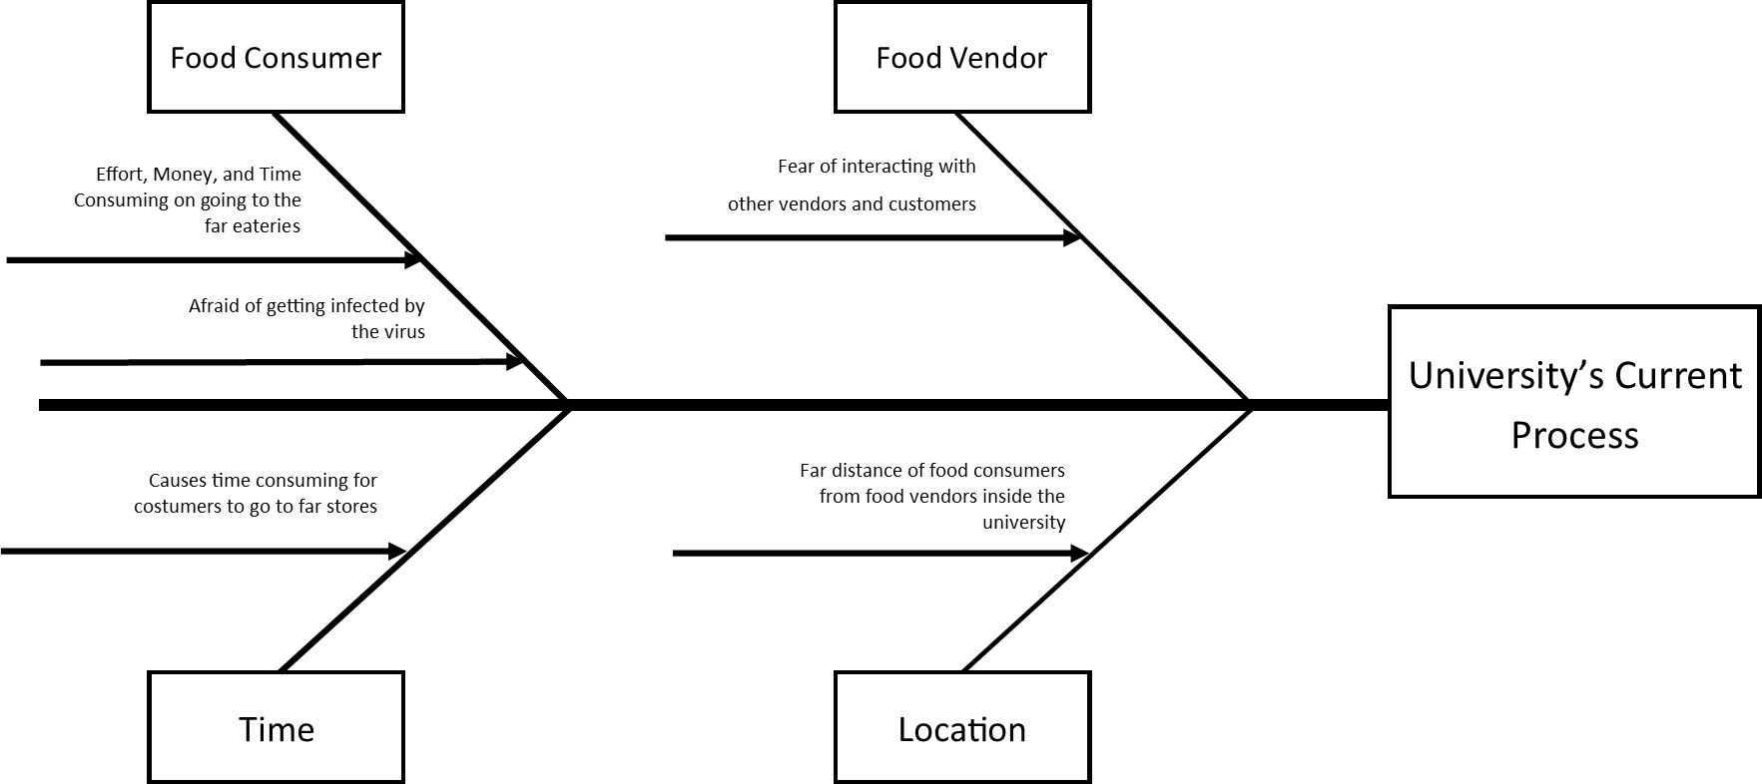
In this part, researchers show the summarized results from the interview with the use of a cause-and-effect diagram.

Figure 2: Cause and Effect Diagram
The figure above shows the different problems encountered and current process of the CLSU community that the developers found out from the interview. The diagram consists of the causes: Food Consumer, Food Vendor, Time, and Location, together with the effect which is the University’s Current Process.
    - Feasibility Study
The developers conducted the study that determines if the project’s capability in terms of technical, operational, and economic feasibility is essential to the organization in which the project will be implemented.
- Technical Feasibility Study
CLSU Click to Eat system is a web and android application-based system. The main technology and tools that are associated with OES are Android Studio, HTML, PHP, CSS, MySql, Web Browser, and Server.
Each of the technology that is listed above are freely available and technical skills required is manageable. The website and android application will be hosted freely in free web hosting space since this project is for final requirements before graduation and will not be maintained. Bandwidth required for the application is low since it only contains texts and pictures. From these, it is clear that the project is technically feasible.
- Operational Feasibility Study
The proposed system is simple to use just like the other food delivery applications on the Philippines today. However, developers will also provide a basic training for the users on how to access and manage the developed system. After that, developers will install the developed system to the user’s devices which they can fully operate the system based on their own knowledge and skills. Seeing that the developers will provide training for the users, therefore, the study is operationally feasible to them.
- Economic Feasibility Study
In this study, it measures the cost and time effectiveness of the system. All the of the estimated cost for the implementation of proposed system is listed on the table below together with the cost of each requirement per year.
Table 7: Estimated Cost of the Proposed System
Expense | Price Per Year
Domain Registration | P 404.25
Web Hosting | P 2,888.64
TOTAL COST: | P 3,292.89

As shown in table 7, the domain registration will cost 404.25 PHP per year and web server that will host the project with a cost of 2,888.64 PHP per year. The total investment required for the project is 3,292.89 PHP annually.
In order to make the application profitable, developers will allow referral marketing which involves promoting third-party products or services. In addition, developers of the proposed system also considered paid advertisement (ads) to the system to optimize revenue opportunities.
With the given computation above, the proposed system is measured as cost effective since the invested money for the project will be returned in just a more half of a year.
Moreover, the system is also measured as time effective because it allows food consumers to maximize their time on doing their academic activities rather than going to the stores. Which results to the students and staffs to be productive. It is also time effective to the vendors because instead of entertaining customers on the store, they just need to prepare and pack the ordered food then let the couriers to bring the food to the customers. In this sense, they will have more time to focus on the store, by cleaning, and following the health protocols. Lastly, with the use of the proposed system, it helps to achieve the goal of the university by prioritizing the health of each student, vendors, staff, and other CLSUan’s inside the university.
  - ANALYSIS
From the gathered, analyzed, and summarized answers from the respondents on the current phase, researchers come up with a detailed review of the organization’s current process and system requirements. Moreover, this phase also discusses the created Conceptual Framework to give a concrete solution for the organization’s problem and system requirements. Lastly, the Process Flow Diagram will also be discussed to illustrate the relationships between major components of the system.
Table 8: System Requirements Checklist
System Requirements | Do researchers, have it? Yes (/) or No (x)
Android Studio | /
HTML | /
PHP | /
CSS | /
MySQL | /
Web Browser | /
Server | /

The table above shows the system requirements of the project that must be address by the researchers, it simply shows that all of the requirements needed to create the system is already available for the developers.

Conceptual Framework
Figure 3: Conceptual Framework
This figure presents visual representation of an expected relationship between variables that is related with the study. It shows the characteristics or properties that are involved with the project. This framework is generally developed based on the literature review and existing alternatives provided in Chapter 2.

Process Flow Diagram
Developers illustrated four (4) process flow diagram for each user.
Figure 4: Process Flow Diagram for Vendor (a)
The Figure 4 presents the flow of process on how the vendor entity operates the application.
Figure 5: Process Flow Diagram for Vendor (b)
The Figure 5 shows the CRUDE (create, update, delete, edit) concept. This figure presents the flow of the system when the entity (vendor) makes a decision on how she/he would manage the developed system.
Figure 6: Process Flow Diagram for Customer
The Figure 6 shows the flow of process on how the customer will do in the developed application. The customer can log in, cancel order, add the item to cart and delete the item to cart. This figure also presents the operations flow that the customer will actually execute to the system.
Figure 7: Process Flow Diagram for Courier
The Figure 7 presents the simple flow of process on how the courier will use the developed application. The figure shows that the courier will create his/her account, then wait for the placed order by the customer and pick up the order, after that, he/she will receive the payment from the customer, then went back to the store and give the payment to the vendor.
  - DESIGN
Developers converts the description of the recommended alternatives to physical system specifications. The following are the diagrams used by the developers as a pattern in designing the system:
Use Case Diagram
The developer used this diagram to present the roles of every user of the system that is being illustrated and discussed below.
Figure 8: Use Case Diagram
This figure shows the restriction of usage of every actor (Admin, Vendor, Courier, Customer) that will be using the developed application. It shows that each actor has their own restriction and can only access certain operation on the application.
Context Diagram
Figure 9: Context Diagram
This figure presents the clarification and boundaries of the CLSU Click to Eat delivery system. It identifies the flow of information between the system and external entities which are the user of the application.

Data Flow Diagram
Figure 10: Data Flow Diagram (DFD)
The figure 10 presents the flows of process within the system and shows where the data is being stored when the customer placed an order using the system. In more simple term, this diagram presents the operational process of the CLSU Click to Eat food delivery system. To further explain the data flow of the delivery system, exploded data flow diagram will present the management of each user of the system which is the vendors, customers, and couriers.
Figure 11: Exploded DFD of Process 1
Figure 12: Exploded DFD of Process 2
Figure 13: Exploded DFD of Process 3
Figure 14: Exploded DFD of Process 4
Figure 15: Exploded DFD of Process 5
Figure 16: Exploded DFD of Process 6

Entity Relationship Diagram
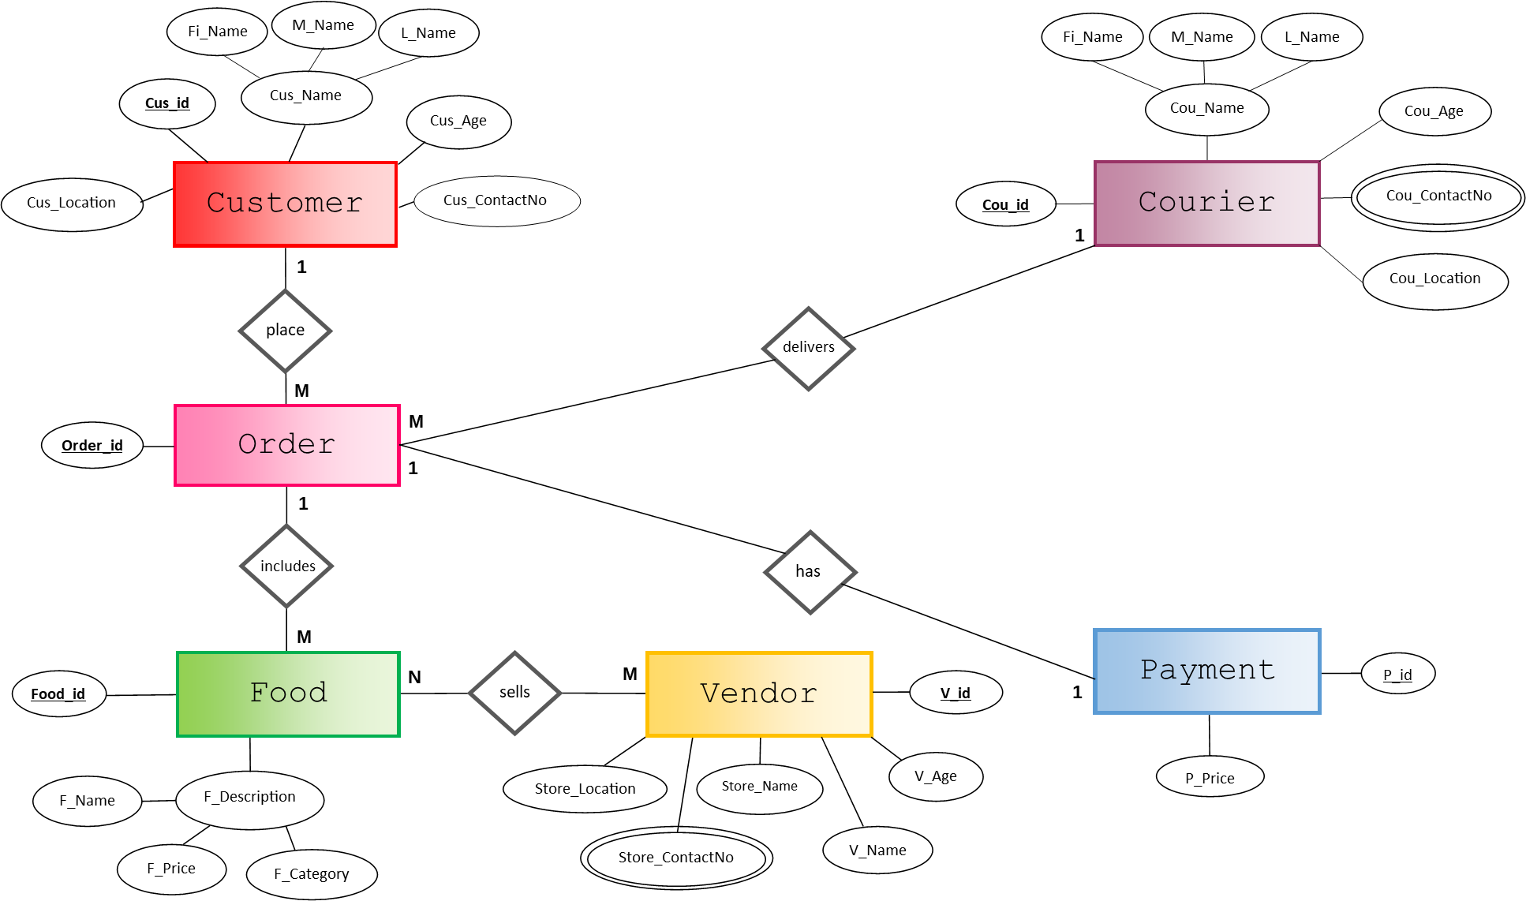
Figure 17: Entity Relationship Diagram
Figure 17 shows the relationships of every entity of the proposed system on the diagram. The diagram contains seven (6) entities which are Customer, Order, Food, Vendor, Courier and Payment. The text notations for each entity are the following: Customer (Cus_id, Cus_Name (Fi_Name, M_Name, L_Name), Cus_Age, Cus_Location, {Cus_ContactNo}), Order (Order_id), Food (F_id, F_Description (F_Name, F_Price, F_Category)), Vendor (V_id, V_Name, V_Age, Store_Name, Store_ContactNo, Store_Location), Courier (Cou_id, Cou_Name (Fi_Name, M_Name, L_Name), Cou_Age, Cou_Location, {Cou_ContactNo}), Payment (P_id, P_Price). In addition, the relationships of entities Customer place an Order is One-to-Many (1:M), and Order that includes Food is also One-to-Many (1:M) relationship. While Order that has a Payment is One-to-One (1:1) relationship, however, the relationship of Vendor sells Food is Many-to-Many (M:N) relationship. The entity Courier which delivers Order has One-to-Many (1:M) relationship, and lastly, the relationship where Courier receives Payment is Many-to-Many (M:N).
Relational Data Model
Figure 18: Relational Data Model
The figure 18 shows the relationship of one entity to another, together with their corresponding values (attributes). The figure also shows the new tables (Receives, and Sells) that were created while summarizing and analyzing the relationships of each row on the table of every entity.

  - IMPLEMENTATION
Developing the application
After analyzing the systems requirements and creating the design, the developers started to develop and code the system.
In the process of developing the system, developers performed meetings virtually and face to face to discuss about the ways and techniques to use in developing it. Documentation of the process is also included in the process of developing the system. Each member of the team has respective roles in developing the system based on their skills and capabilities. In addition, this part also includes the set of schedules on the development of each part of the system which is being used by the developers to follow. Lastly, the developers will provide the user interface of the system in a mobile and website view together with the user manual to guide the users for the proper use of the developed system.
Table 9. Development Components
 | Components | Tasks
1. | Initial Development | Gathering System Needs – developers conduct an interview to the target users to gather information for the needs in development of the system.
1. | Initial Development | Visualizing the System – the prototype of the web and android is created to have a visual interpretation of the system.
2. | Application | HTML – developers use HTML in developing the system.
2. | Application | CSS(Bootstrap) – in designing the system, developers use CSS and Bootstrap for the system to be appealing to the eyes of the user.
2. | Application | JavaScript – this was used to perform the transactions in the system.
2. | Application | PHP – developing the system using PHP
2. | Application | Android Studio – since the system is mobile based, developers use converted the system in android studio.
3. | API Keys | PHP Mailer – this API key uses to verify the accounts of users together with the email notification.
4. | Documenting | Documenting – while developing the system, documenting of the development of the system is also on the process.
5. | Testing | Localhost Testing – it is use in the stage of developing the system to test it.
5. | Testing | Webhost Testing – after the development stage, webhost testing is where developers test the whole system if they meet the requirements needed for the development and test if all the transactions perform well.

Table 11 discuss how and what are the ways in developing the system with the help of the five components of development, these components are Initial Development, Application, API Keys, Documenting, and Testing.
The first component is the Initial Development where developers conduct an interview to the target users of the system (students, faculties, staff, vendors, couriers) to know the problems that is being encountered by them. The problems are being analyzed and was used by the developers as the basis to start the system. Developers also designed a prototype to visualize the system that is needed to develop to address the problems and needs of users.
Deciding of the application to be used is the second component. The developers come up to a large variety of developing tool and ends up using both HyperText Markup Language (HTML) and Hypertext Preprocessor (PHP) because it where developers are capable of using when developing websites and it is part of their curriculum. In designing the website, developers use the designing tools such as Cascading Style Sheet (CSS) and Bootstrap to assimilate to the type of system and to their users.
The third component is API keys, the developers use PHPMailer to verify the accounts of each user who are registered to the system. Also, the PHPMailer was used to send a direct email to the users such as food consumers, food vendors, and food couriers whenever they perform such tasks.
The fourth component is documenting, the process of documentation was being done at wherever the developers completed a task. The documentation is helpful to the developers because it was being used as their basis to know the progress of their project.
The last component is testing, it is performed after the system is finally working and ready to use by the users. The testing happened in localhost together with the webhost where developers test the whole system if they meet the requirements needed for the development and test if all the transactions perform well.
Testing the developed application
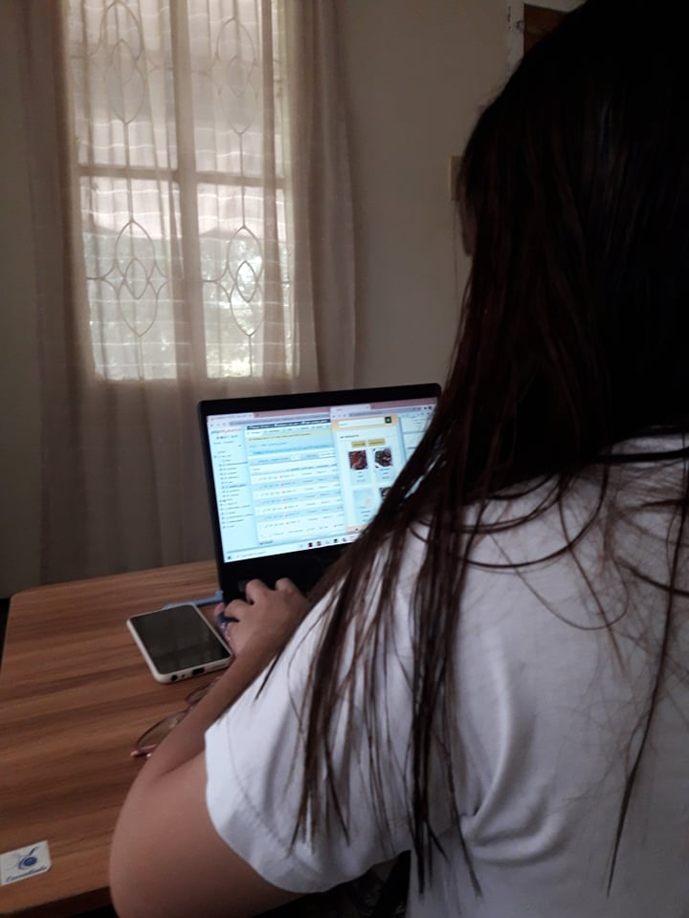
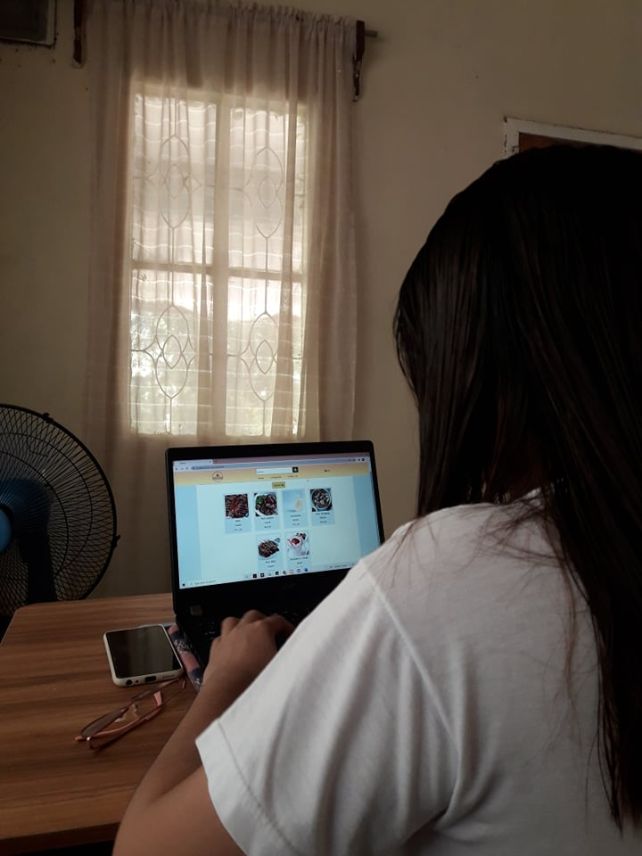
When the proposed system is already developed and documented, the system undergoes into multiple testing performed by the developers. The system will be checked based on its behavior if the functionalities met the user requirements and the system requirements specifications. This phase checks if the system meets the requirements specified in the former phases. The Test Case of the system is included on the Appendices together with the results of the test.

Figure 19. System Testing in Localhost
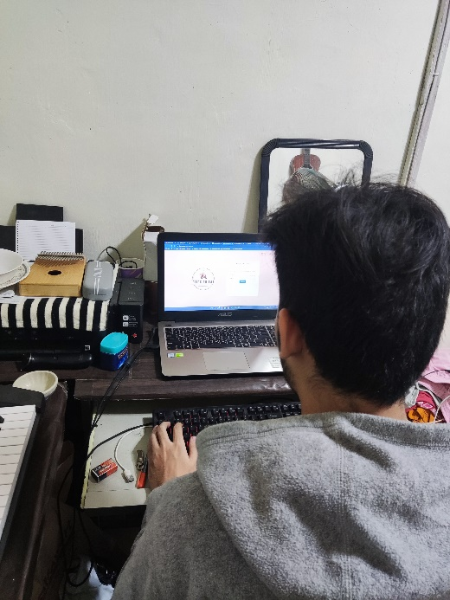
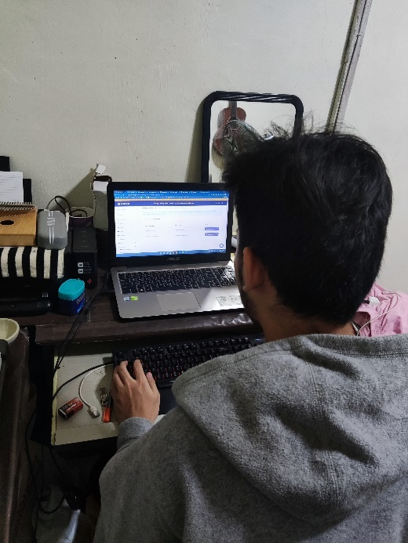
Figure 19 shows the testing on the developed system on localhost, even the system is a web and mobile based, it still undergoes into multiple testing by developers to make sure if all the functions operate properly.
Figure 20. System Testing in Webhost
After testing the system several times using localhost for bug fixing and functionality testing, the developers migrated the system in a premium webhosting which is Hostinger. Then, developers test the functionality of the system using a host from a web to check if the system behavior is the same as its behavior in the localhost. After multiple testing and debugging in the webhosted system, the developers deployed the system for testing random vendor and students.

Deployment of the system
In terms of deployment of the system, the developers had the chance to enter the university to deploy the system to the target users of the system. The system was being test by one of the most popular stores inside the university which is Aling Ipay’s store and was being used personally by the owner of the store. It was also deployed for the use of a food consumer who was a student of CLSU together with the courier who was also a student who are considered as a working student by his own. Before the developers have deploy their developed application to the users, they first give some explanations about the system of how the system addresses the problems encountered by the users and what are the steps they have made to accomplish the system. After the deployment, the developers let the users to evaluate the developed application with the use of the evaluation form. The evaluation form is about the user acceptability of the system which tests the Usability, Reliability, Effectiveness, User Interface, and Security of the system. The evaluated Evaluation Form by the users was included on the Appendices.
Below is the documentation of the deployment of the system together with the evaluation of the system by the users (Food Consumer, Food Vendor, Food Courier).

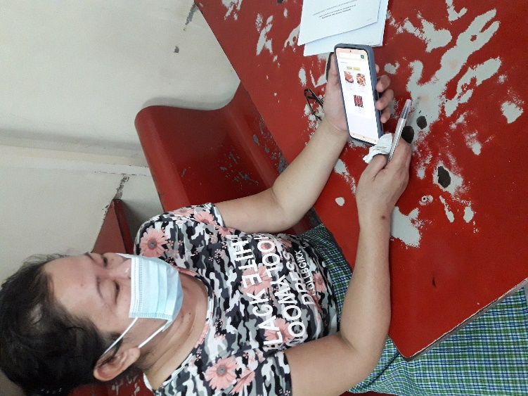
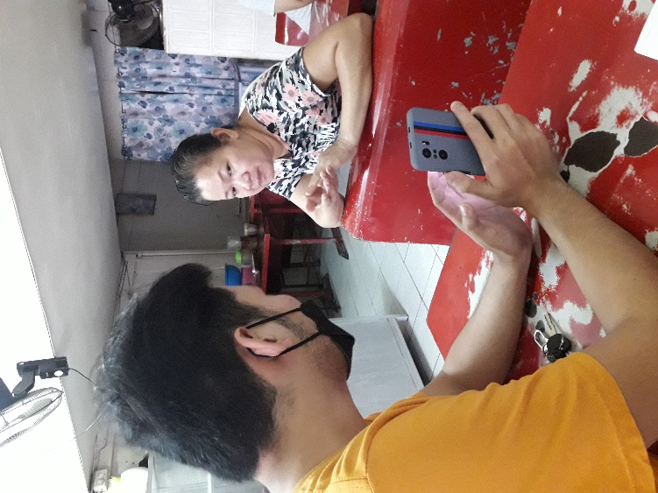

Figure 21. Explanation about System Figure 22. Vendor Testing the System

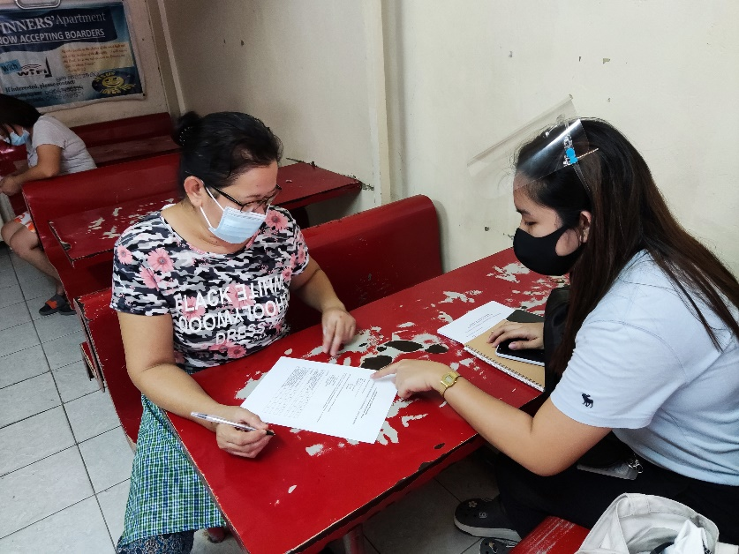

Figure 23. Vendor Evaluation of System

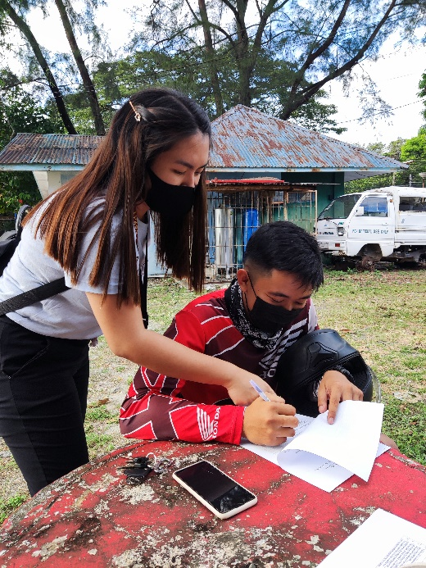
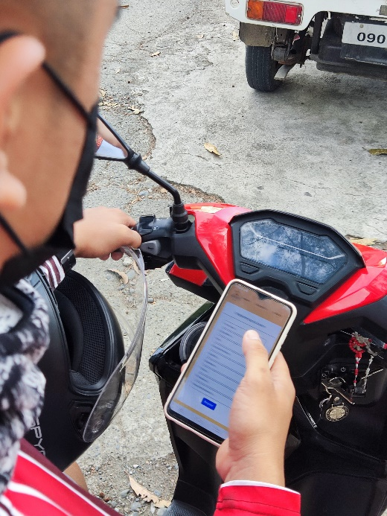

Figure 24. Courier Testing the System Figure 25. Courier Evaluation of System
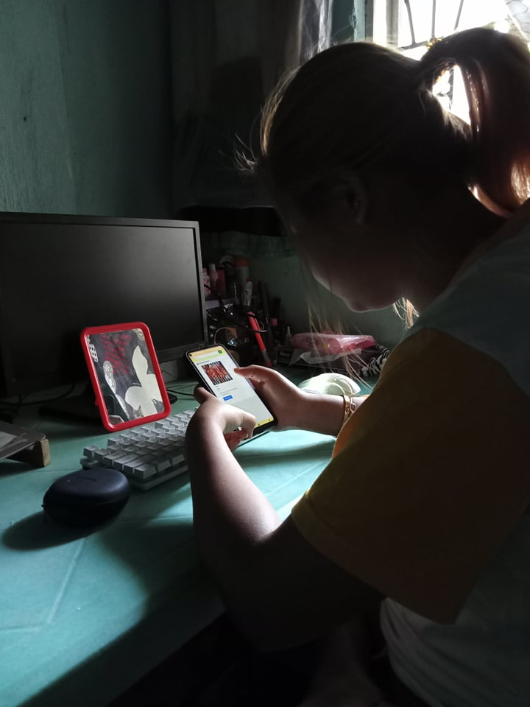
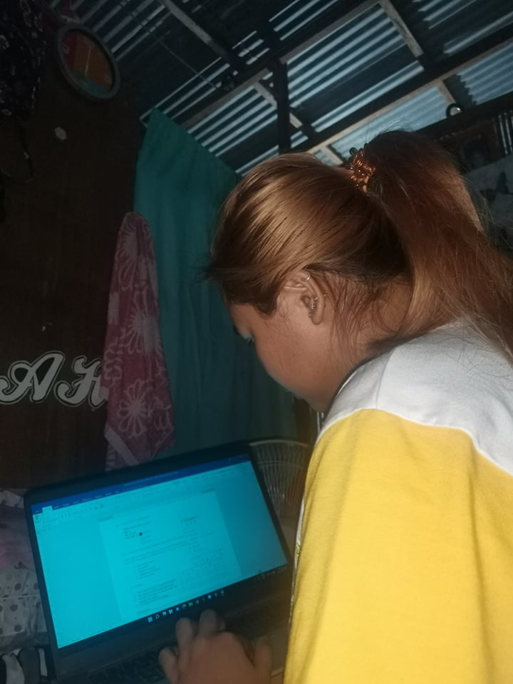

Figure 27. Customer Testing the System Figure 27. Customer’s Evaluation

The figures above show the testing and evaluation of individuals that uses the system. However, developers only had the chance to deploy the system to a single store since it is the only store that is operating inside the university. The system was also tested by a single courier and customer because of the pandemic, individuals must need to minimize the interactions with others to follow safety protocols inside the CLSU.

CHAPTER V
CONCLUSION AND RECOMMENDATION
On the developers own outlook, the developed system which is the Click to Eat addresses the problems that will be encountered by the individuals inside the CLSU especially the food consumers, and food vendors when face-to-face classes has come. Once the pandemic ends and the university allows students to have a face-to-face class and let the vendors to operate inside the university. With the use of the system the fear of individuals inside the university of getting infected by the virus will vanish. Food consumers such as students, faculty, staff, and residents inside the university is now capable to order food online and have their ordered food to be delivered to them at the comfort of their places. As well as for the food vendors, local stores inside the university will have the chance to easily have an order by simply uploading food on the system and accepting orders from customers, in that way they can earn more capital and will keep them safe because the system helps them to avoid a crowded store that may cause by customers. Lastly, this system is convenient for individuals who lost their job during pandemic because the system needs to have a food courier who is responsible of delivering the ordered food to its designated customers.
The developers therefore, developed the system named “Click to Eat: A Mobile-Based Food Delivery Application Exclusive for the CLSU Community” to meet the user’s problem and helps the whole CLSU community to have a convenient, efficient, and reliable application that keep the university safe.
For the enhancement of the current developed system, developers have made a recommendation for researchers who wish to improve and create a better version of it. The developers recommend the future developers of the system to add new features to the system like ratings of the products and display the best-selling products. In addition, developers also recommend to make the area of the scope of the system to become larger and imply the system to nearby Barangay’s and residents near CLSU. Other than that, developers are open for any suggestions, questions, queries, comments, and complaints about the system. The developers are willing to help and contribute for further enhancement and improvement regarding the system’s functionalities.

APPENDICES
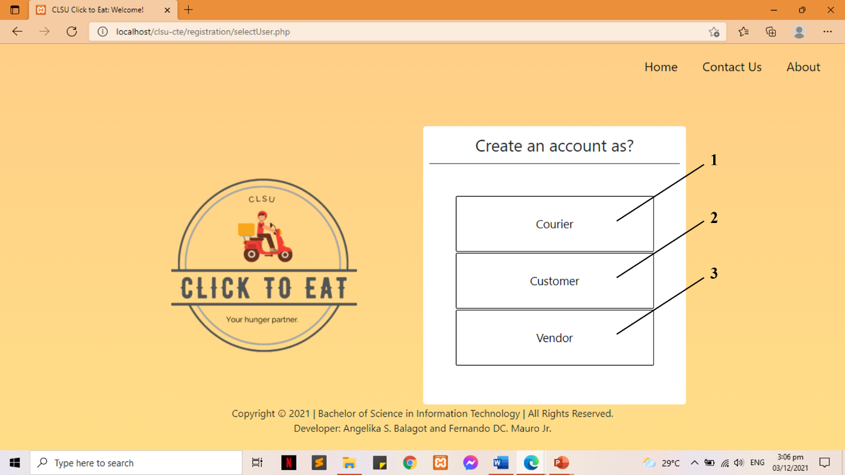
  - USER INTERFACE AND USER MANUAL
Figure 28: Create an account
1. Create account as Courier
2. Create account as Customer
3. Create account as Vendor

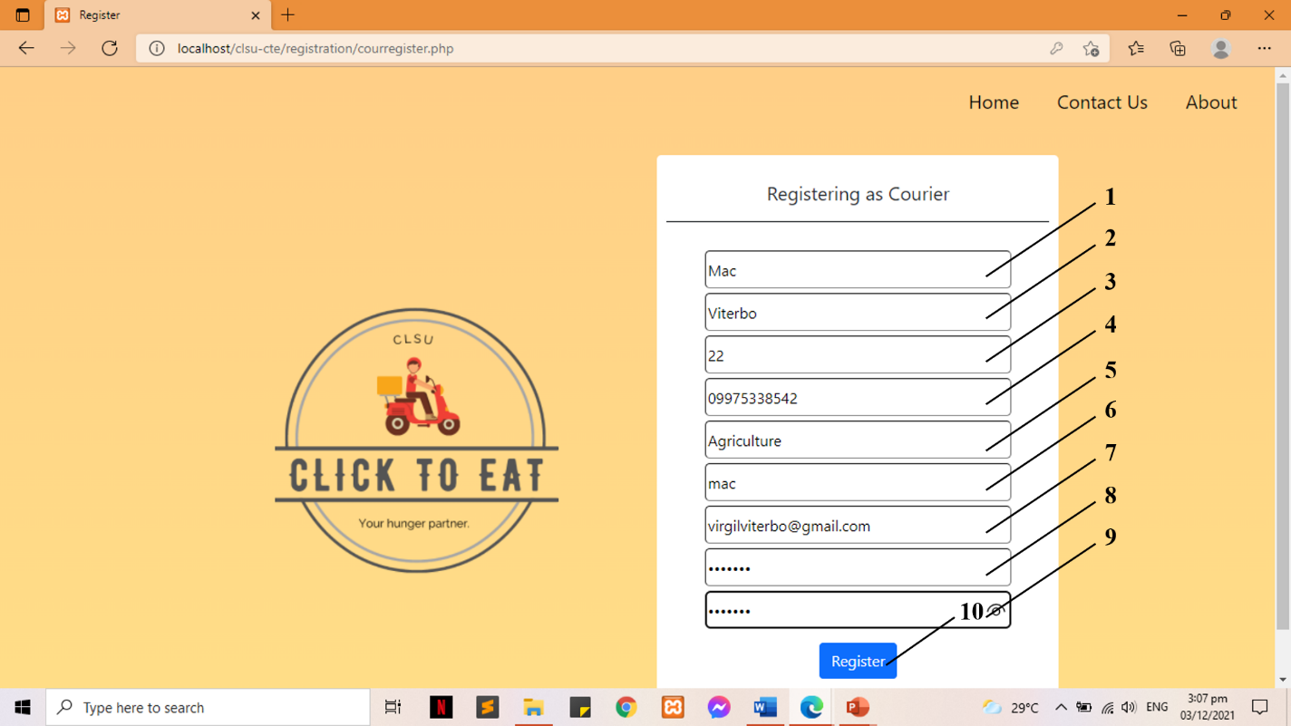
Figure 29: Register as Courier
1. First Name
2. Last Name
3. Age
4. Contact Number
5. Location
6. Username
7. Email
8. Password
9. Confirm Password
10. Register Button
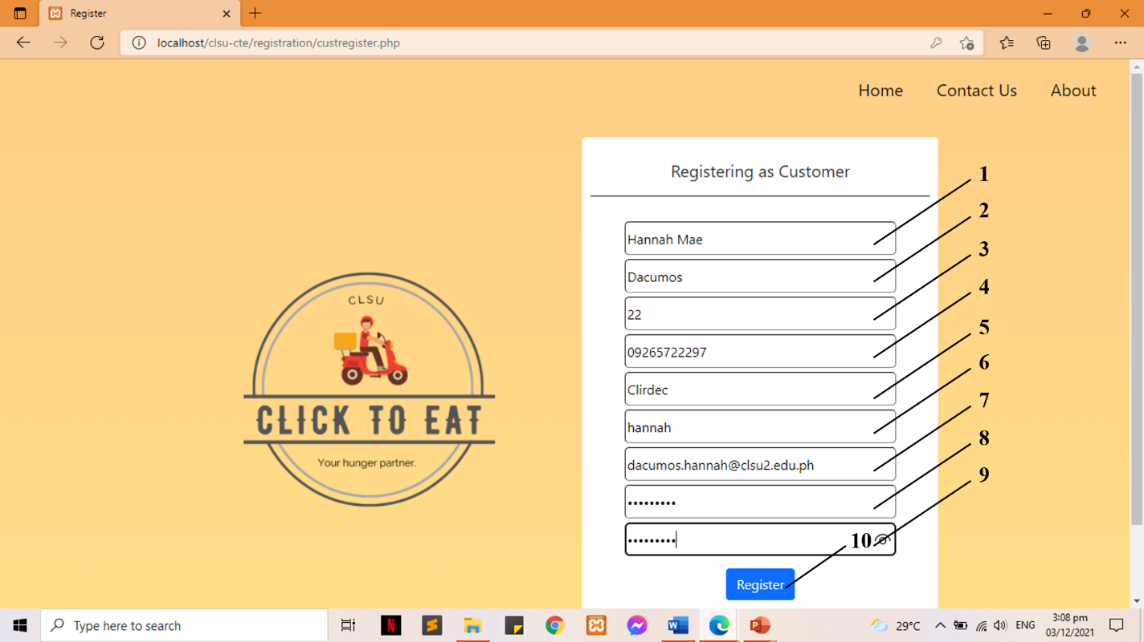
Figure 30: Register as Customer
1. First Name
2. Last Name
3. Age
4. Contact Number
5. College/Building Location
6. Username
7. Email
8. Password
9. Confirm Password
10. Register Button
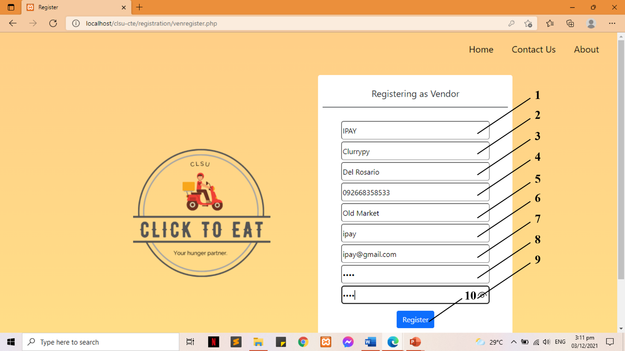
Figure 31: Register as Vendor
1. Store Name
2. Vendor’s First Name
3. Vendor’s Last Name
4. Contact Number
5. Store Location
6. Username
7. Email
8. Password
9. Confirm Password
10. Register Button
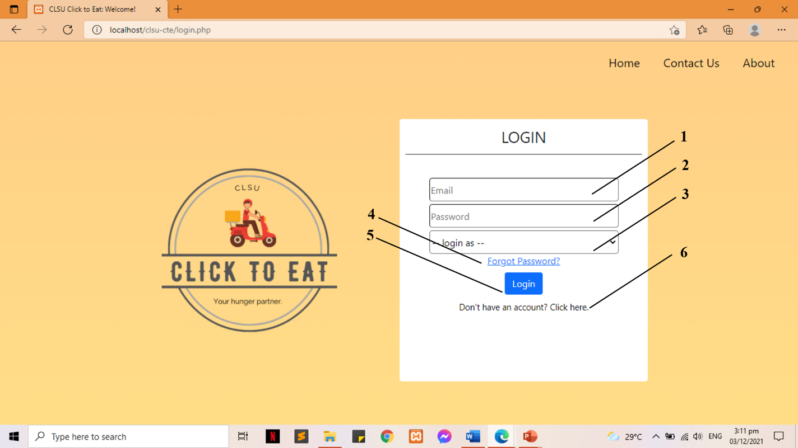
Figure 32: Login
1. Email
2. Password
3. Log in as (Courier, Customer, Vendor)
4. Forgot Password
5. Login Button
6. Create an Account Link

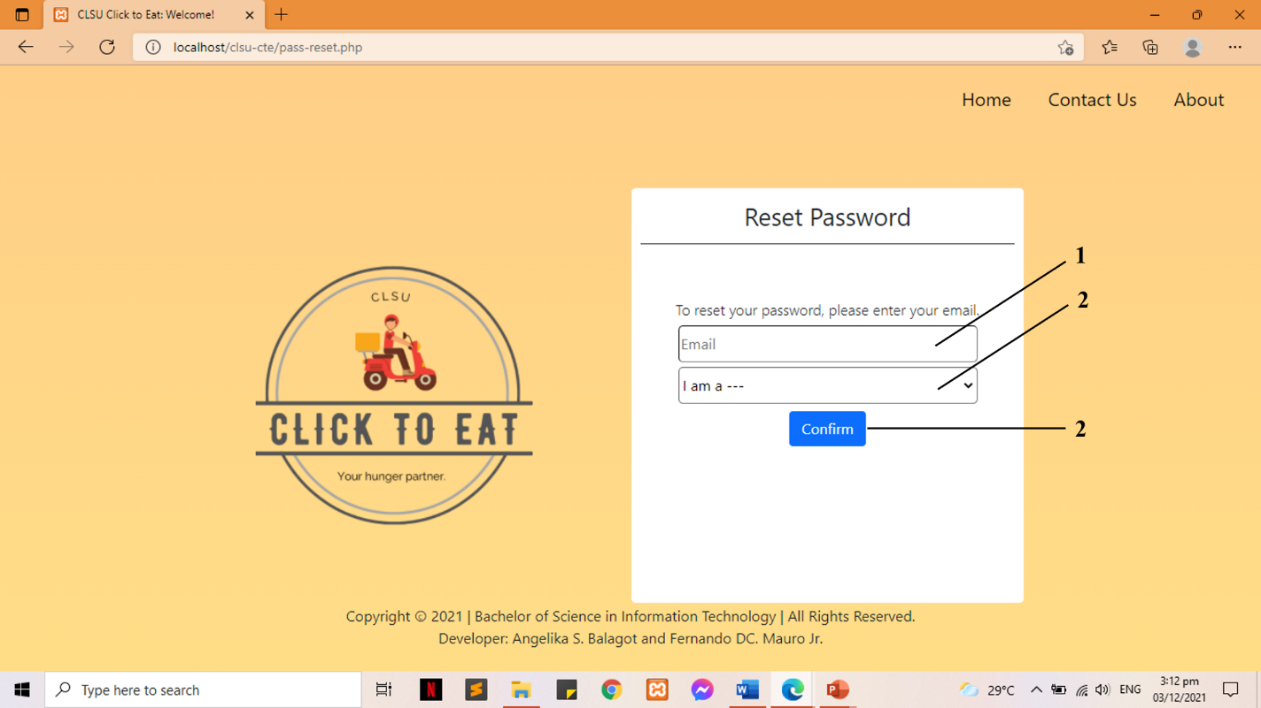
Figure 33: Reset Password
1. Email
2. I am a (Courier, Customer, Vendor)
3. Confirm Button

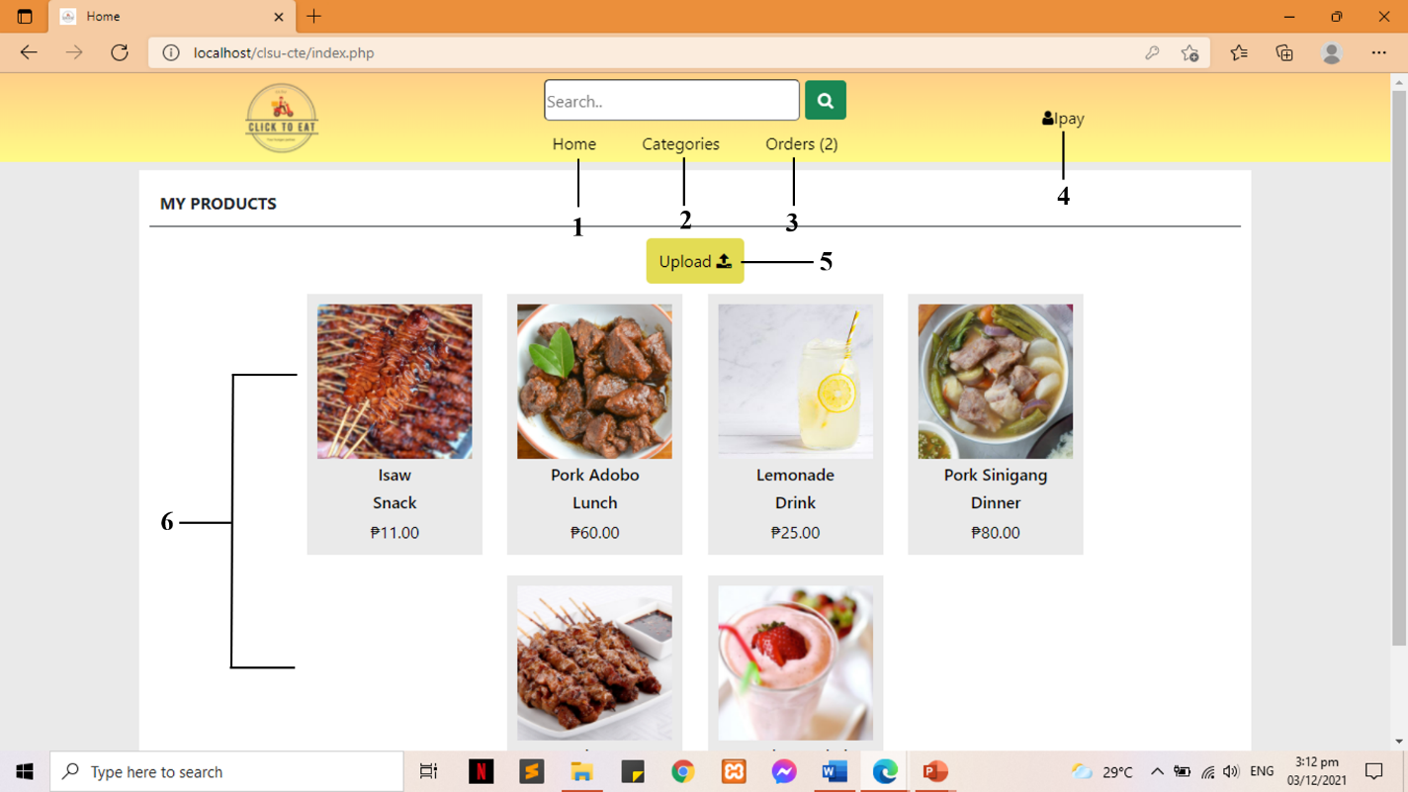
Figure 34: Index for Vendor
1. Home Page
2. Categories Page
3. Orders Page
4. Profile Page
5. Upload Product Button
6. List of Uploaded/Available Products

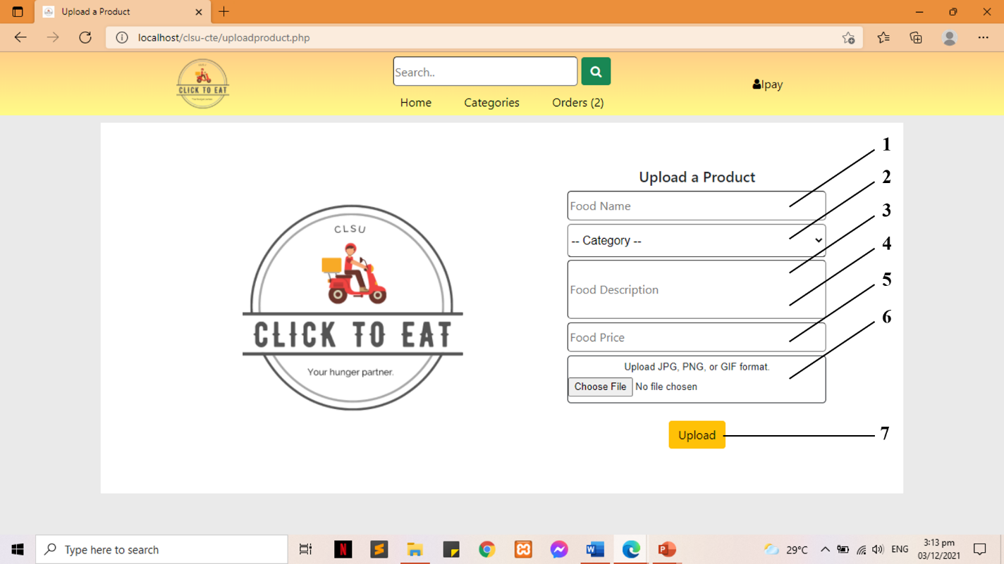
Figure 35: Upload New Product
1. Food Name
2. Food Category
3. Food Description
4. Food Price
5. Food Image
6. Upload food Button

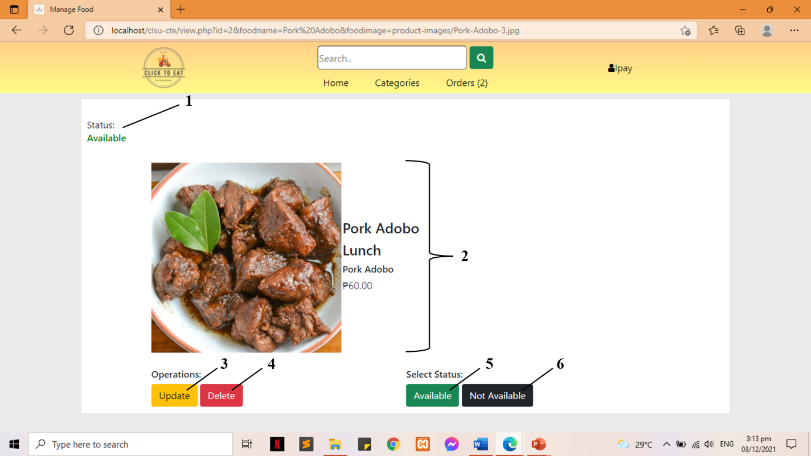
Figure 36: View/Manage Food
1. Food Status/Availability
2. Food Details
3. Update Product button
4. Delete Product button
5. Set Food to Available button
6. Set Food to Not Available button

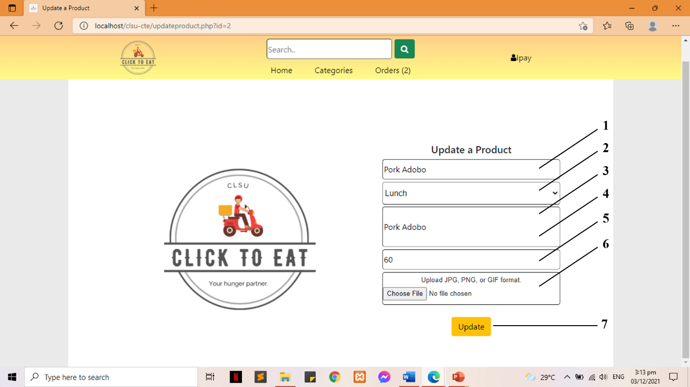
Figure 37: Update Product
1. Food Name
2. Food Category
3. Food Description
4. Food Price
5. Food Image
6. Update food Button

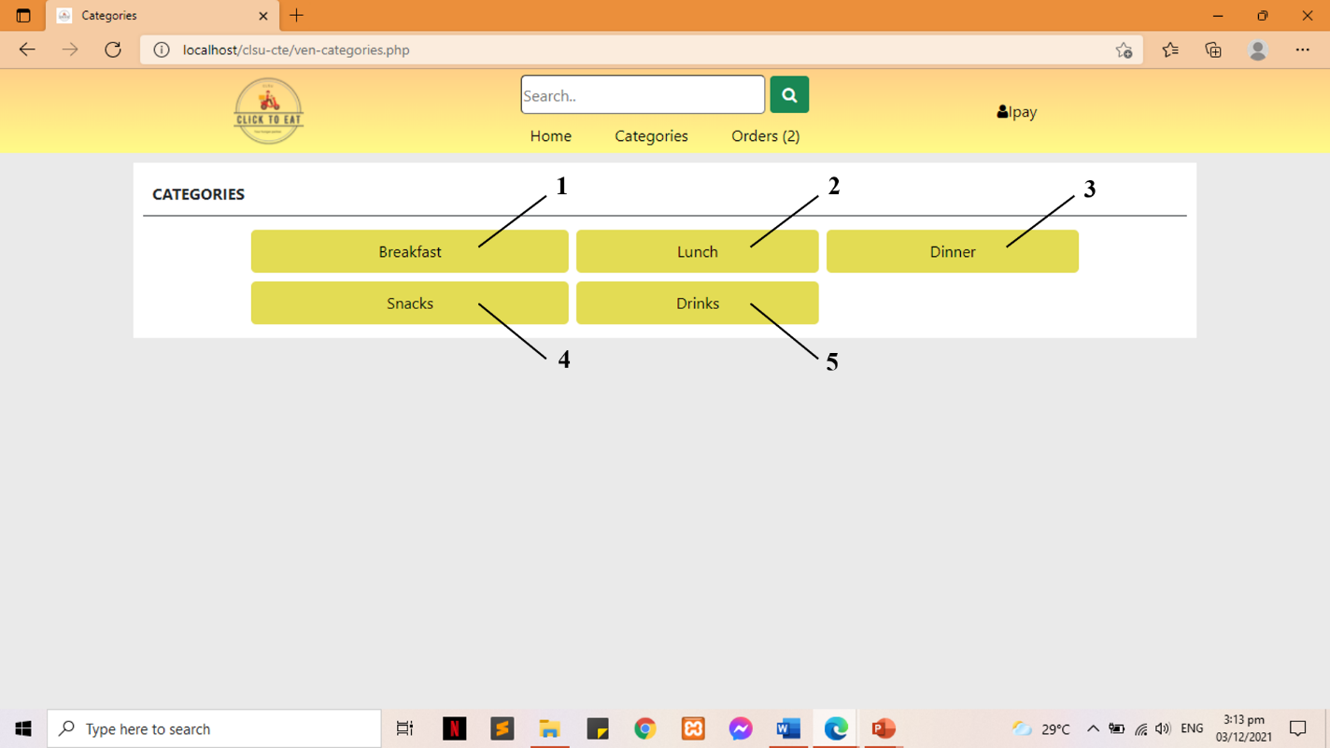
Figure 38: Food Categories Page
1. Breakfast
2. Lunch
3. Dinner
4. Snacks
5. Drinks

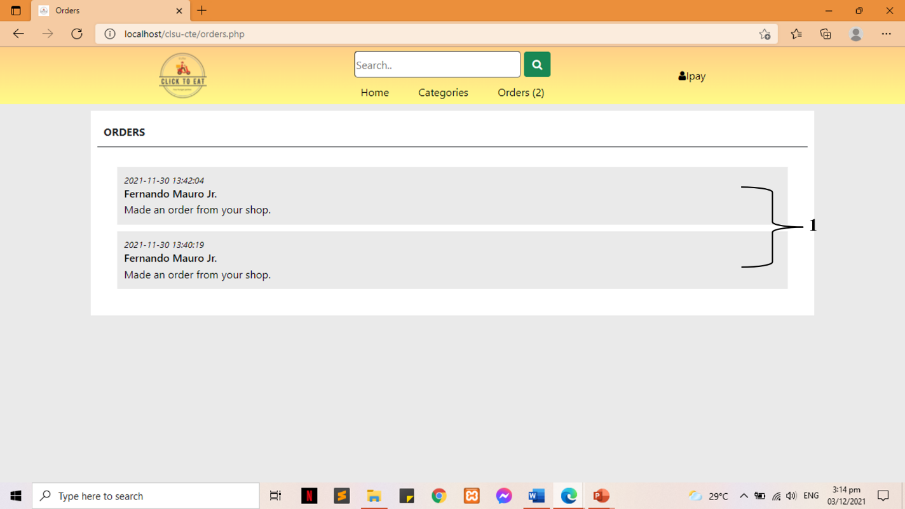
Figure 39: Food Orders on Vendor
1. List of notifications of ordered food

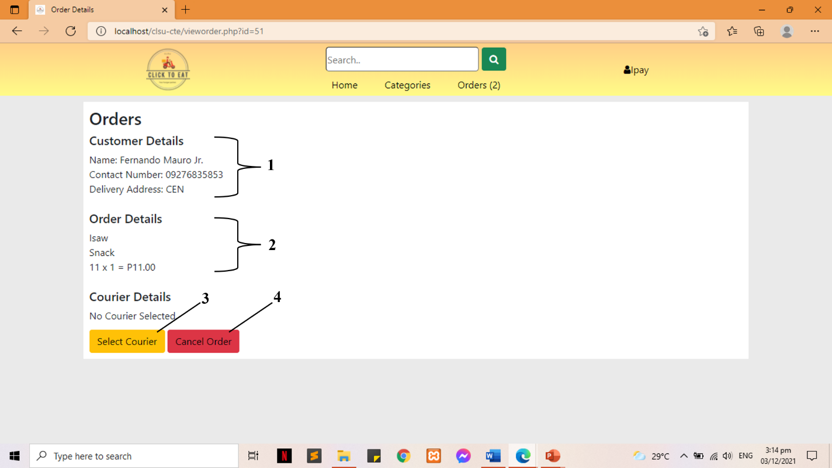
Figure 40: View Order Details
1. Customer Details
2. Ordered Food Details
3. Select Courier button
4. Cancel Order button

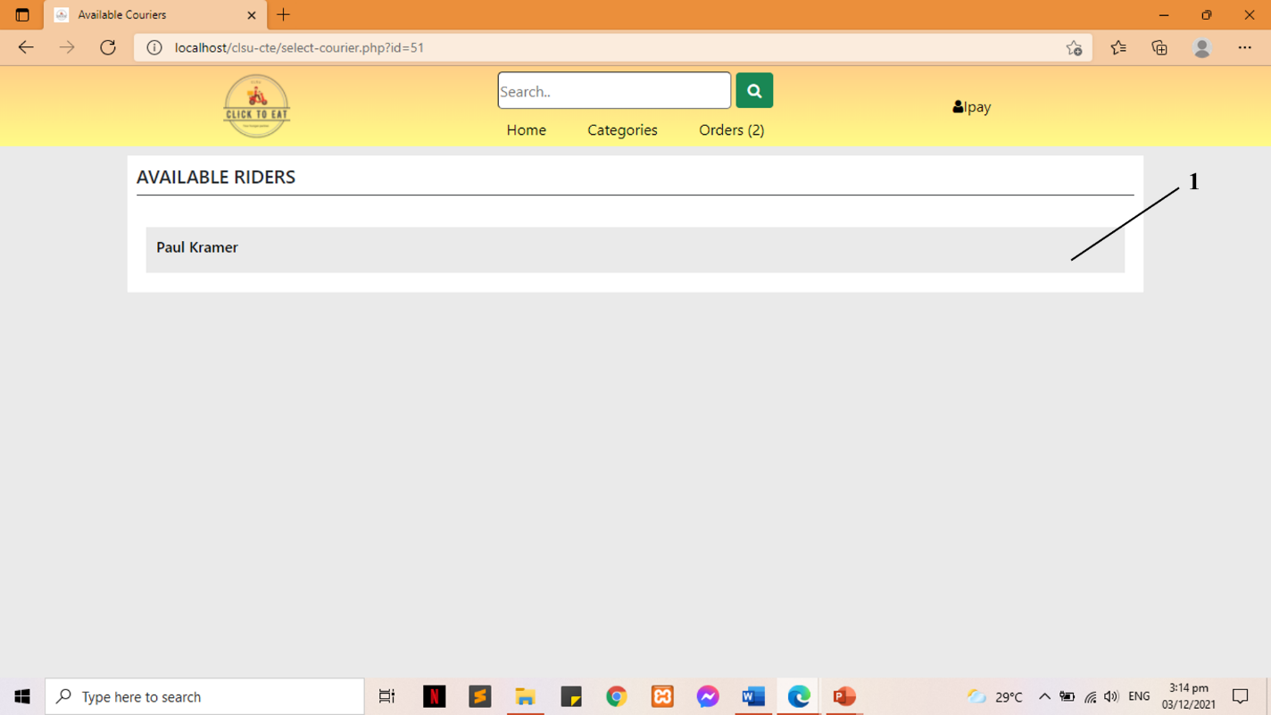
Figure 41: Available Orders
1. List of Available/Registered Couriers

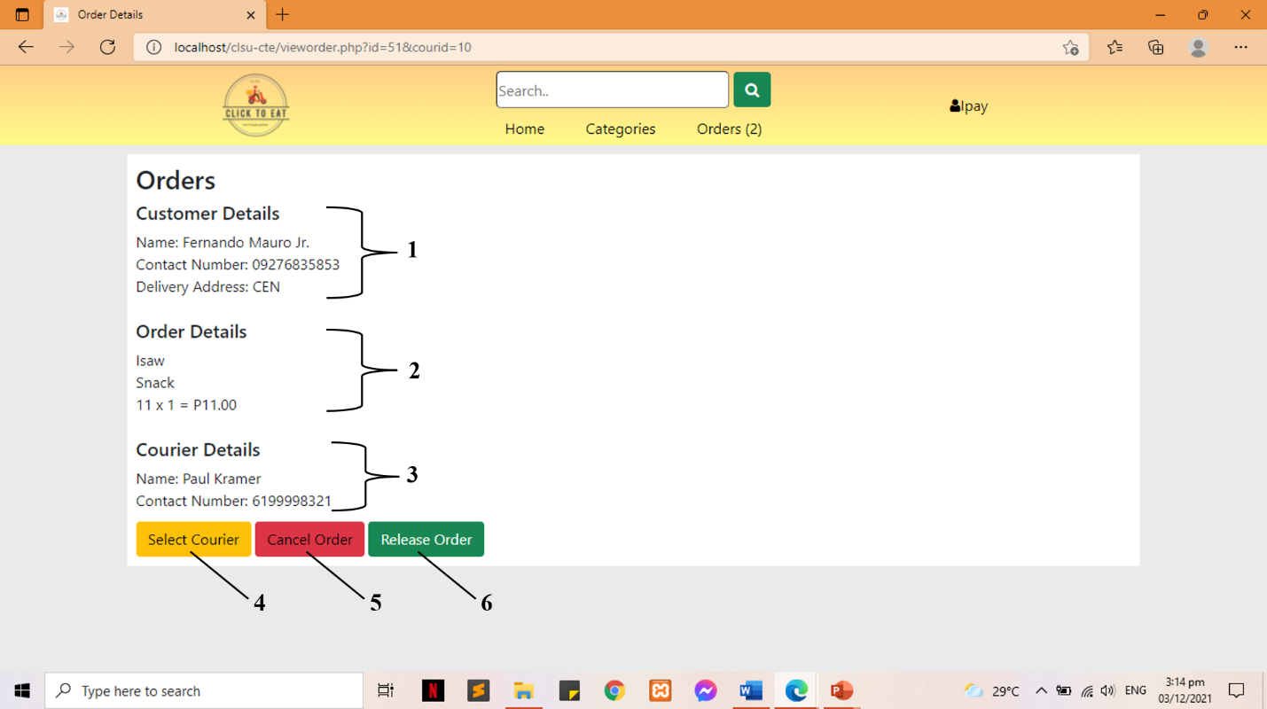
Figure 42: Order Details with Courier
1. Customer Details
2. Ordered Food Details
3. Courier Details
4. Select Courier button
5. Cancel Order button
6. Release Order button
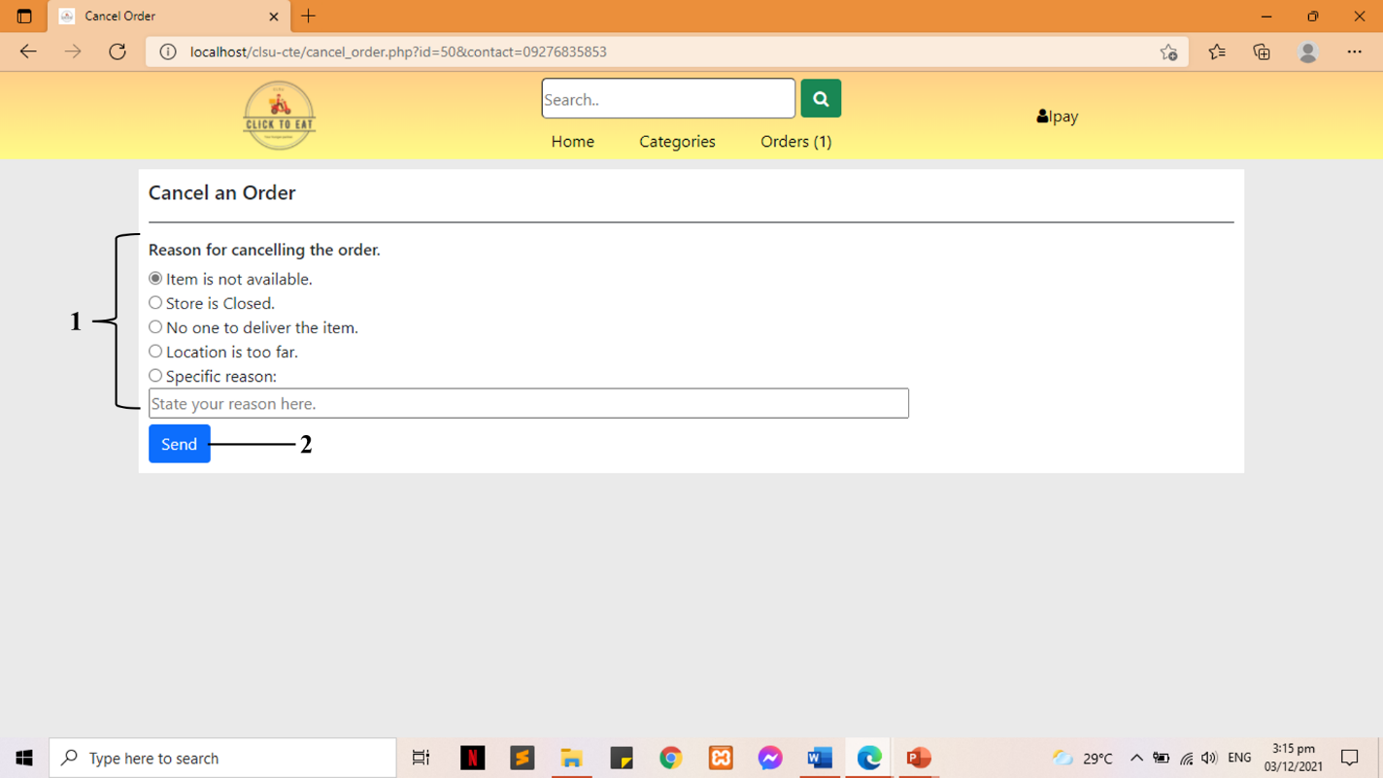

Figure 43: Cancel an Order
1. Selection for the reason of cancelling the order
2. Send button

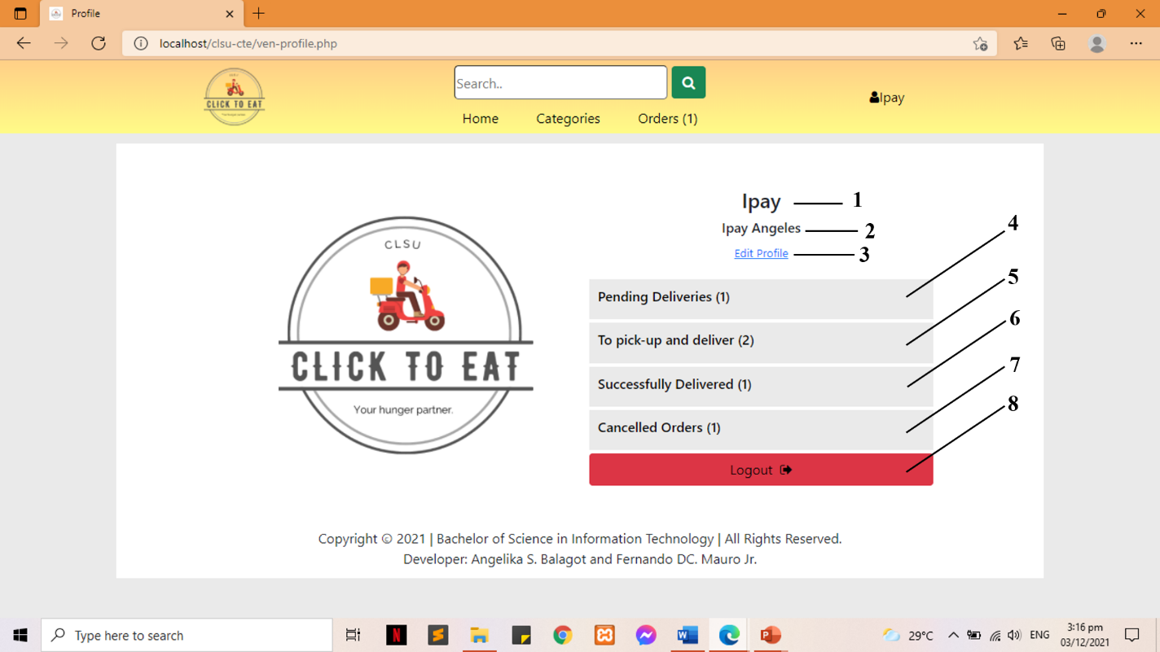
Figure 44: Vendor Profile
1. Username
2. Vendor Name
3. Edit Profile
4. Pending Deliveries
5. To pick-up and deliver
6. Successfully Delivered
7. Cancelled Orders
8. Logout

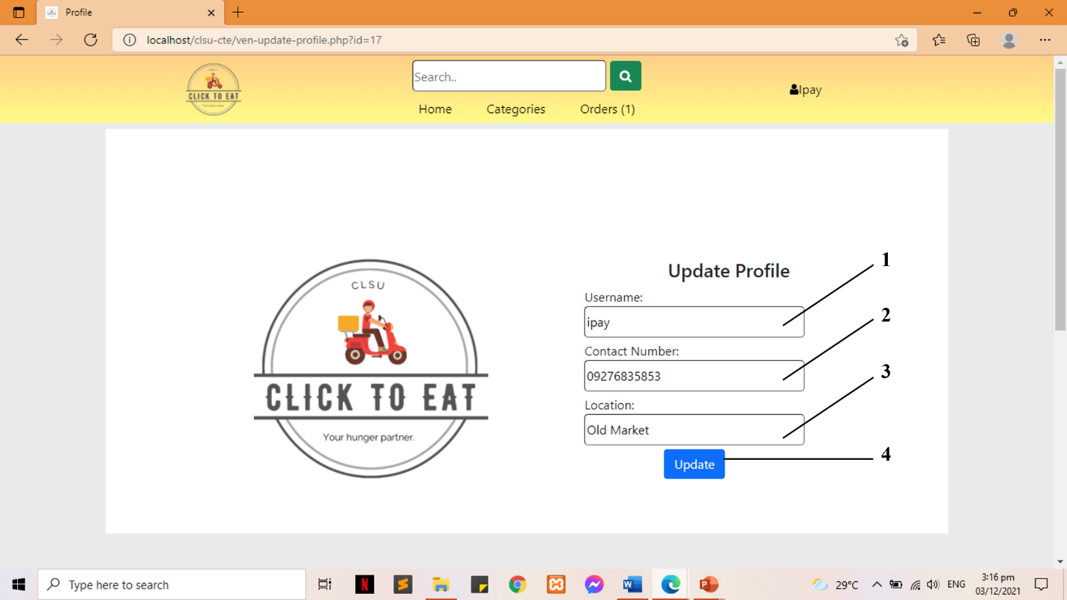
Figure 45: Update Profile
1. Username
2. Contact Number
3. Location
4. Update Profile button

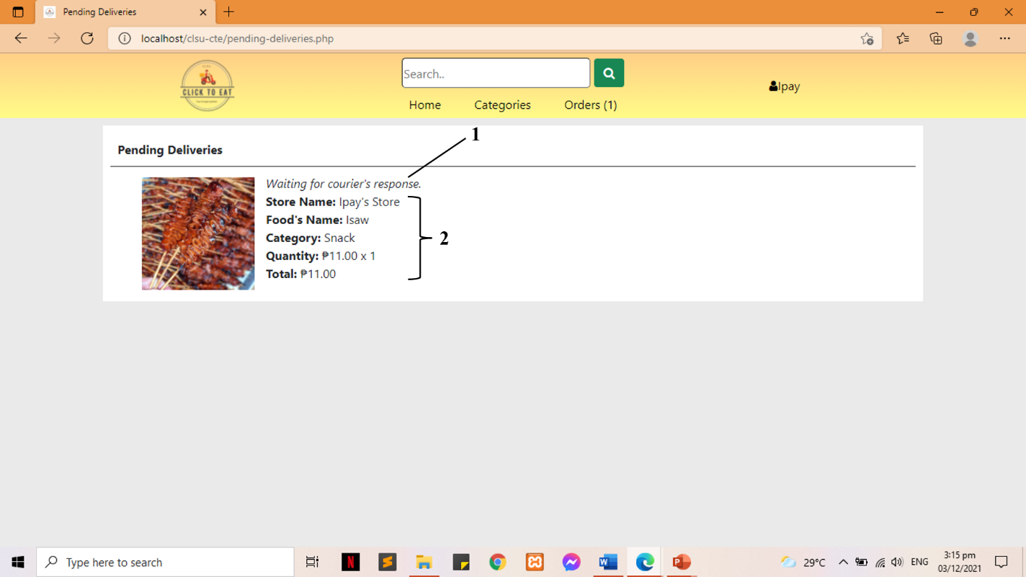
Figure 46: Pending Deliveries
1. Order Status
2. Order Details

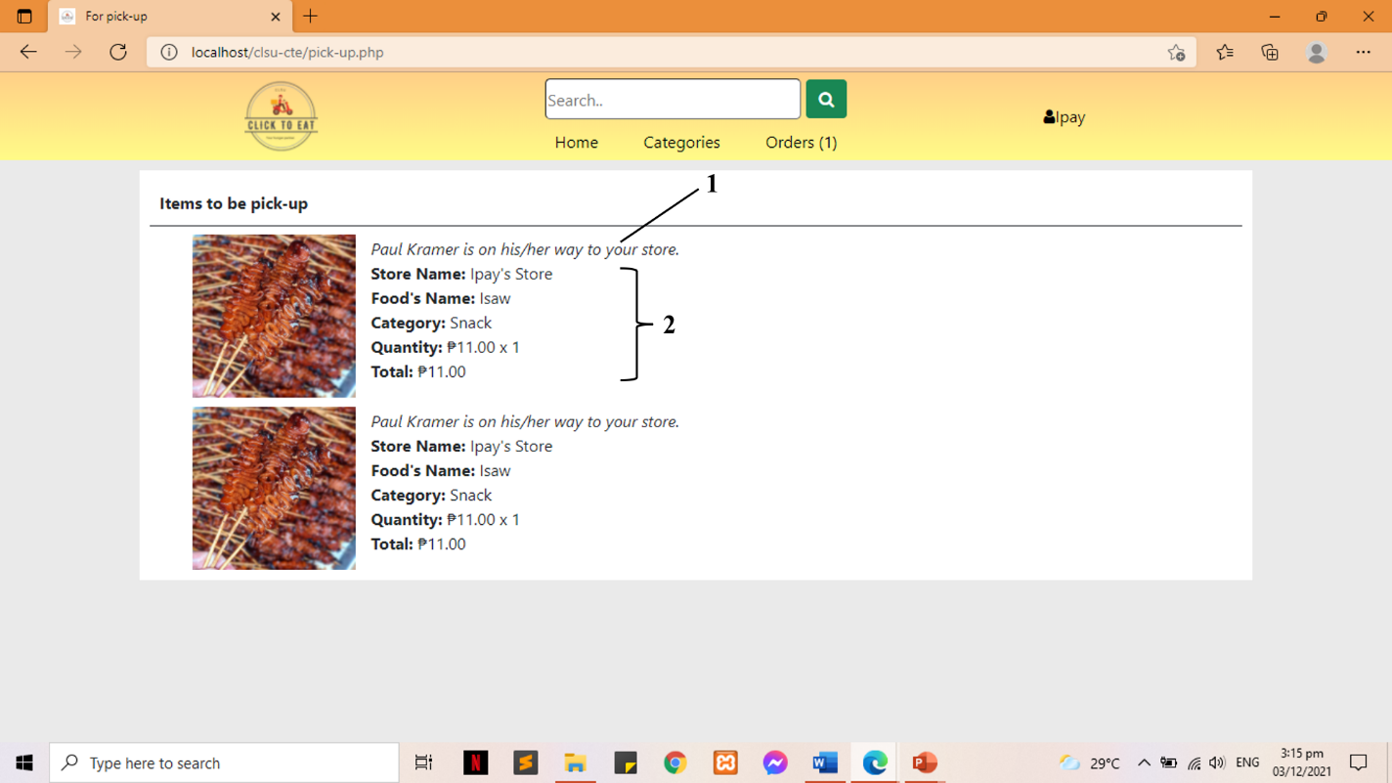
Figure 47: Items to be pick-up
1. Order Status
2. Order Details

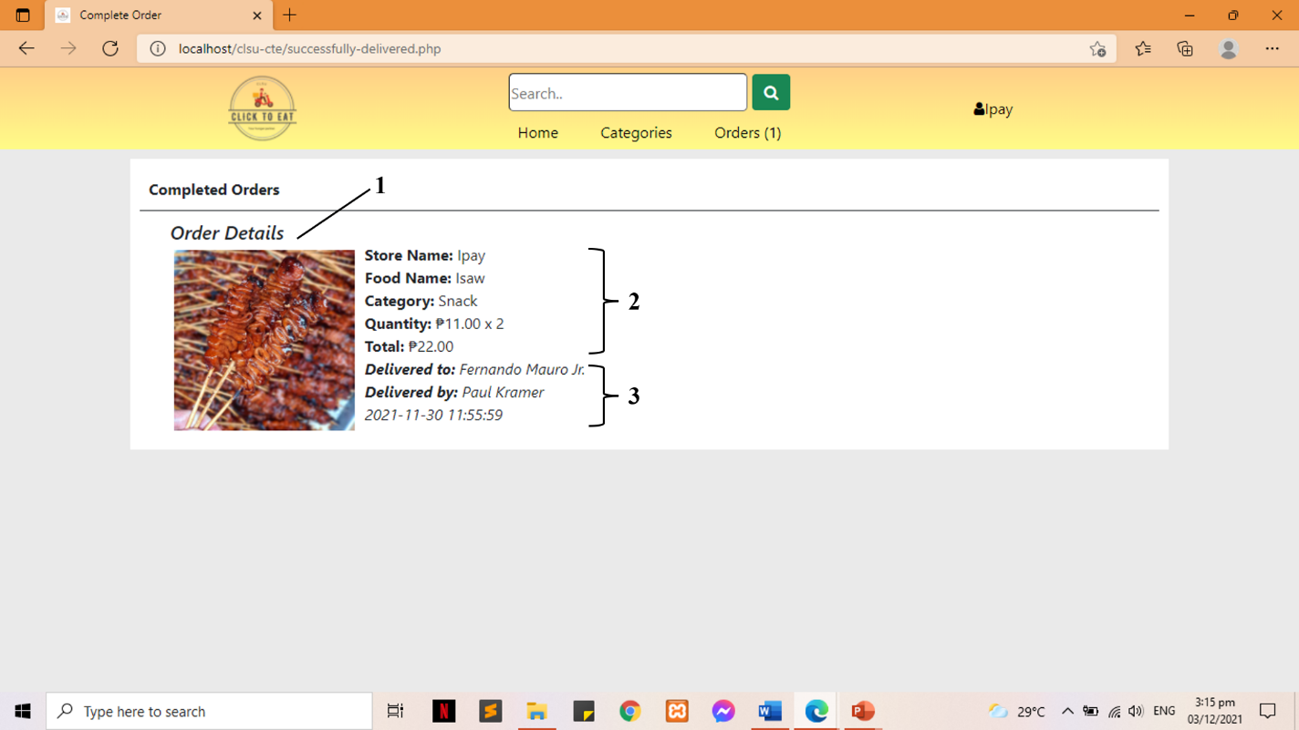

Figure 48: Completed Orders
1. Order Status
2. Order Details
3. Delivery Details

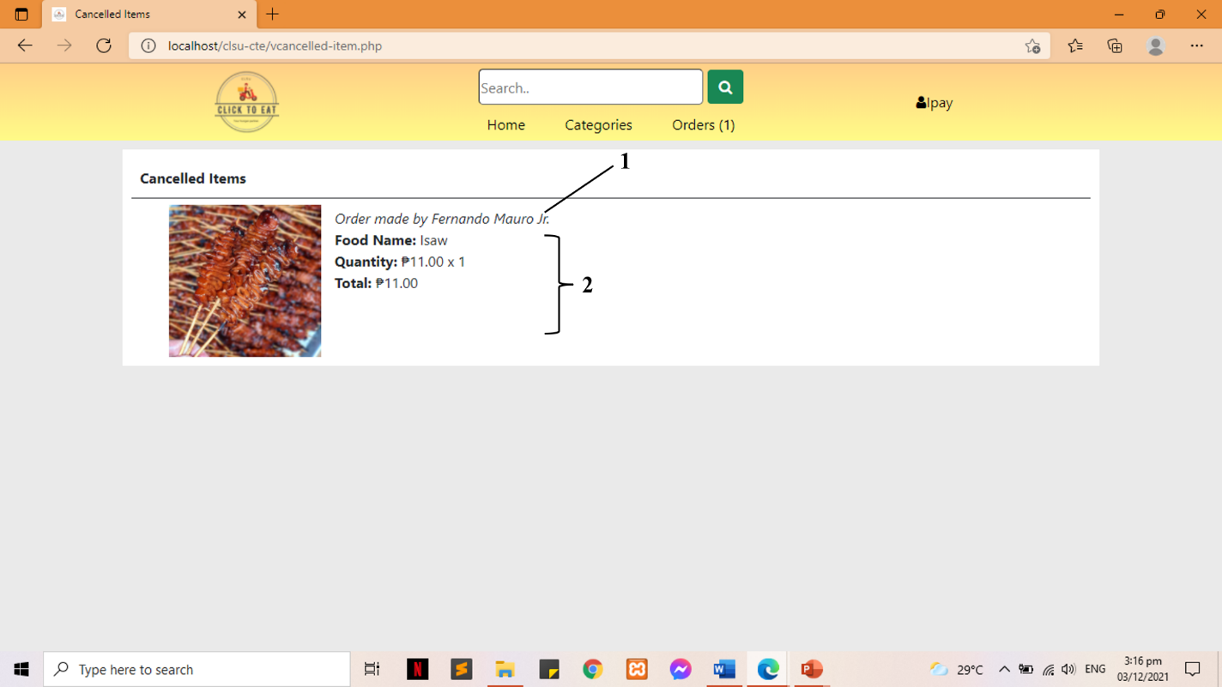
Figure 49: Cancelled Items
1. Cancel Order Details
2. Cancelled Food Details

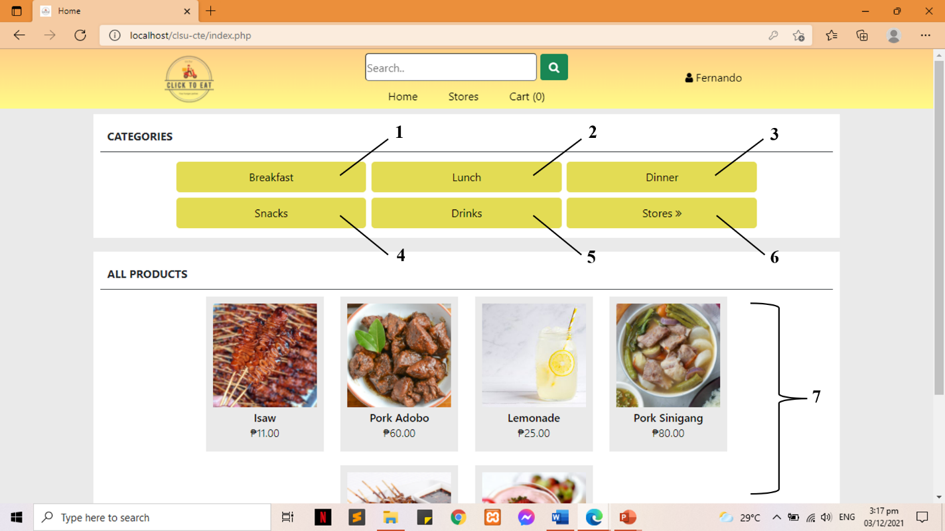
Figure 50: Index for Customer
1. Breakfast
2. Lunch
3. Dinner
4. Snacks
5. Details
6. Stores
7. List of all available products

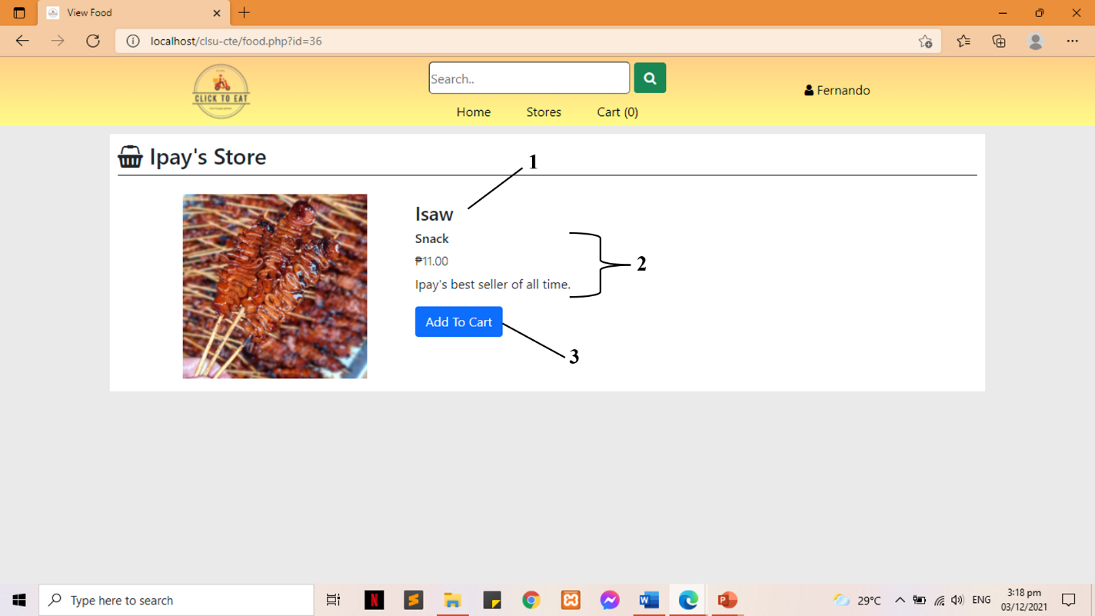
Figure 51: View Food
1. Food Name
2. Food Details
3. Add To Cart button

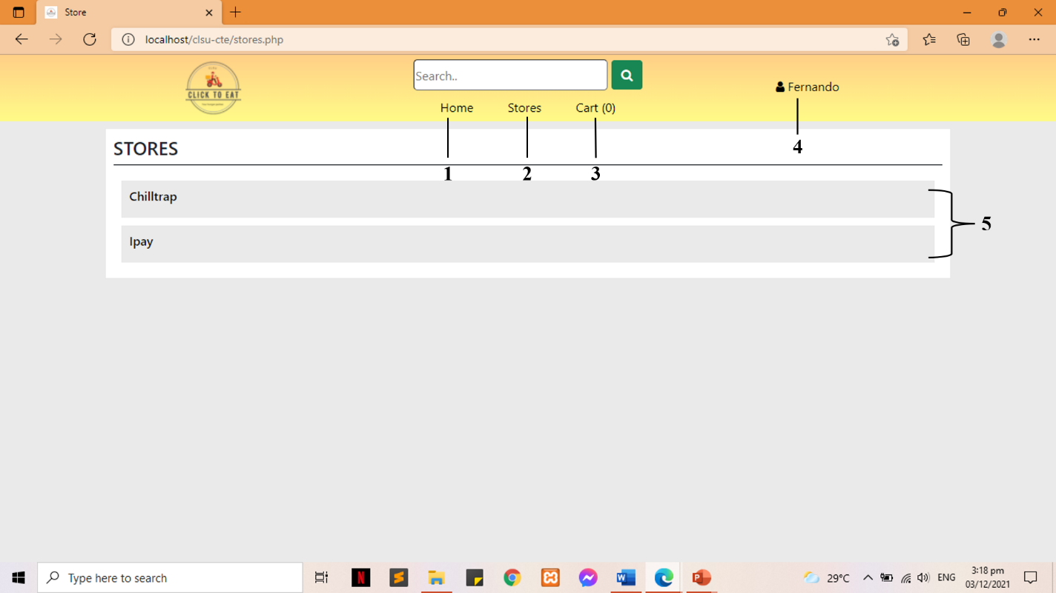
Figure 52: List of Registered Vendors
1. Home/Index Page
2. Stores Page
3. Cart Page
4. Profile Page
5. List of Registered Vendors

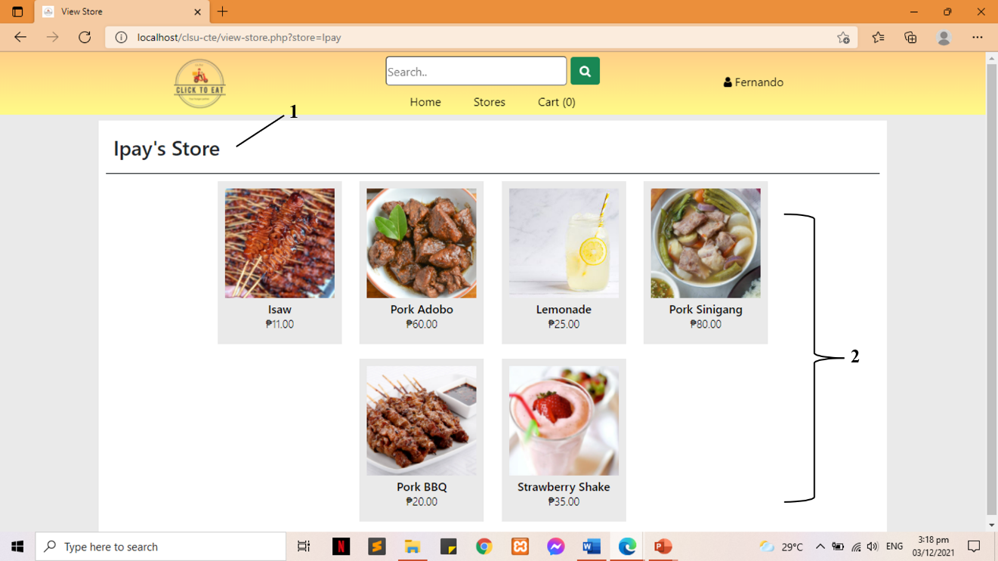
Figure 53: View Store with Available Items
1. Store Name
2. Available Foods of the Store

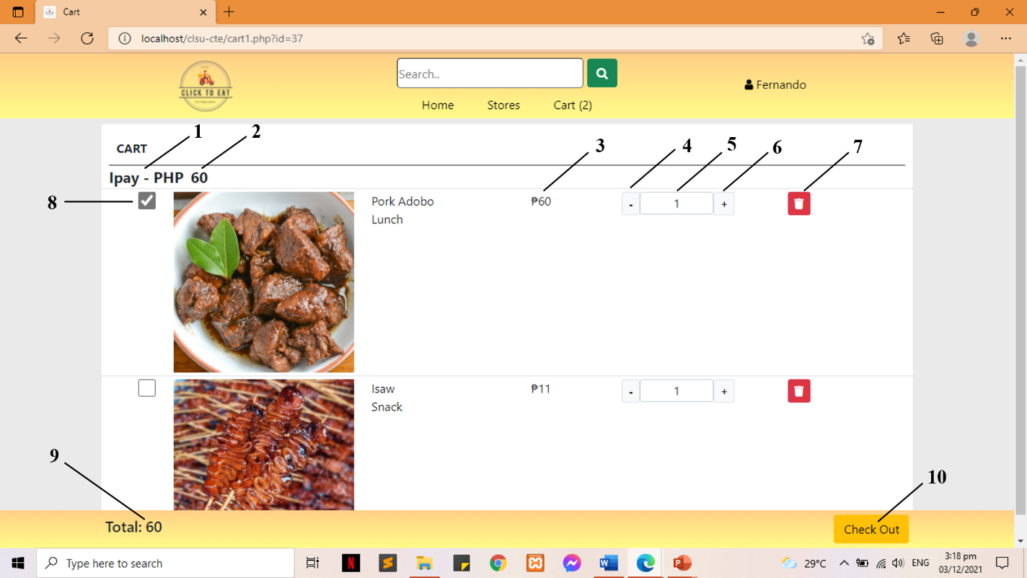
Figure 54: Cart
1. Store Name
2. Sub Total (for vendor)
3. Sub Total (per item)
4. Decrement Quantity
5. Quantity
6. Increment Quantity
7. Remove Item
8. Checkbox
9. TOTAL
10. Check Out button
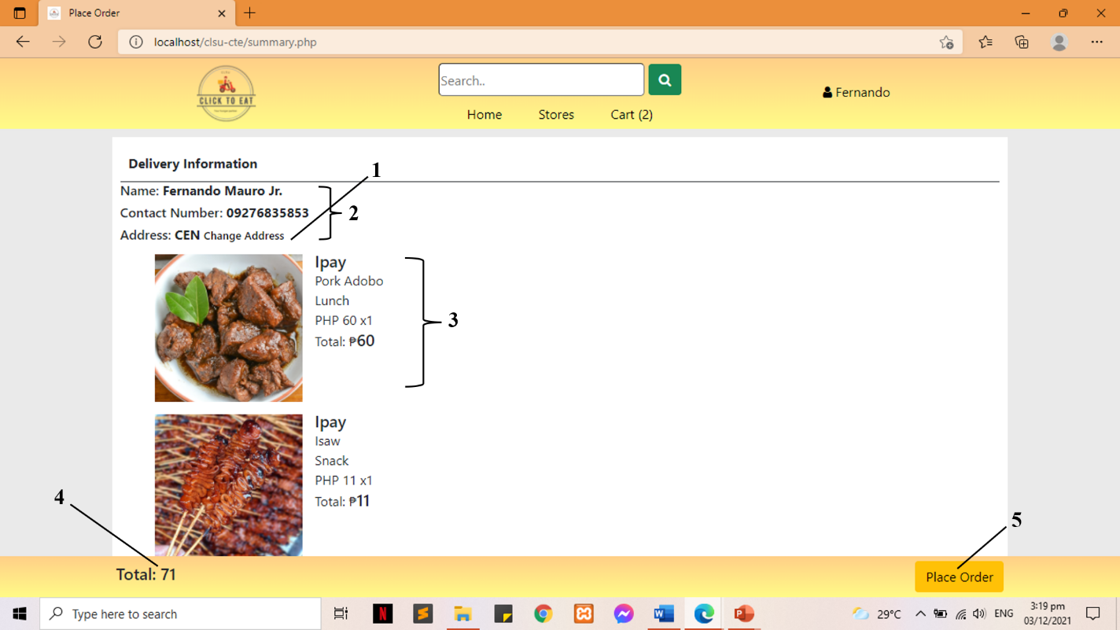
Figure 55: Summary
1. Change Address
2. Customer Details
3. Ordered Food Details
4. Order TOTAL
5. Place Order button

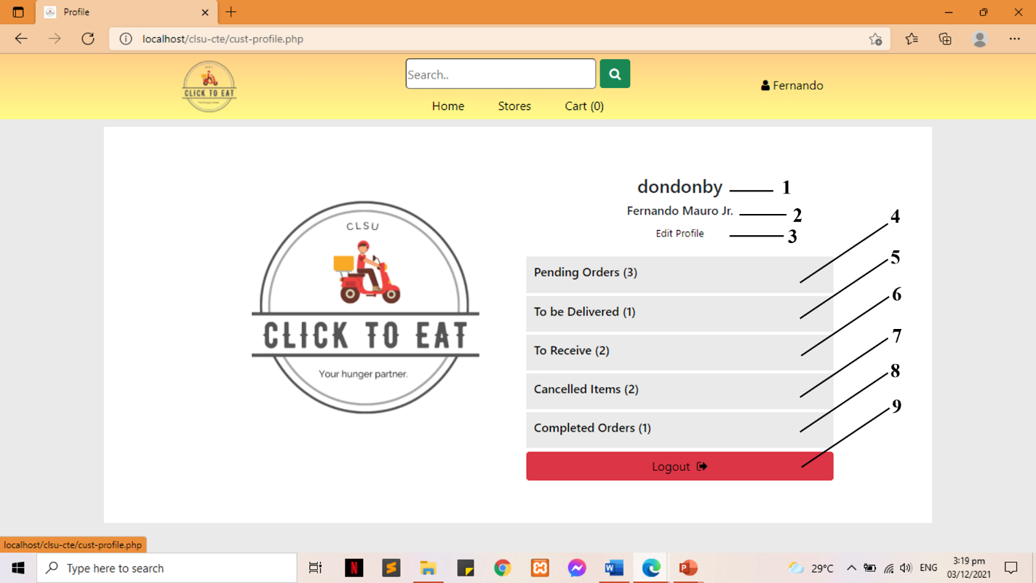
Figure 56: Customer’s Profile
1. Username
2. Customer Name
3. Edit Profile
4. Pending Orders
5. To be Delivered
6. To Receive
7. Cancelled Items
8. Completed Orders
9. Logout

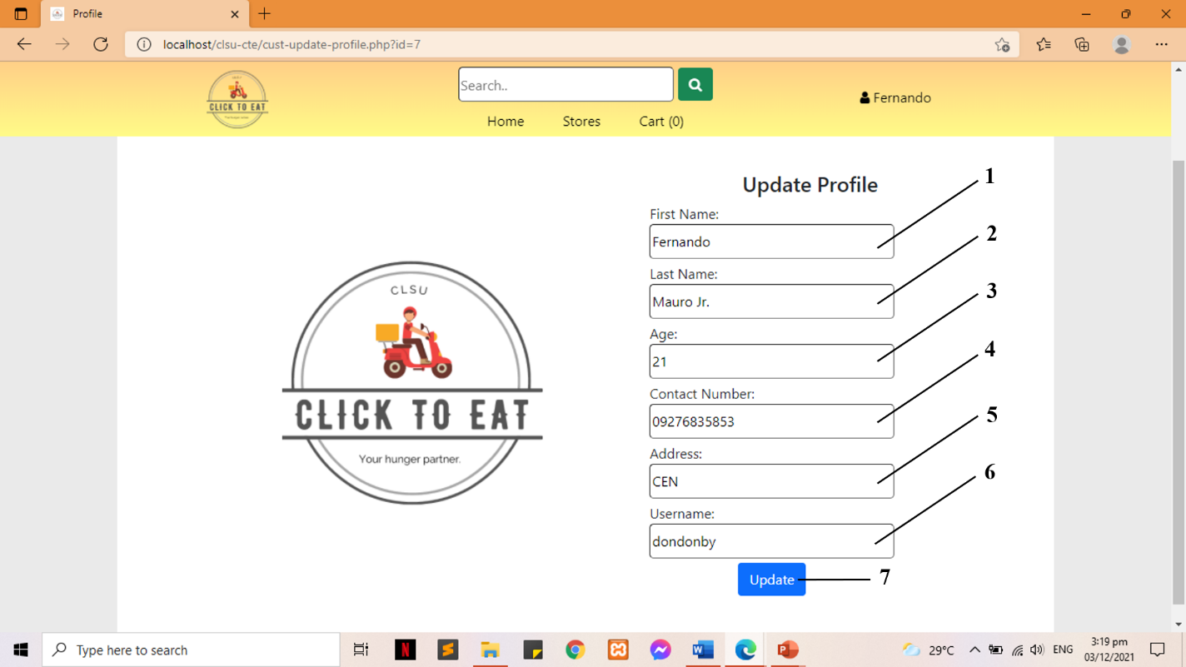
Figure 57: Update Profile
1. First Name
2. Last Name
3. Age
4. Contact Number
5. Address
6. Username
7. Update Profile button

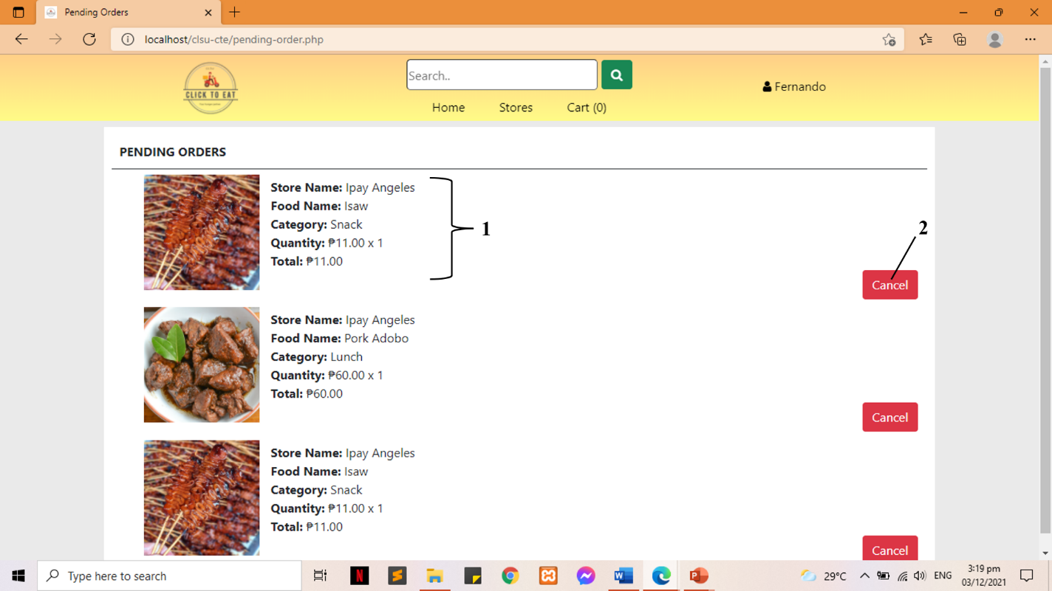
Figure 58: Pending Orders
1. Order Details
2. Cancel button

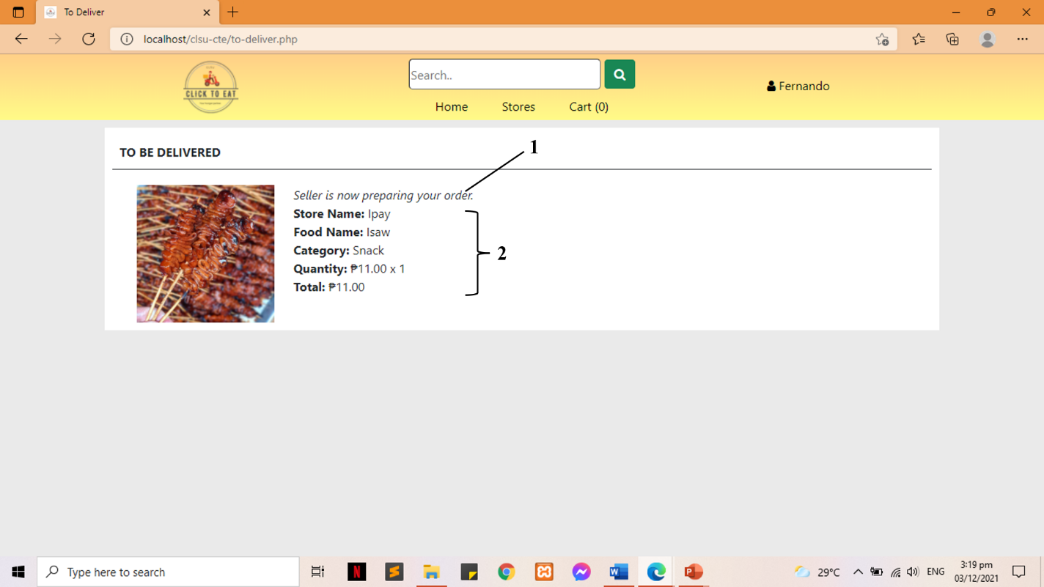
Figure 59: To be Delivered
1. Order Status
2. Order Details

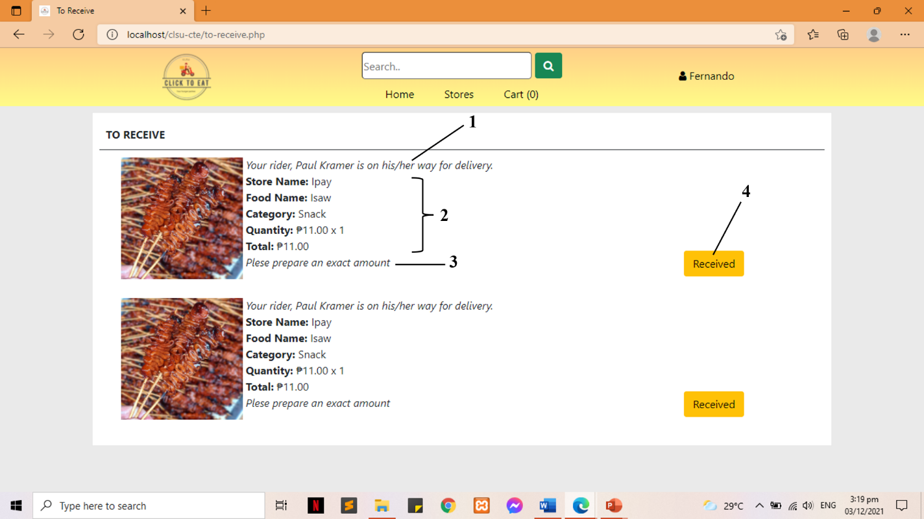
Figure 60: To Receive
1. Order Status
2. Order Details
3. Reminder
4. Received button

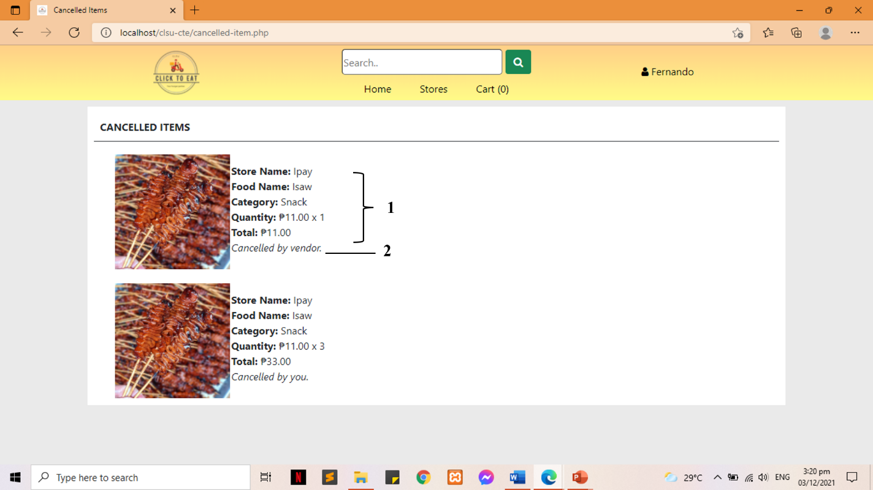
Figure 61: Cancelled Items
1. Order Details
2. Cancelled by (customer or vendor)

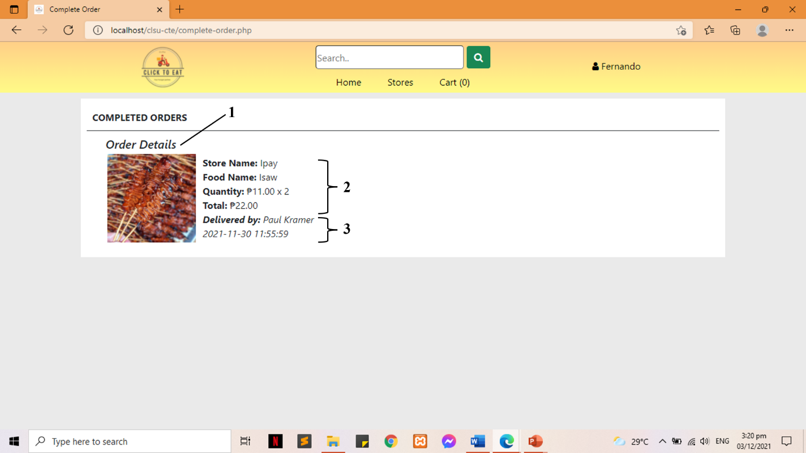
Figure 62: Completed Orders
1. Order Status
2. Order Details
3. Delivery Details

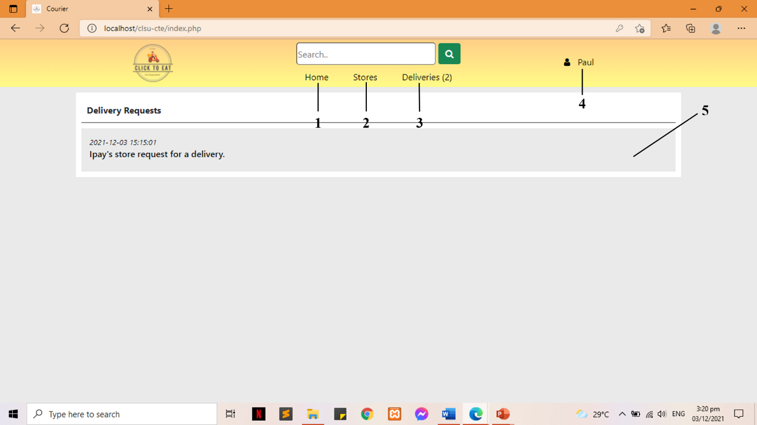
Figure 63: Courier’s Index
1. Home/Index Page
2. Stores Page
3. Deliveries Page
4. Profile Page
5. List of Delivery Requests

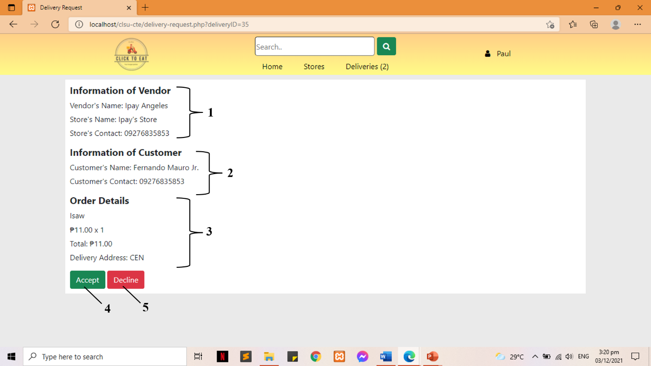
Figure 64: Delivery Requests
1. Store Details
2. Customer Details
3. Order Details
4. Accept Order button
5. Decline Order button

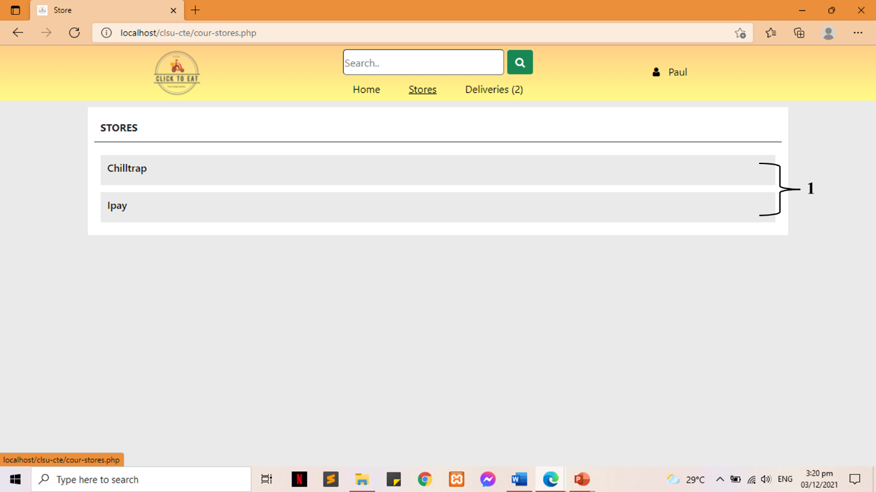
Figure 65: Stores
1. List of Registered Stores

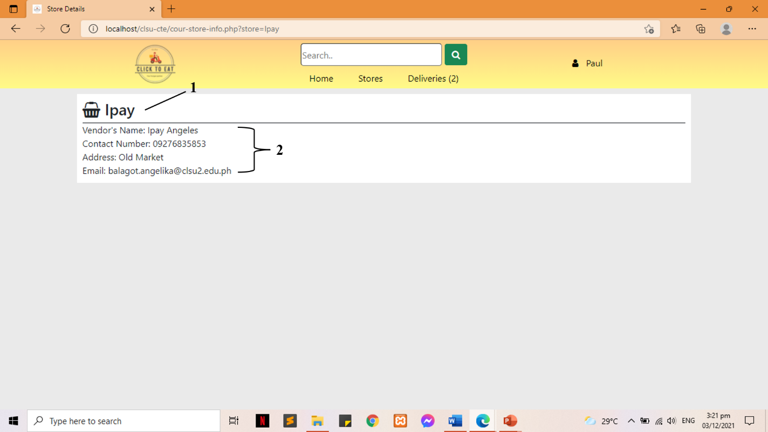
Figure 66: View Store
1. Store Name
2. Vendor Details

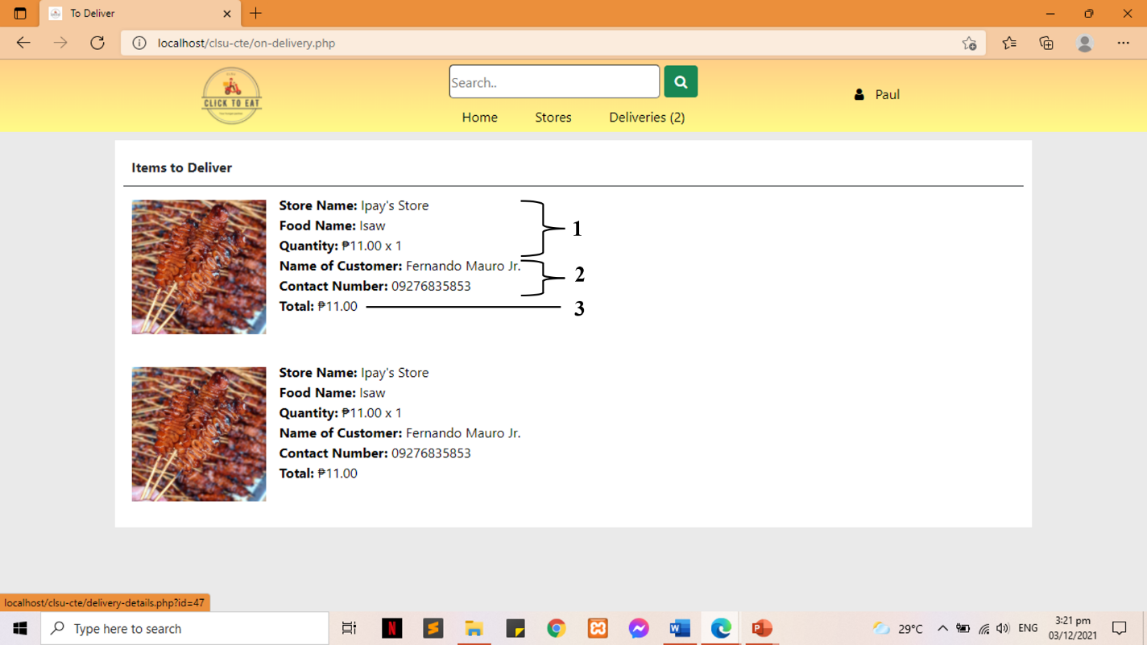
Figure 67: Deliveries
1. Store Details
2. Customer Details
3. Order TOTAL

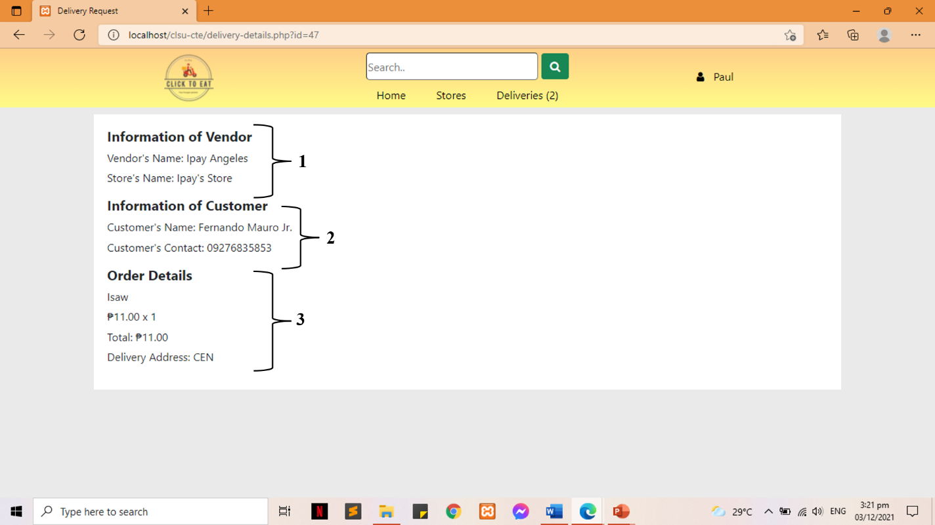
Figure 68: Item to Deliver
1. Store Details
2. Customer Details
3. Order/Food Details

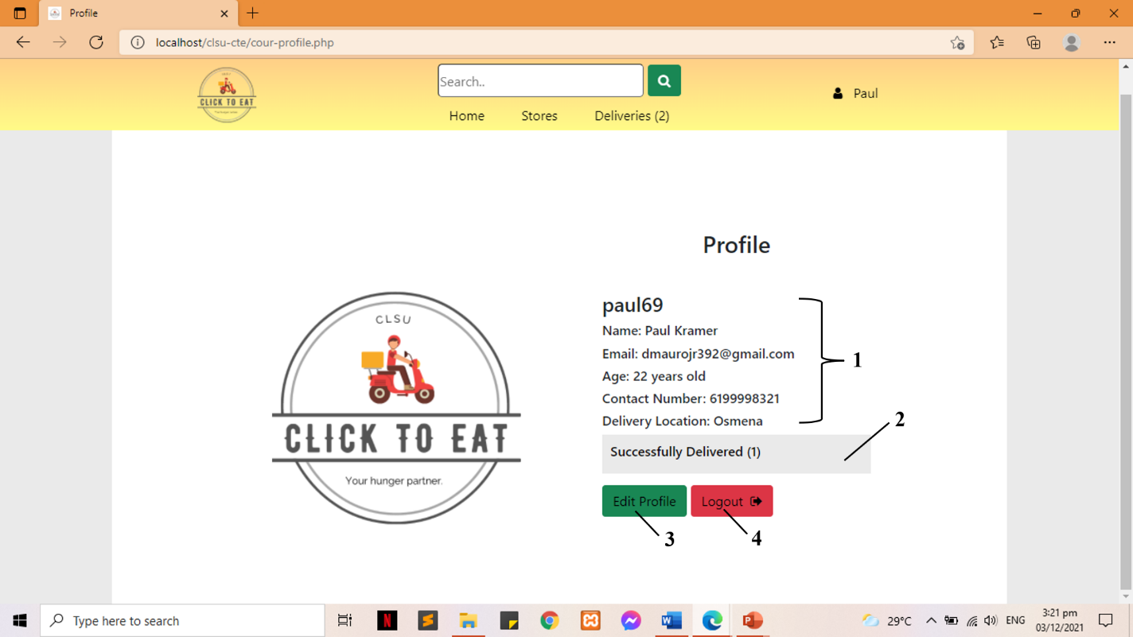
Figure 69: Courier Profile
1. Courier Information
2. Successfully Delivered
3. Edit Profile
4. Logout

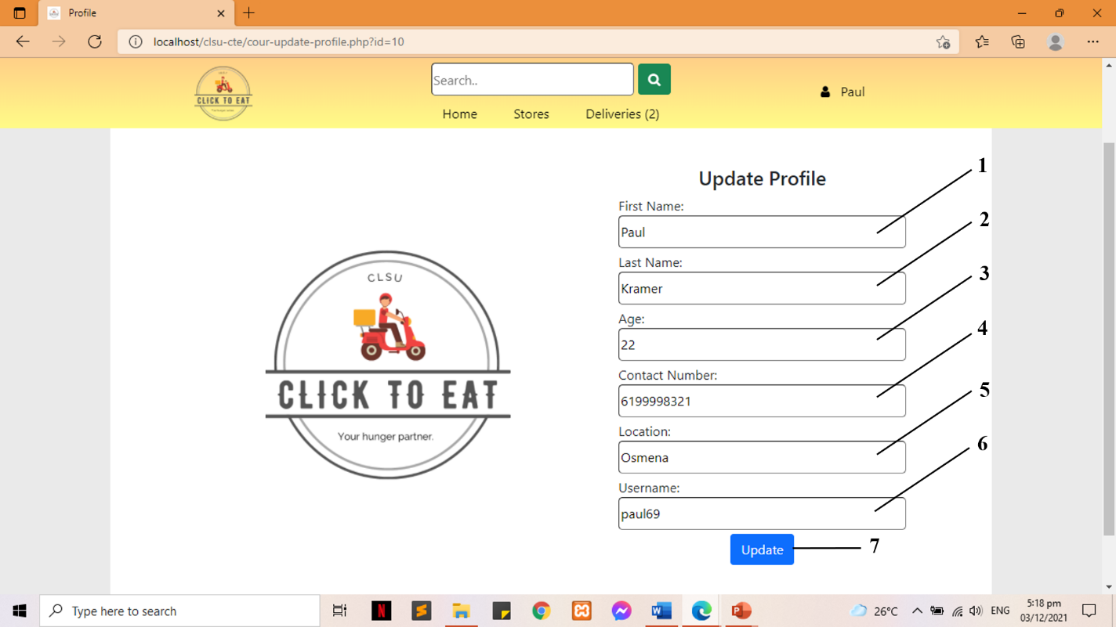
Figure 70: Update Profile
1. First Name
2. Last Name
3. Age
4. Contact Number
5. Location
6. Username
7. Update button

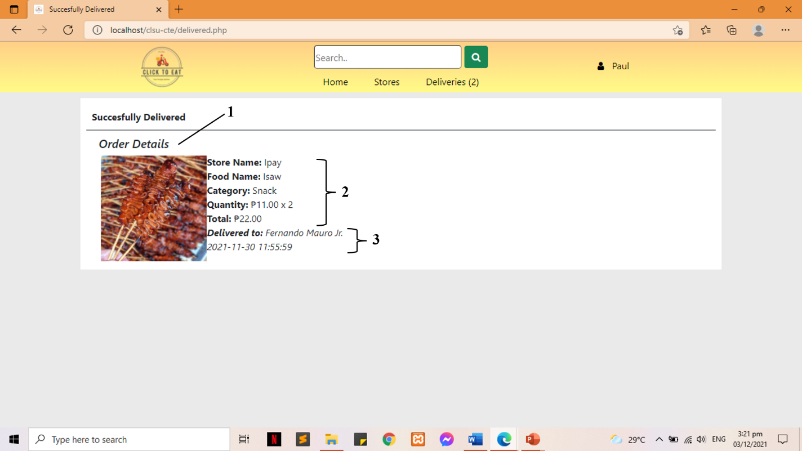
Figure 71: Successfully Delivered
1. Order Details Title
2. Order Details
3. Delivery Details

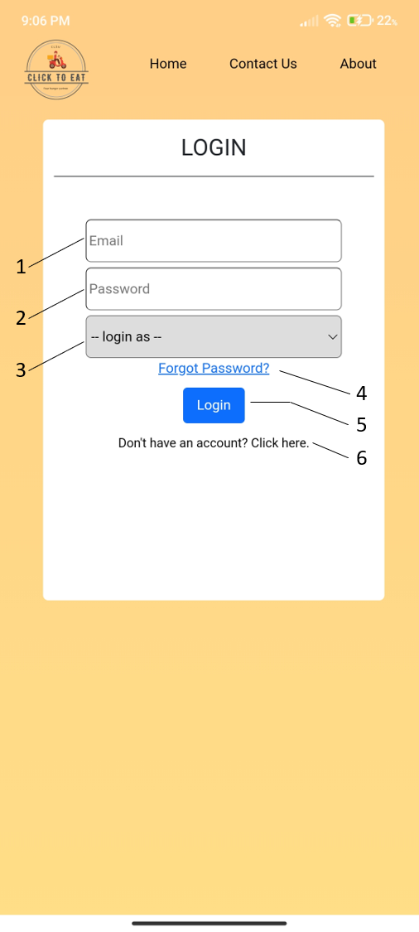  Figure 72. Login  1. User’s Email  2. User’s Password  3. User Type Selection  4. Forgot Password  5. Login Button  6. Account Registration Link | 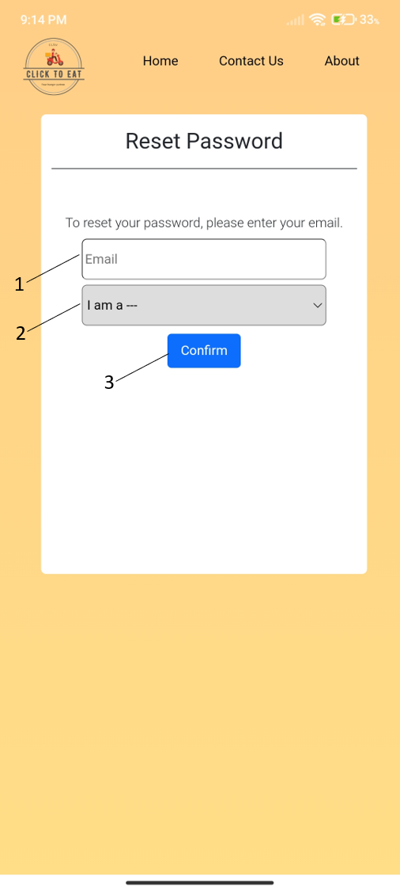  Figure 73. Password Reset  1. User’s Email  2. User Type Selection  3. Confirm Button

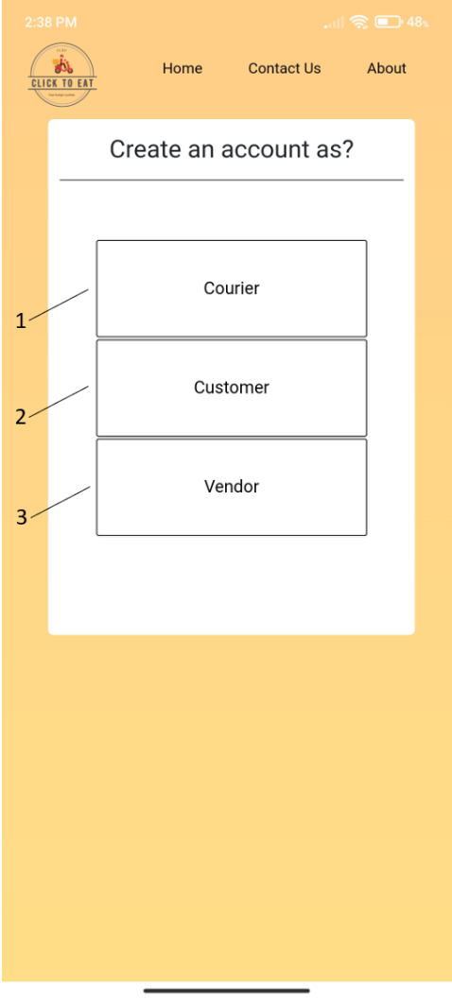  Figure 74. User Registration Selection  1. Register as Courier  2. Register as Customer  3. Register as Vendor | 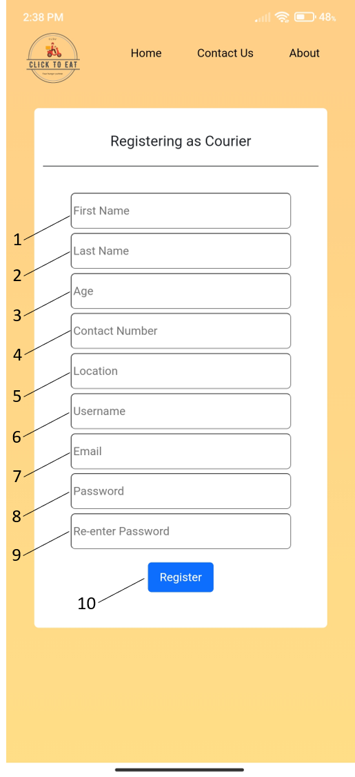  Figure 75. Courier Registration  1. First Name  2. Last Name  3. Age  4. Contact Number  5. Location  6. Username  7. Email  8. Password  9. Password Repeat  10. Register Button
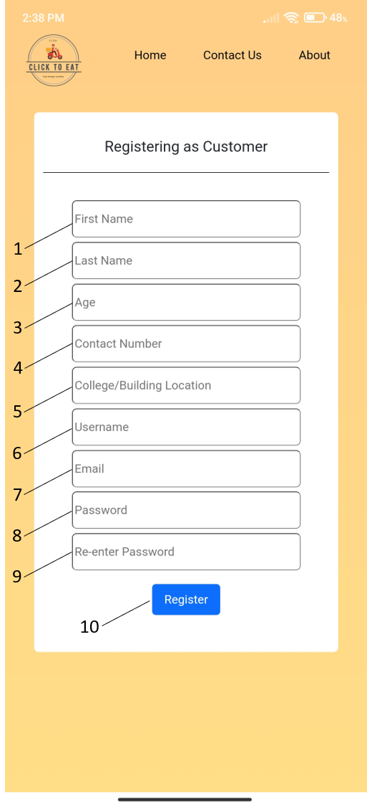  Figure 76. Customer Registration  1. First Name  2. Last Name  3. Age  4. Contact Number  5. Building Location  6. Username  7. Email  8. Password  9. Password Repeat  10. Register Button | 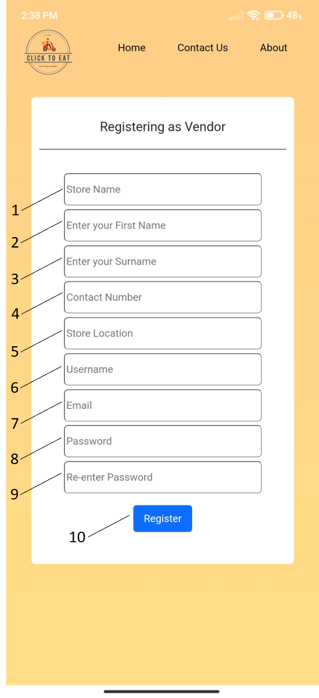  Figure 77. Vendor Registration  1. Store Name  2. First Name  3. Last Name  4. Contact Number  5. Store Location  6. Username  7. Email  8. Password  9. Password Repeat  10. Register Button
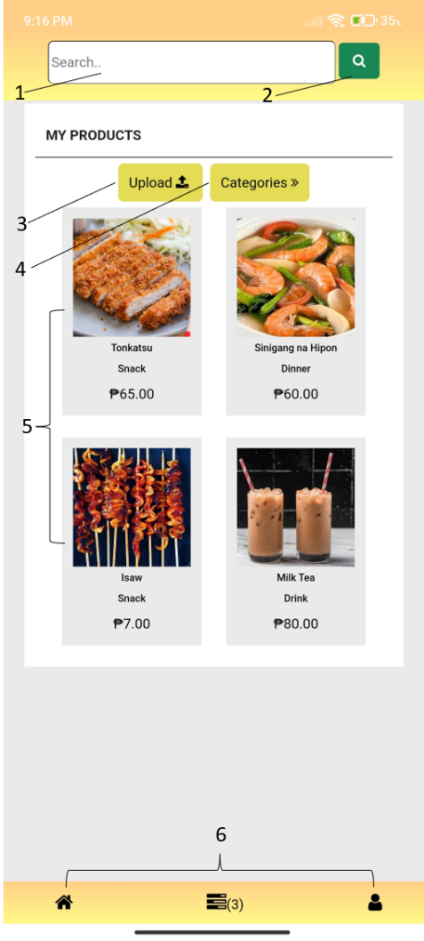  Figure 78. Vendor Homepage  1. Search Field  2. Search Button  3. Upload Button  4. View products in category  5. Uploaded Products  6. Navigation Bar | 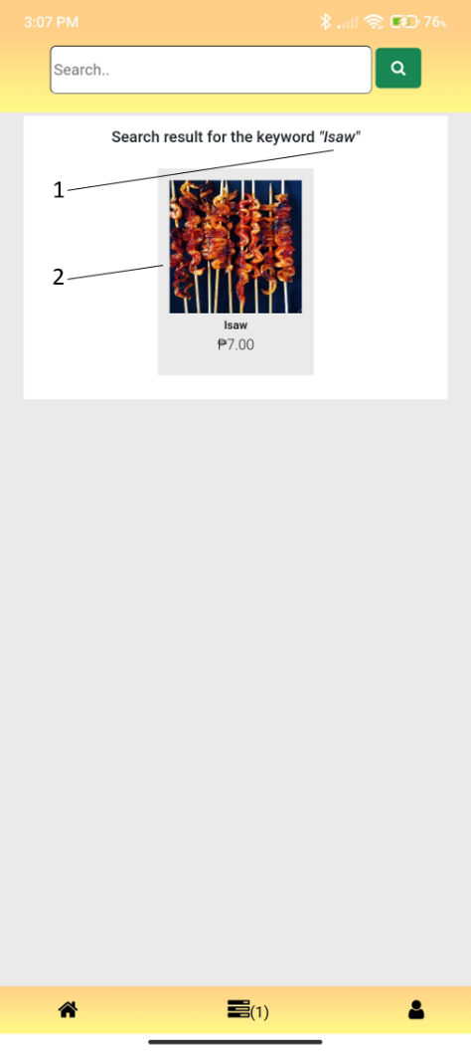  Figure 79. Vendor Search Result  1. Keyword to search  2. Result
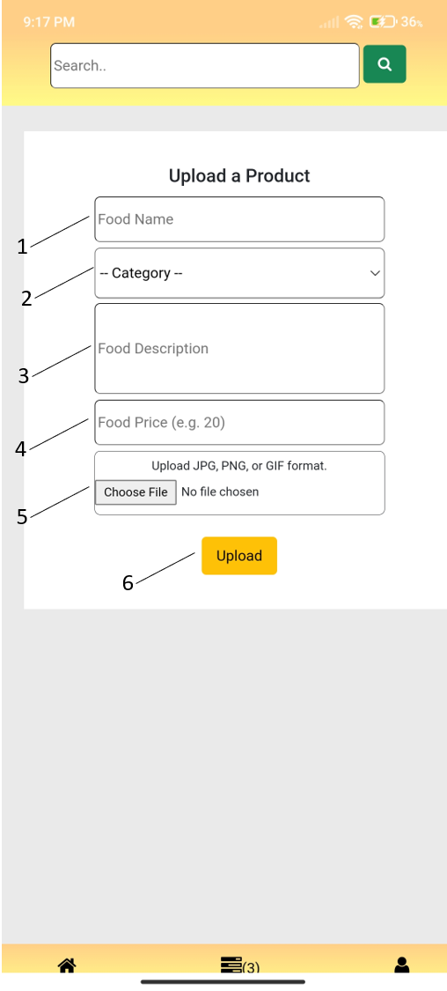  Figure 80. Product Upload  1. Product Name  2. Category Selection  3. Product Description  4. Product Price  5. Photo Upload  6. Upload Button | 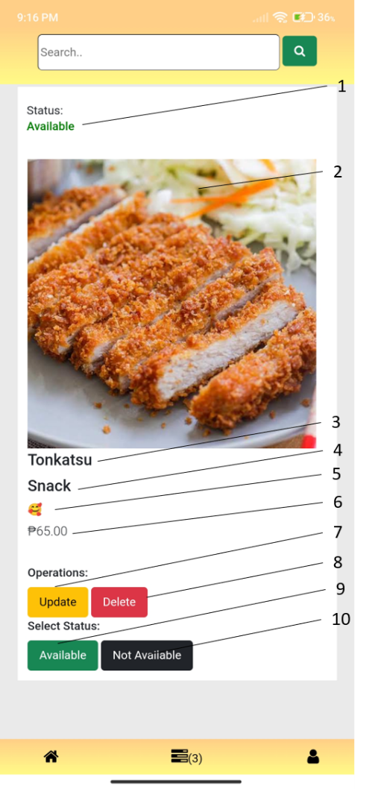  Figure 81. Product Details  1. Product Status  2. Product Image  3. Product Name  4. Product’s Category  5. Product Description  6. Product Price  7. Update Product Button  8. Delete Product Button  9. Make the Product Available  10. Make the Product Unavailable
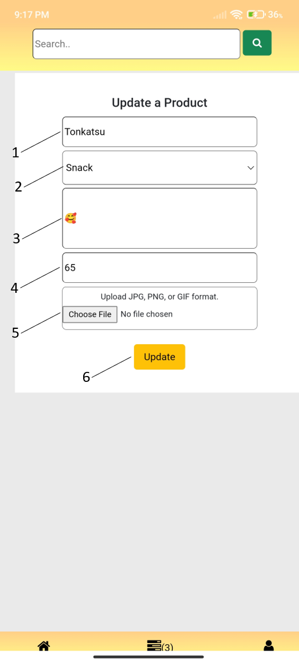  Figure 82. Update Product  1. Update Product’s Name  2. Update Product’s Category  3. Update Product’s Description  4. Update Product’s Price  5. Update Product’s Image  6. Update button | 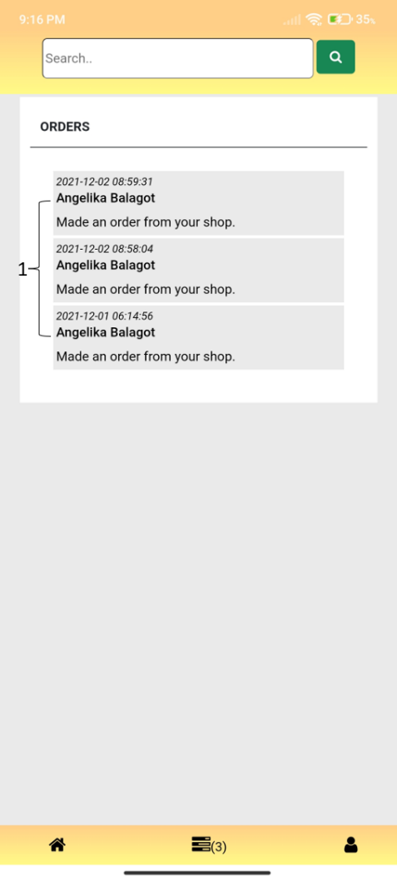  Figure 83. View Orders  1. Orders from customer
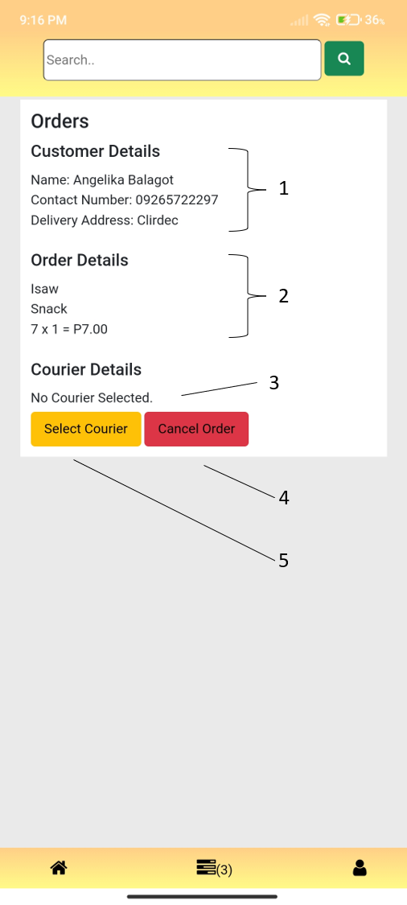  Figure 84. View Order Details w/o Courier Selected  1. Customer Details  2. Order Details  3. Courier is not Selected Info  4. Cancel Order button  5. Select Courier button | 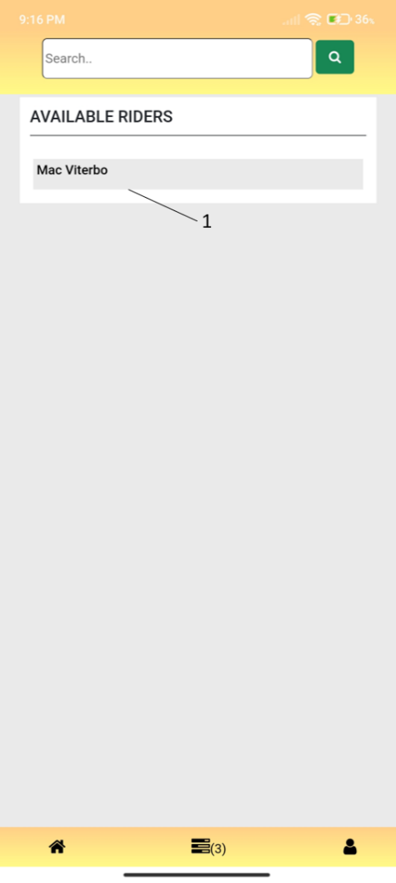  Figure 85. Selection of Courier  1. Registered Riders/Courier

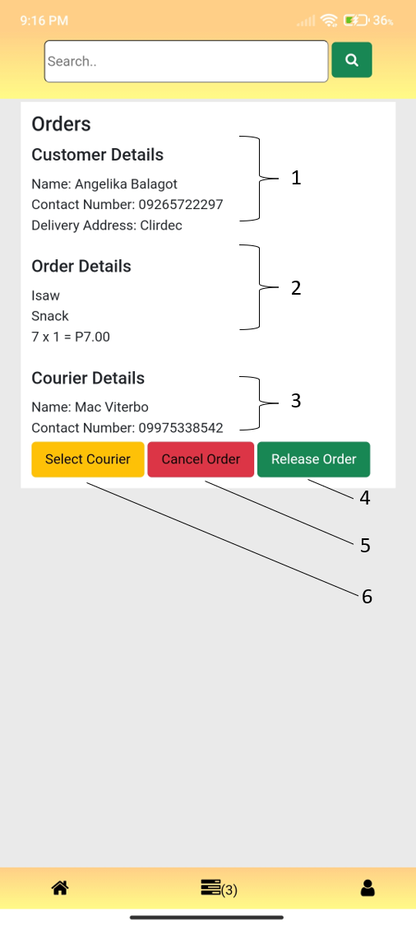  Figure 86. View Order Details with Selected Courier  1. Customer Details  2. Order Details  3. Courier Details  4. Cancel Order button  5. Select Courier button | 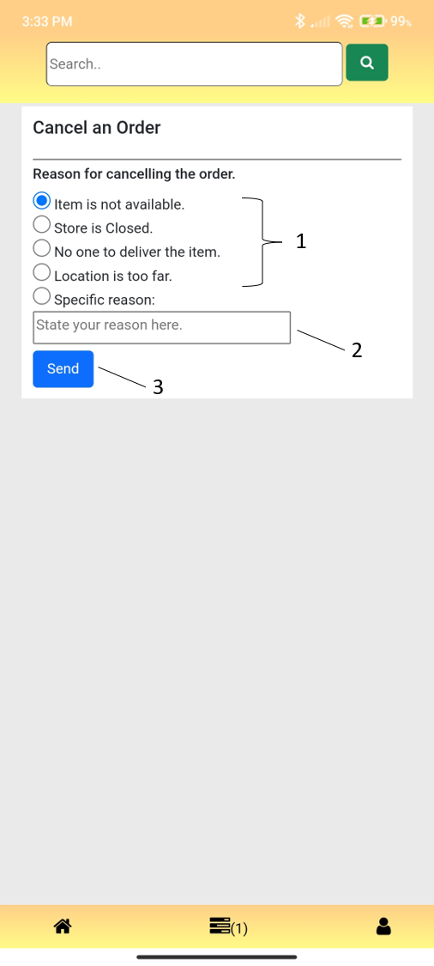  Figure 87. Order Cancellation  1. Frequent reasons for order cancellation  2. Providing specific reason field  3. Send button

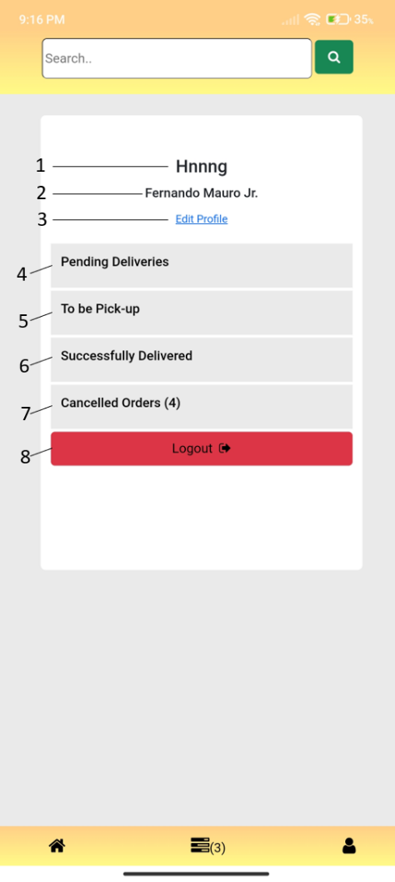  Figure 88. Vendor’s Profile  1. Store Name  2. Vendor Name  3. Edit Profile Link  4. Pending Deliveries button  5. To be pick-up button  6. Successfully Delivered button  7. Cancelled Orders  8. Logout Button | 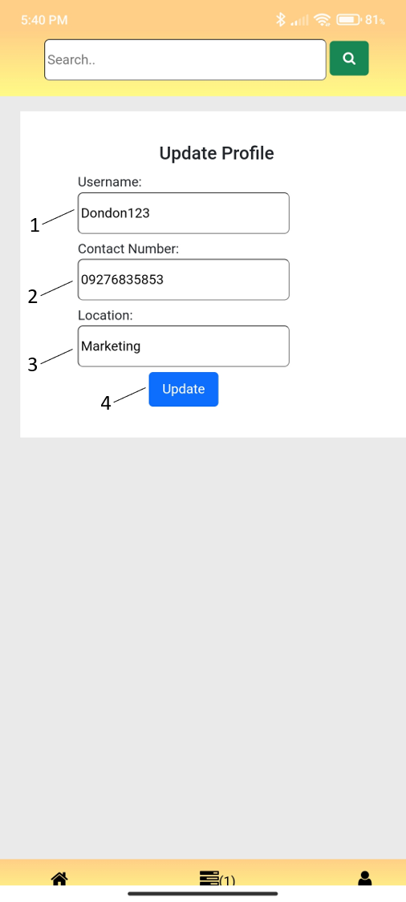  Figure 89. Vendor Update Profile  1. Update Username Field  2. Update Contact Number Field  3. Update Location Field  4. Update button

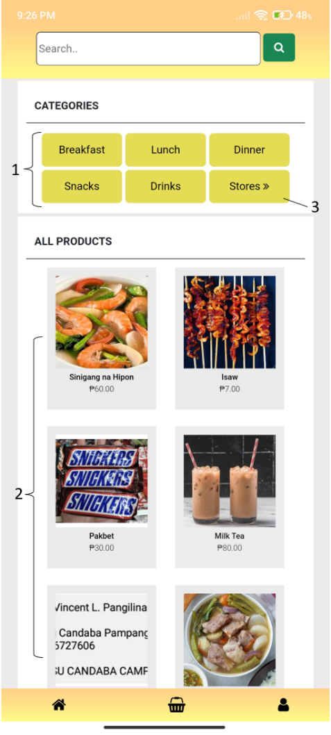  Figure 90. Customer’s Homepage  1. Categories  2. Available Products  3. View Stores | 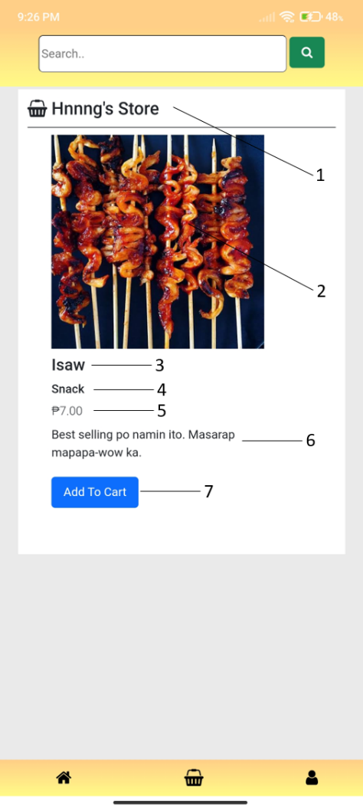  Figure 91. Product Details  1. Store Name  2. Product’s Image  3. Product’s Name  4. Product’s Category  5. Product’s Price  6. Product’s Description  7. Add to Cart button

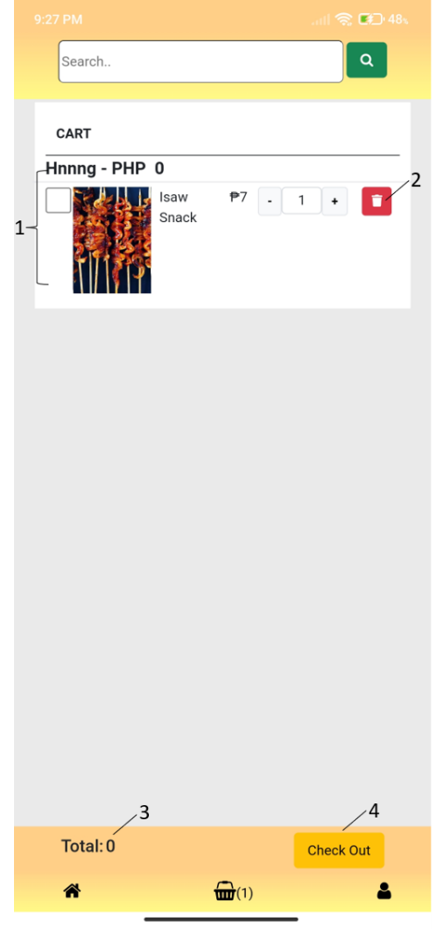  Figure 92. Unchecked item in Cart  1. Unchecked added to cart product  2. Remove from cart button  3. Total when unchecked  4. Checkout button | 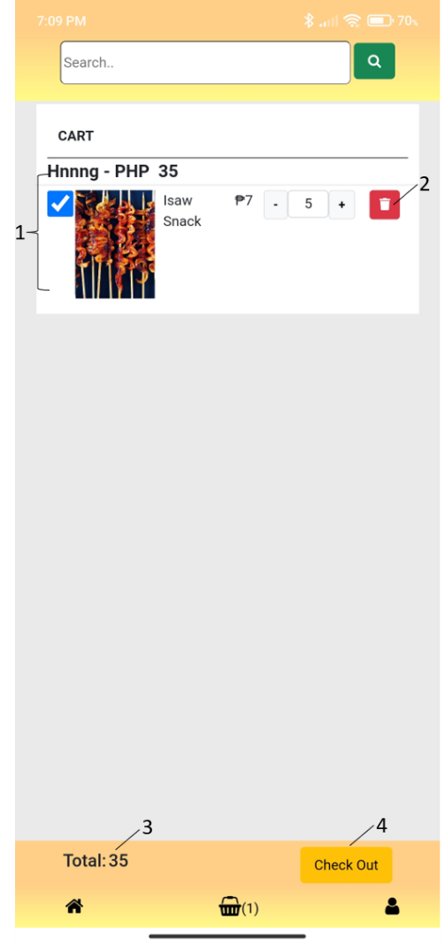  Figure 93. Checked Item in Cart  1. Checked added to cart product  2. Remove from cart button  3. Total when checked  4. Checkout button
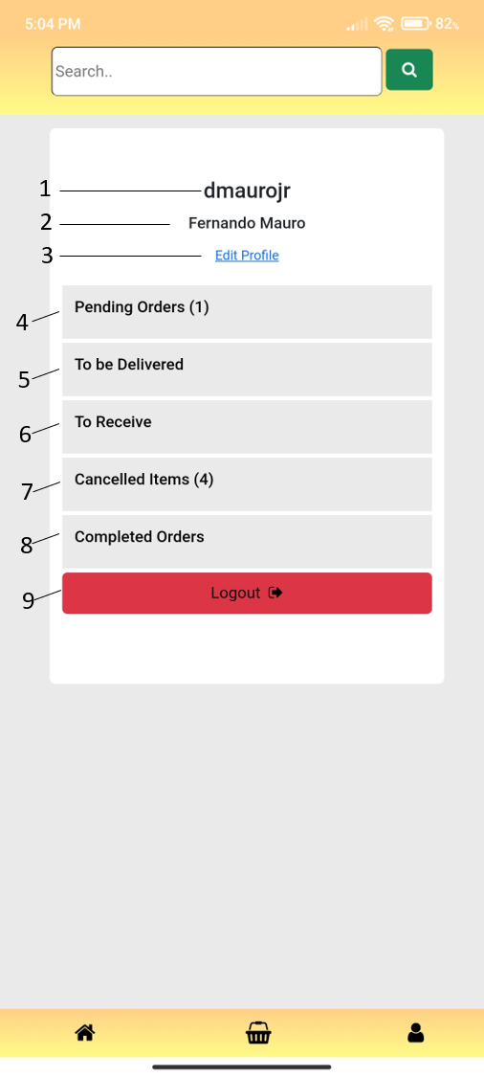  Figure 94. Customer’s Profile  1. Username  2. Customer Name  3. Edit Profile link  4. Pending Orders button  5. To be Delivered button  6. To Receive button  7. Cancelled Orders  8. Completed Orders  9. Logout Button | 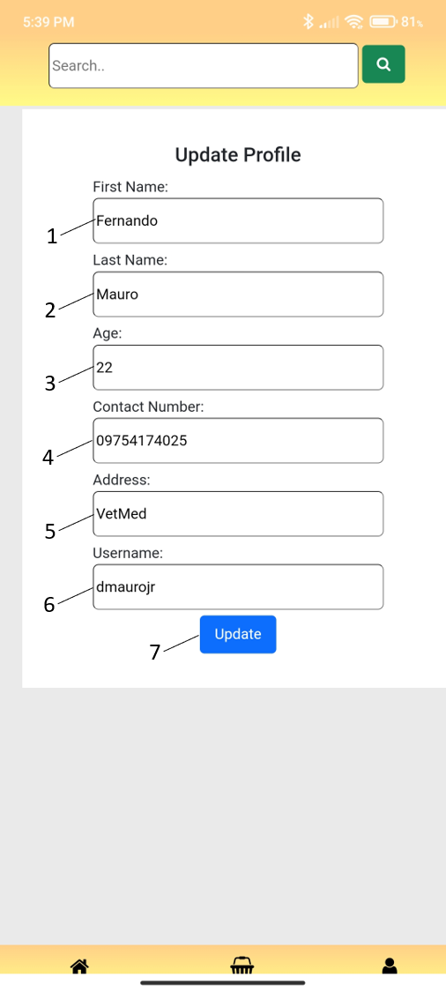  Figure 95. Customer Update Profile  1. Update First Name Field  2.Update Second Name Field  3. Update Age Field  4. Update Contact Number Field  5. Update Delivery Address Field  6. Update Username Field  7. Update button
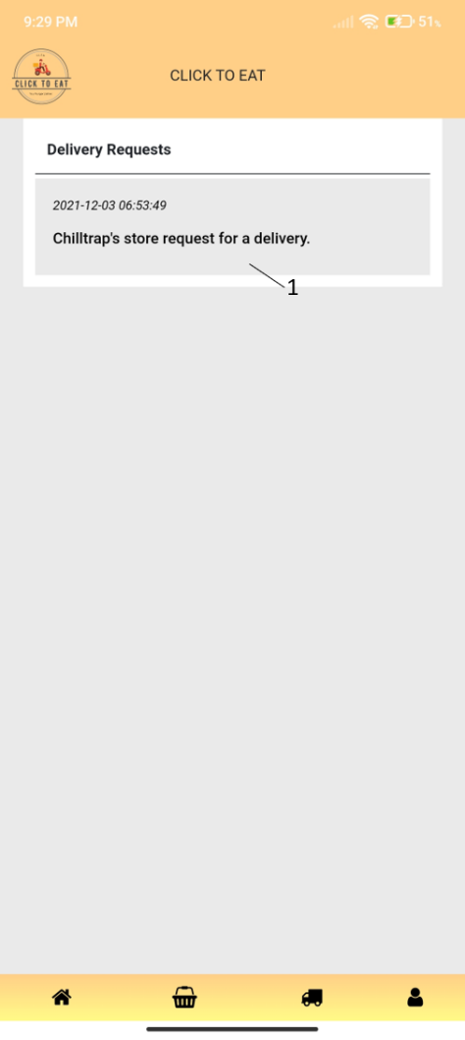  Figure 96. Courier Homepage  1. Delivery Request/s | 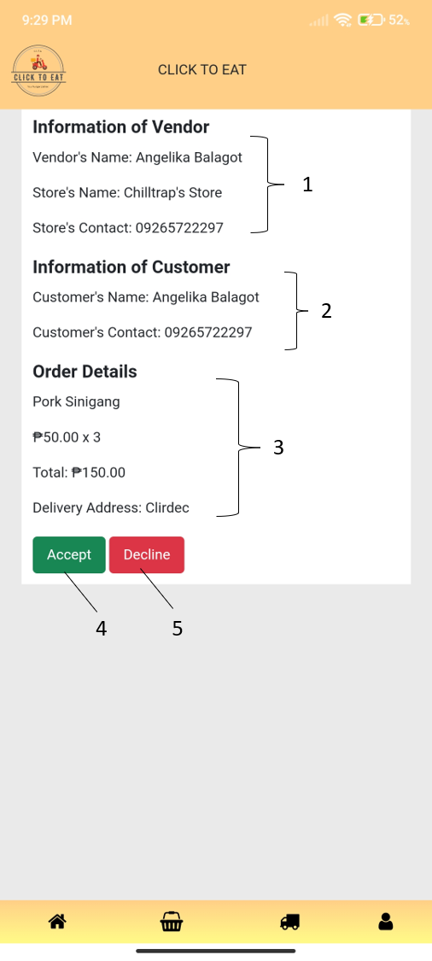  Figure 97. Delivery Request Details  1. Information of Vendor  2. Information of Customer  3. Order Details  4. Accept Delivery Request  5. Decline Delivery Request

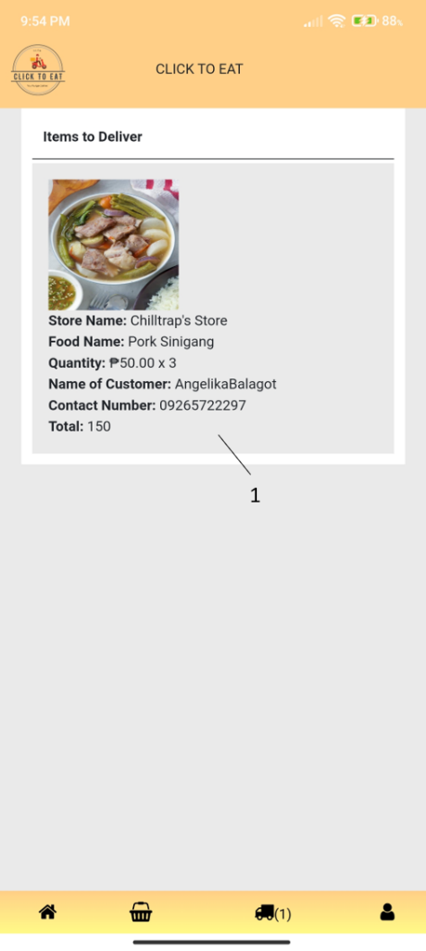  Figure 98. Items to Deliver  1. Item/s to Deliver Full Details | 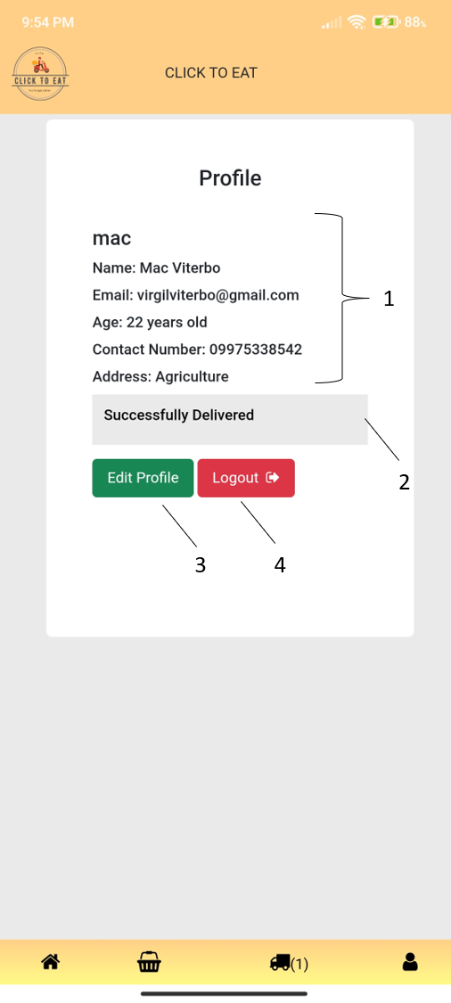  Figure 99. Courier Profile  1. Courier’s Profile Information.  2. Successfully Delivered button  3. Edit Profile  5. Logout button

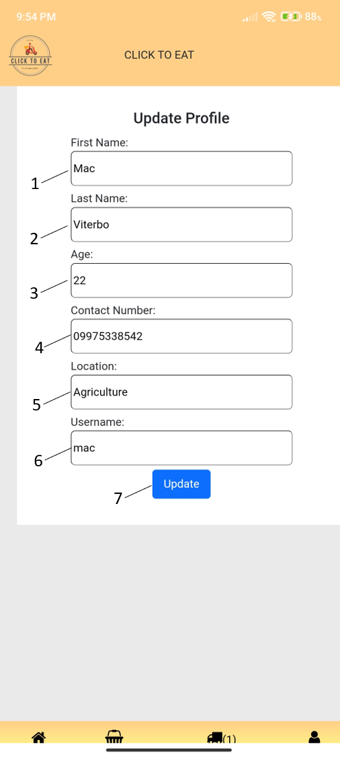
Figure 100. Courier Update Profile
1. Update First Name Field
2. Update Last Name Field
3. Update Age Field
4. Update Contact Number Field
5. Update Address Field
6. Update Username Field
7. Update button

  - EVALUATION FORM FOR USER ACCEPTABILITY
Evaluation Tool for User Acceptability
End-users (definition). The legitimate users of a particular software.

(This evaluation tool is intended only for IT Capstone Project 2 – Systems Development)

Part 1. Characteristics of Respondents

Name: Hannah Mae Dacumos
Age: 21
Sex: Female
User Type: (/) * Customer
Courier
Vendor

Part 2. Evaluation for Usability, Reliability, Effectiveness, User Interface, and Security

Please indicate a check mark under the column that best describes your response for each item about the CLSU Click to Eat Mobile and Website System. Please use the rating below:

5 – Beyond Acceptable
4 – Acceptable
3 – Slightly Acceptable
2 – Slightly Not Acceptable
1 – Not Acceptable

2.1 Usability
 | 5 | 4 | 3 | 2 | 1
- The system is easy to control and operate. | /
- The system is easy to learn how to use. | /
- It is easy to register an account, login, and logout in the system. | /
- It is easy to access the system. | /

2.2 Reliability
 | 5 | 4 | 3 | 2 | 1
- The system is accessible and operational when required for use. | /
- The system allows users to edit the incorrect information they inputted on the system. | /
- The system allows users to recover their account when they forgot their password. | /
- The system lets the user to verify first their accounts before logging in to the system. |  | /

2.3 Effectiveness

- This part of evaluation is for the CUSTOMERS inside the CLSU ONLY.
 | 5 | 4 | 3 | 2 | 1
- The system allows customers to add items to the cart easily. | /
- The system lets customers to remove item from the cart as well as to place order from the cart. | /
- Customers can cancel their orders even after placing it on the system. | /
- Customers are allowed to view the transactions between vendors and couriers once they placed an order. | /
- The system lets the customer to set the ordered items into completed items once the customer receives the order. |  | /
- Customer can view the list of purchase items from the system. | /

- This part of evaluation is for the COURIERS inside the CLSU ONLY.
 | 5 | 4 | 3 | 2 | 1
- The system allows courier to view the list of stores that is being registered in the system.
- Couriers can view the orders that he/she needs to deliver to the customer.
- The system lets courier to accept or decline the delivery request.
- Courier can view the list of delivered items on the system

- This part of evaluation is for the VENDORS inside the CLSU ONLY.
 | 5 | 4 | 3 | 2 | 1
- The system lets vendor to upload, update, and delete products.
- Vendors can set the uploaded products into Available or Not Available status upon the availability of the product.
- Vendors are allowed to view the items that is being ordered from the store together with the information of the customer.
- Vendors can accept or decline orders.
- The system lets vendor to choose his/her desired courier to deliver the ordered item.
- Vendor can view the list of release orders from the store on the system.

2.4 User Interface
 | 5 | 4 | 3 | 2 | 1
- Overall visual appearance is appealing and appropriate. |  | /
- Overall system interface can be navigated easily. |  | /
- Design matches the user’s design theme. |  | /
- Buttons/Links functions and operates well. |  | /

2.5 Security
 | 5 | 4 | 3 | 2 | 1
- Users has control over his/her personal information. | /
- User trusts the system that his/her personal information is secured and can’t be accessed by others except the administrator in charge. | /
- Users have controls on the settings of their account. | /

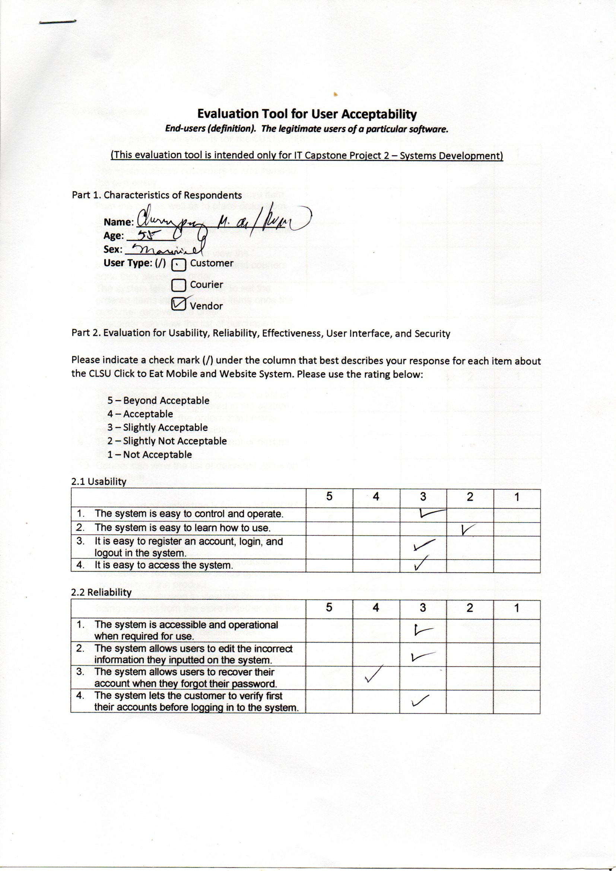

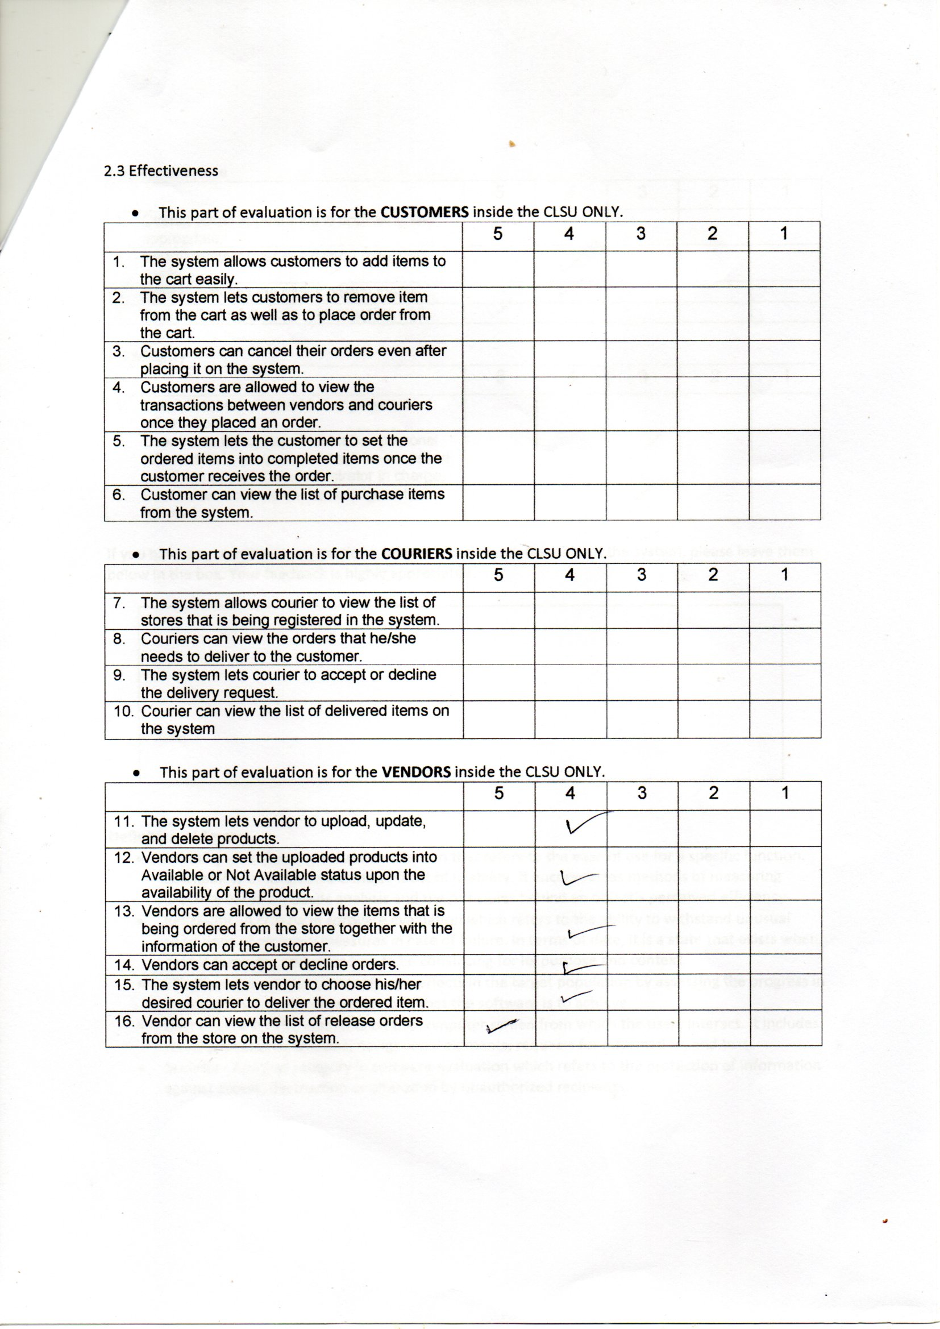

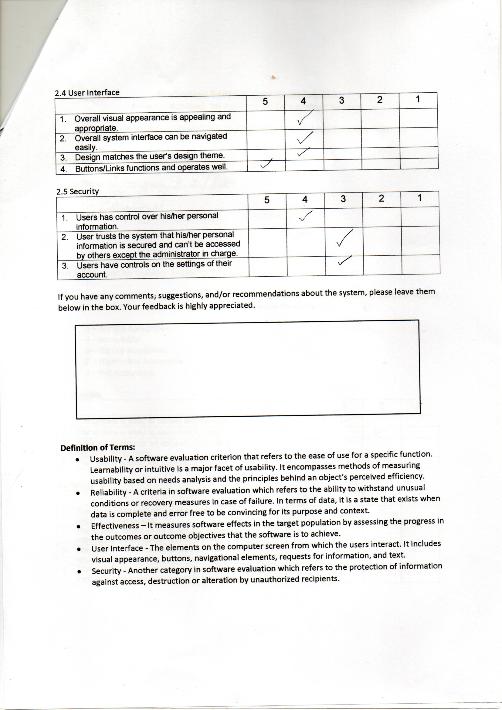

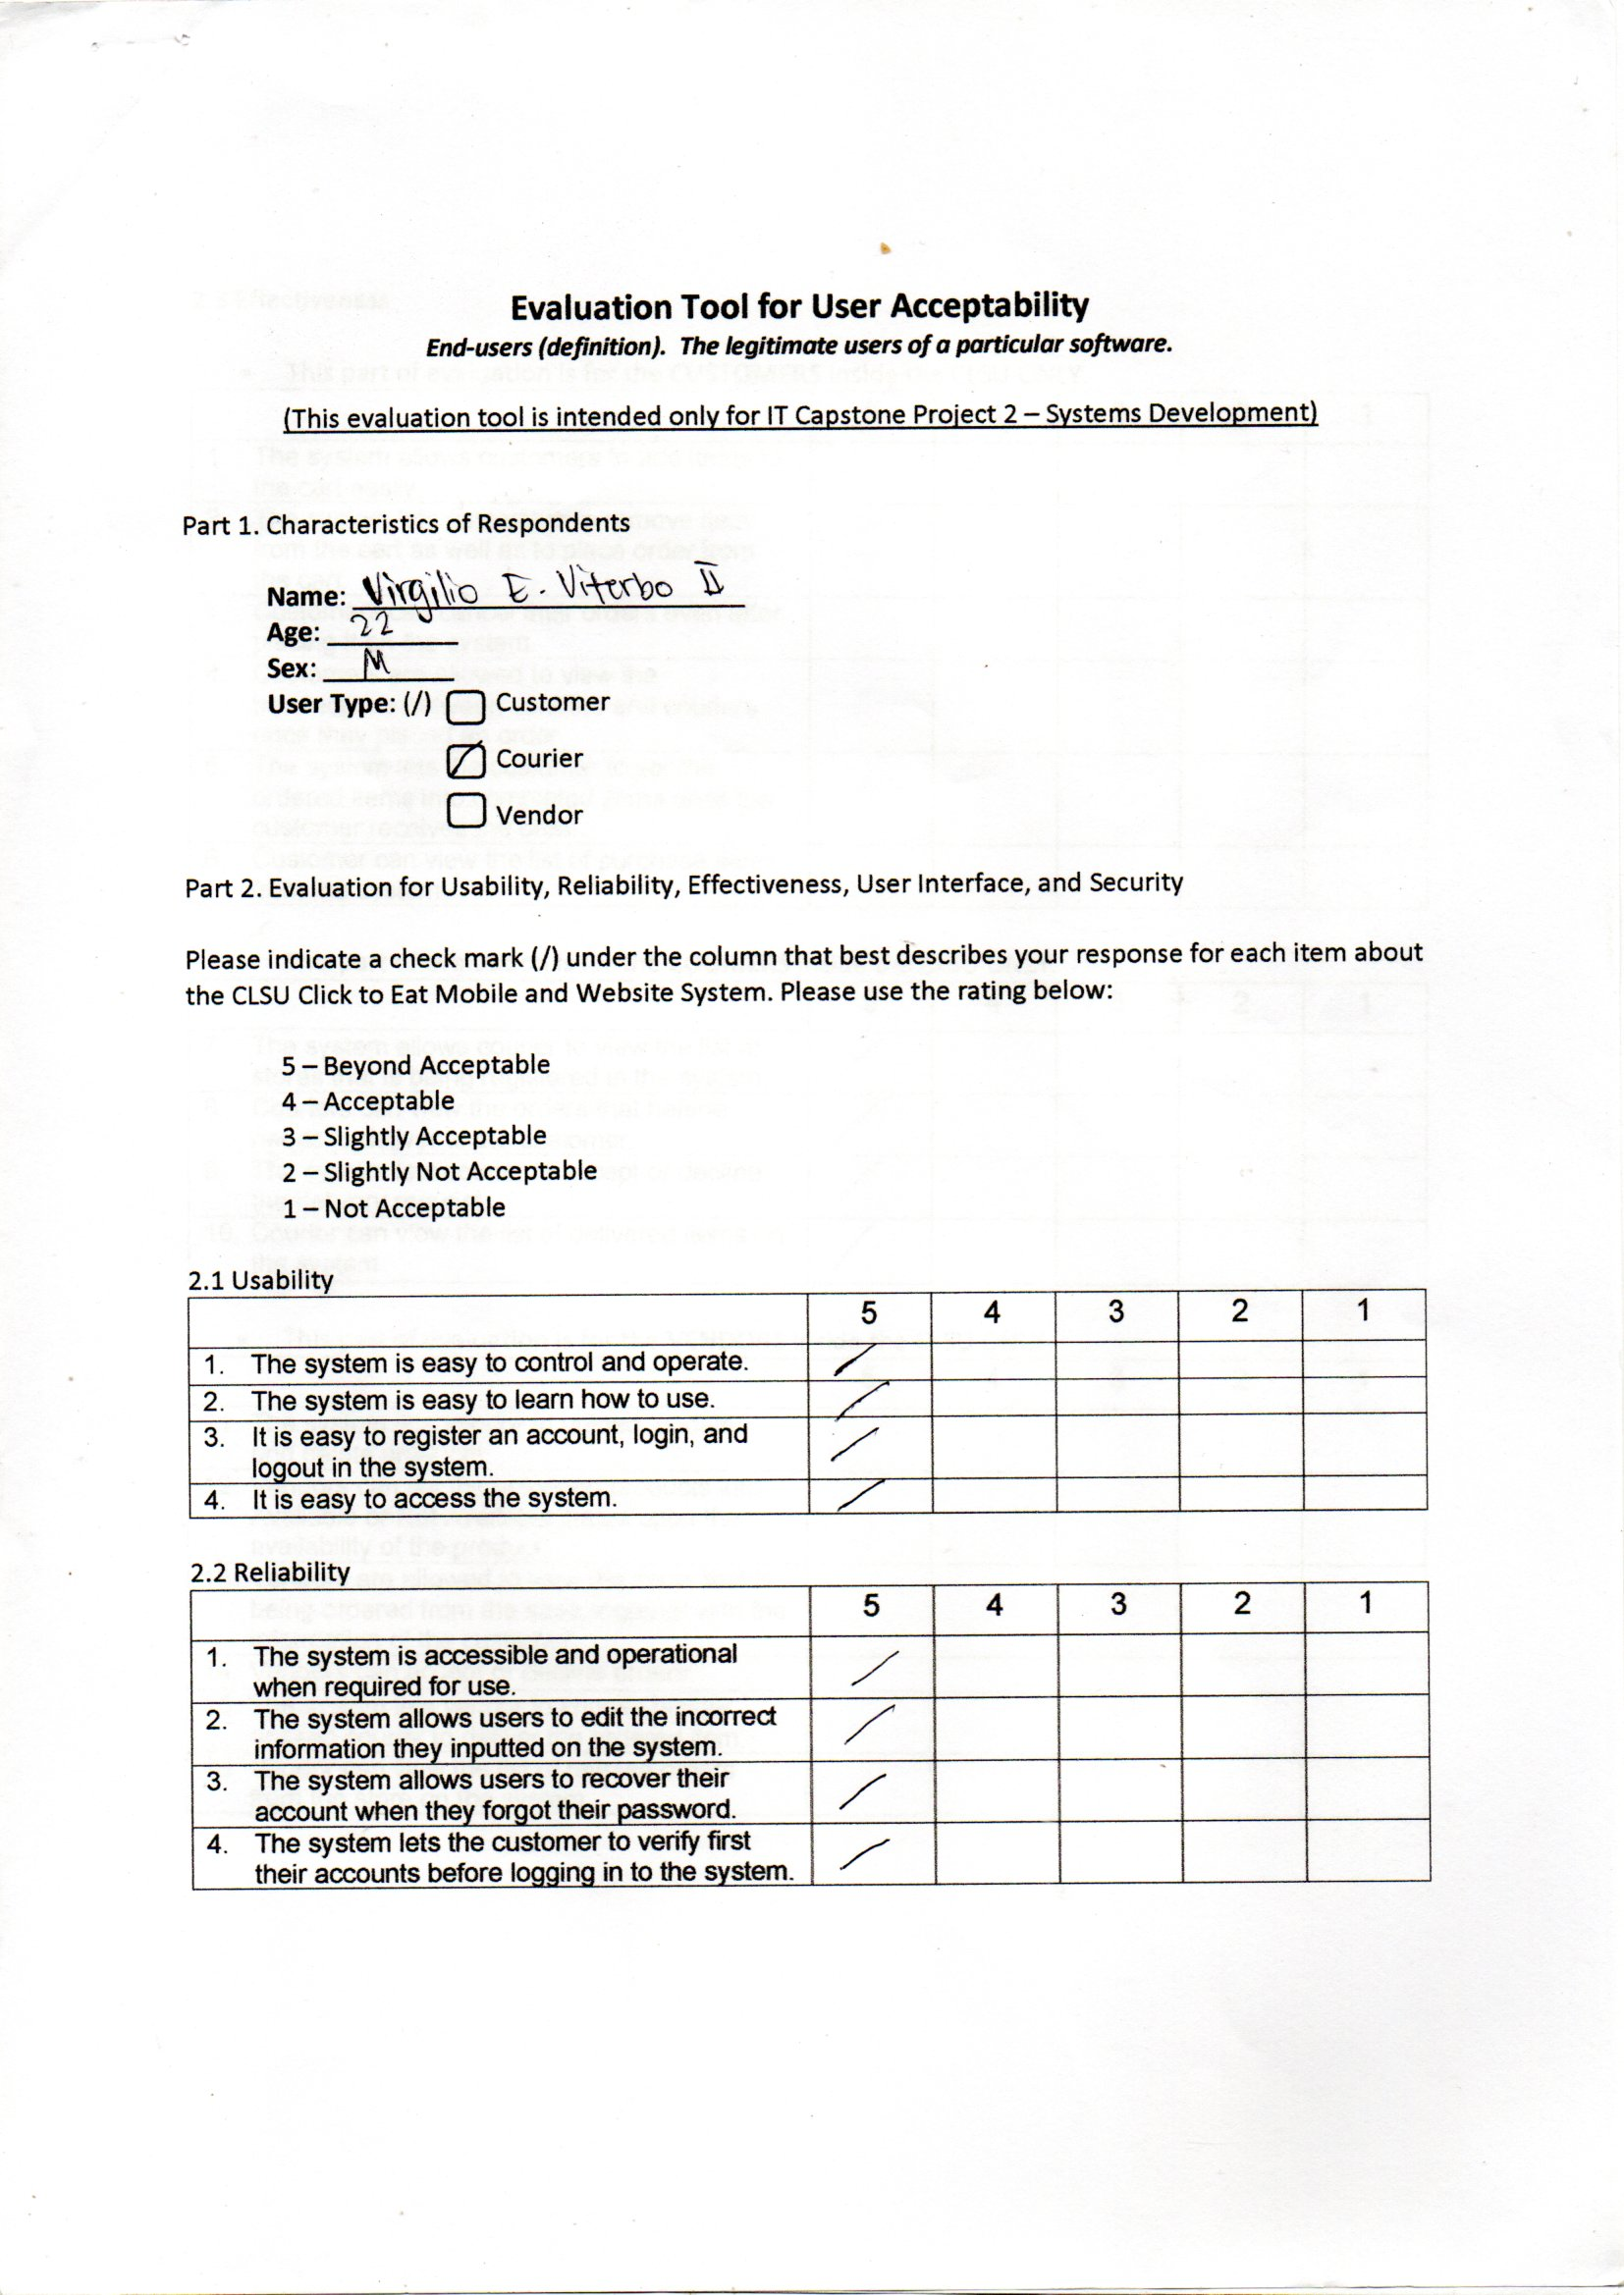

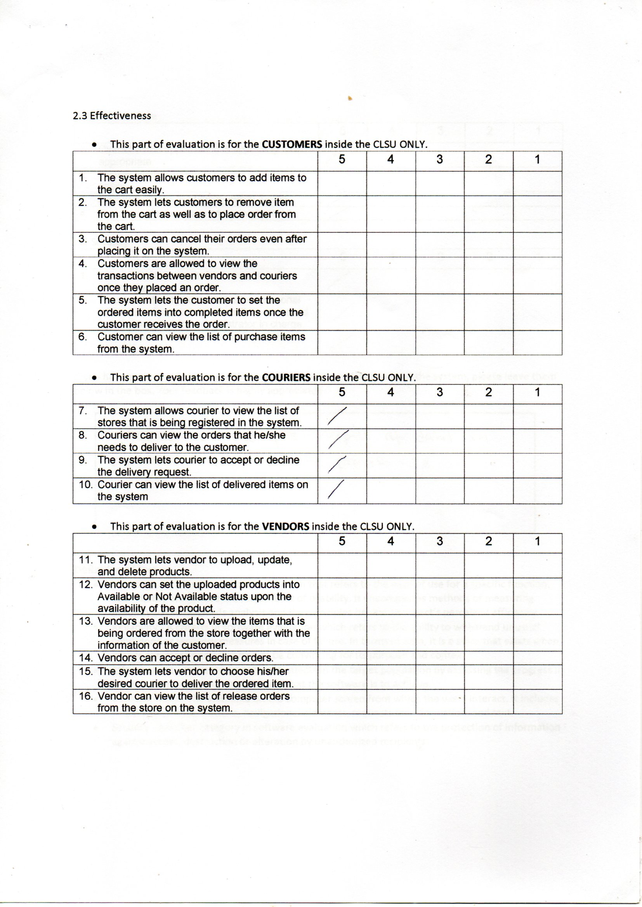

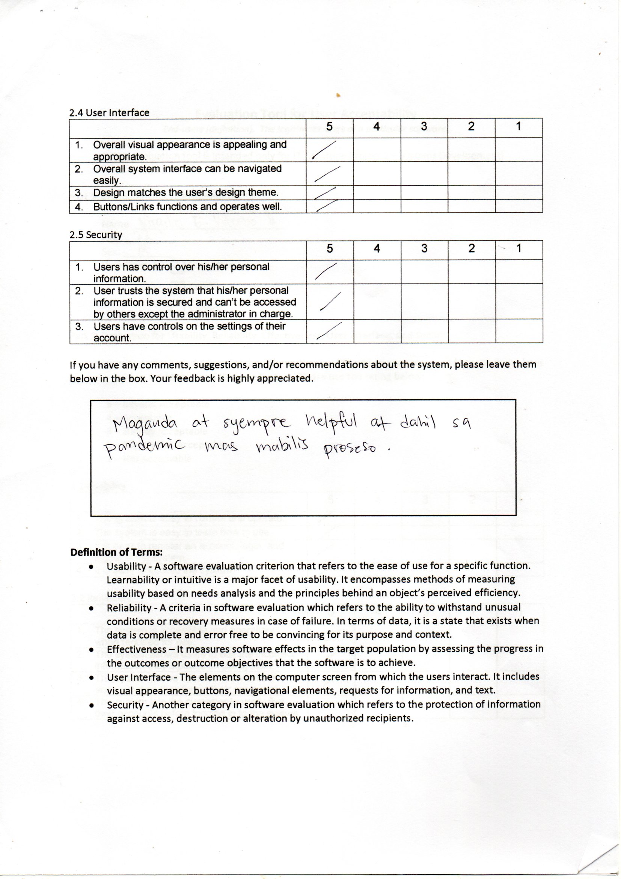

REFERENCES:
AG, C. (2020, April 3). Best food delivery apps to turn to in the Philippines during a Community Quarantine. Retrieved March 07, 2021, from https://ph.priceprice.com/mobilephones/news/best-food-delivery-apps-ph-8827/
Cleverism.com (2021). About Food Panda Retrieved March 07, 2021, from https://www.foodpanda.ph/contents/about.htm
Duman, R. (2020, September 03). What is software development life CYCLE (SDLC)? Retrieved April 07, 2021, from https://strolve.com/what-is-software-development-life-cycle-sdlc/
Dunn, J. (2018, March 23). 7 food ordering apps for hungry students. Retrieved March 21, 2021, from https://www.uloop.com/news/view.php/261953/7-Food-Ordering-Apps-For-Hungry-Students
Grab.com (n.d.). What is GRABFOOD? (n.d.). Retrieved March 07, 2021, from https://www.grab.com/ph/food/#:~:text=GrabFood%20is%20a%20food%20delivery,to%20bring%20it%20to%20you.
Joshi , S., & Ansari, A. (2019, January 3). Food – More than an essential need. Nutrition Meets Food Science. https://nutritionmeetsfoodscience.com/2019/01/03/food-more-than-an-essentialneed/#:~:text=Food%20is%20one%20of%20the,the%20very%20existences%20of%20humans.
Wibisono, A., Hendrawan, R. A., Nisafani, A. S., ER, M., Suryani, E., & Aristio, A. P. (2018). Issues and lessons learned in registering restaurant business into Google business and online food delivery platforms in Indonesia. SEWAGATI, 2(2). doi:10.12962/j26139960.v2i2.4268
Sharma, S. (2020, February 20). How to Build a Food Delivery App in 5 Easy Steps (Guide 2021). Oyelabs. https://oyelabs.com/build-food-delivery-app/.

